Al Hussein Technical University
Faculty of Computer Science and Engineering

Cloud Computing Systems Design and Implementation Project

Course: 40201450 — Cloud Computing | BTEC Level 5 HND
Academic Year: 2025–2026 | Submission Date: 13/06/2026

Field | Details
Student Name | Ahmad Marwan Maghaireh
Student ID | 23110205
Section | 1
Course Tutor | Yazan Alshannik
Date Submitted | 13/6/2026

AI USAGE DISCLOSURE: Claude (Anthropic) was used to assist in structuring this report and generating initial code samples. All AI-generated content has been reviewed, understood, and adapted by the student. Technical decisions, architectural choices, and justifications reflect the student's own understanding of AWS best practices and have been validated through hands-on implementation. Screenshots throughout this report are from the student's own AWS implementation.

Table of Contents

SCENARIO 1: HTUNews Cloud Migration — AWS Infrastructure Design

HTUNews is a startup news company delivering content across the Middle East. It is migrating from on-premise infrastructure to Amazon Web Services (AWS) in a phased approach. The following sections design and implement all required cloud solutions, covering identity management, compute, storage, monitoring, and DNS security.

Section 1: Access Management and Security (IAM)

1.1 Overview and Design Justification
AWS Identity and Access Management (IAM) is a global service that enables secure control over who can access AWS resources and what actions they can perform. It operates on the Principle of Least Privilege: each user is granted only the permissions needed to fulfill their role, and no more. HTUNews has nine users across three departments, and managing permissions individually for each user would be error-prone and unmanageable at scale.
This section focuses on IAM Users and Groups, which manage access for human users. Later sections will introduce IAM Roles — temporary credentials assigned to AWS services like EC2 — enabling secure service-to-service communication without storing long-term credentials.
Rather than assigning permissions directly to individual users, the best practice is to create IAM Groups per department, attach appropriate policies to each group, and then add users into their respective group. This approach centralises permission management and ensures consistency.

1.2 IAM Group and Policy Design
Group Name | Members | Policies Attached | Access Scope
Admins-Group | Yazan, Ahmad | AdministratorAccess (AWS Managed) | Full infrastructure: EC2, S3, IAM, CloudWatch, VPC, all services
Developers-Group | Lina, Omar, Khaled | AmazonEC2FullAccess, AmazonS3ReadOnlyAccess, CloudWatchReadOnlyAccess | Application servers, read storage, view monitoring — no IAM/security config
ContentEditors-Group | Sara, Noor, Huda, Ali | Custom: S3 PutObject, GetObject, DeleteObject, ListBucket on htunews-media-bucket | Upload/manage media files in S3 — no EC2, IAM, or network access

IMPORTANT: Developers require iam:PassRole permission to attach IAM roles to EC2 instances during launch. This will be added as a custom policy in Section 3 when the EC2-S3 role is created. Without this permission, developers can manage existing instances but cannot launch new ones with the required S3 access role.

1.3 MFA Requirement for Admin Accounts
Because Admin accounts have full infrastructure access, Multi-Factor Authentication (MFA) must be enforced. MFA requires a second form of authentication in addition to a password, ensuring that even if an Admin password is compromised, unauthorised access is blocked. AWS supports Virtual MFA (e.g., Google Authenticator), U2F hardware keys, and physical MFA tokens.
An IAM policy condition can be attached to the Admins-Group to deny all API actions unless MFA is active:

{ "Version": "2012-10-17", "Statement": [ { "Sid": "DenyAllWithoutMFA", "Effect": "Deny", "Action": "*", "Resource": "*", "Condition": { "BoolIfExists": { "aws:MultiFactorAuthPresent": "false" } } } ] }

This policy denies ALL actions unless the user has authenticated with MFA. The 'BoolIfExists' operator is used instead of 'Bool' because it allows API calls made using temporary credentials (like those from IAM Roles), which do not carry MFA context. Without 'IfExists', this policy would also block EC2 instances using IAM Roles — which would break the application entirely.
To implement: Create a customer-managed policy named 'EnforceMFA-AdminPolicy' and attach it to Admins-Group alongside AdministratorAccess. The explicit Deny overrides the Allow in AdministratorAccess, as AWS evaluates Deny before Allow in IAM policy evaluation.
NOTE: For this assignment, MFA is enabled manually as described in Task 1.4.4; this policy is documented as the proper production approach. In a production environment, this policy must be attached before distributing Admin credentials.

1.4 Step-by-Step Implementation

Task 1.4.1 — Create IAM Groups
Step 1: Navigate to IAM
Open the AWS Management Console. In the search bar at the top, type 'IAM' and select the IAM service.
Step 2: Open Groups
In the left navigation panel, click 'User groups', then click 'Create group'.
Step 3: Create Admins-Group
Enter the group name: Admins-Group. In the 'Attach permissions policies' section, search for and select 'AdministratorAccess'. Click 'Create group'.
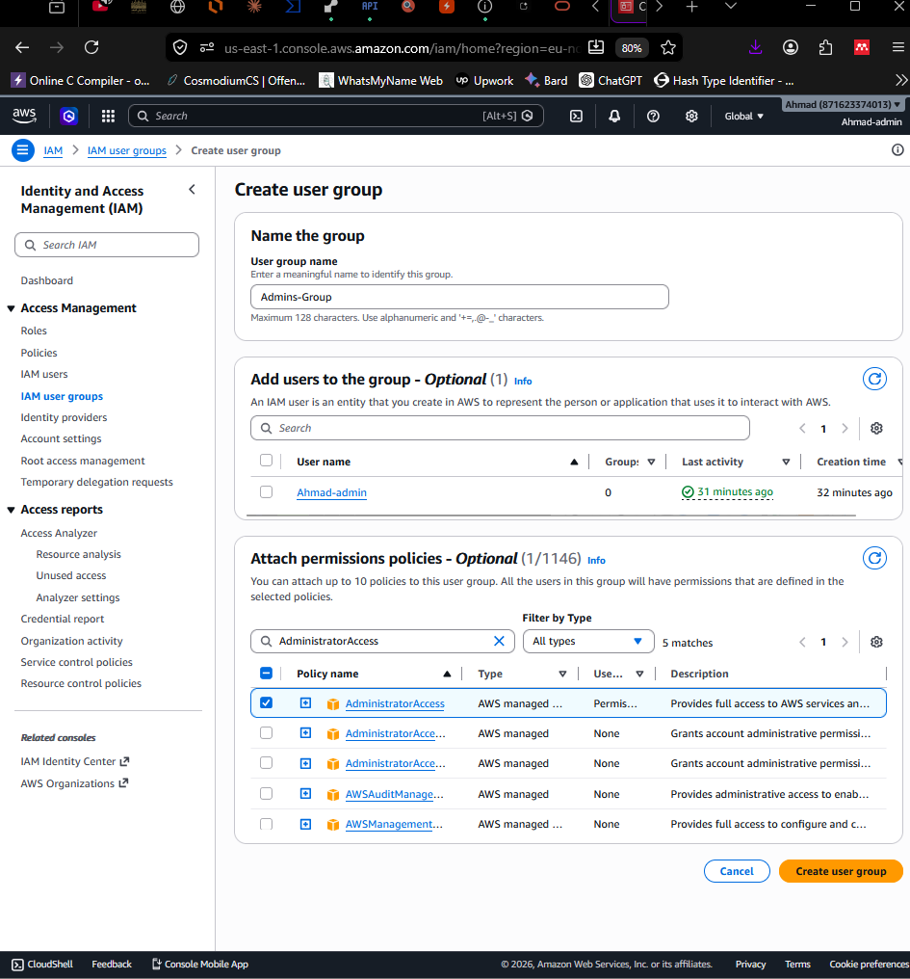

Step 4: Create Developers-Group
Click 'Create group'. Name it: Developers-Group. Attach the following AWS managed policies: AmazonEC2FullAccess, AmazonS3ReadOnlyAccess, CloudWatchReadOnlyAccess. Click 'Create group'.
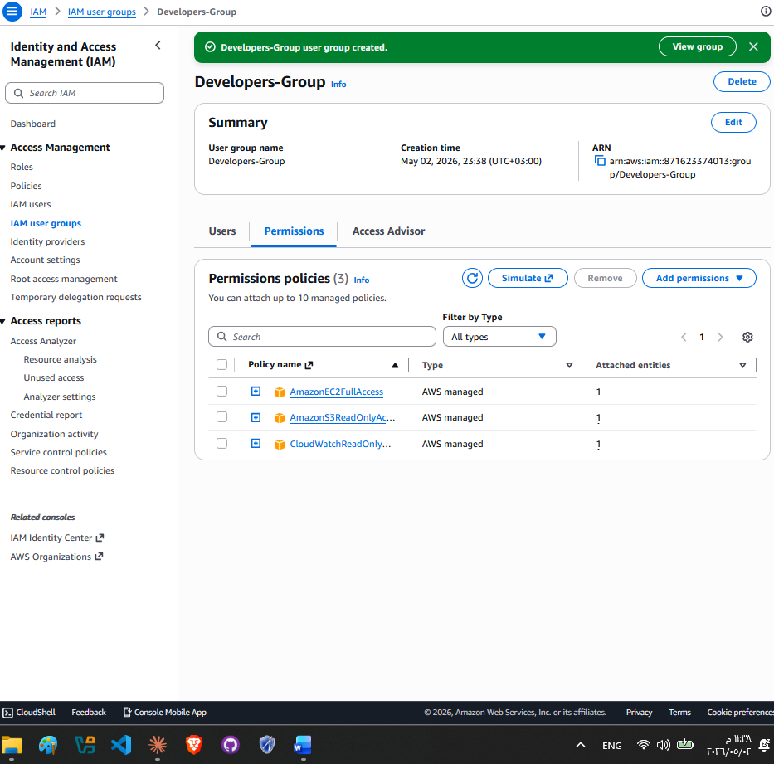
Step 5: Create ContentEditors-Group
Click 'Create group'. Name it: ContentEditors-Group. Do NOT attach any managed policy yet — a custom policy will be created in Task 1.4.2. Click 'Create group'.

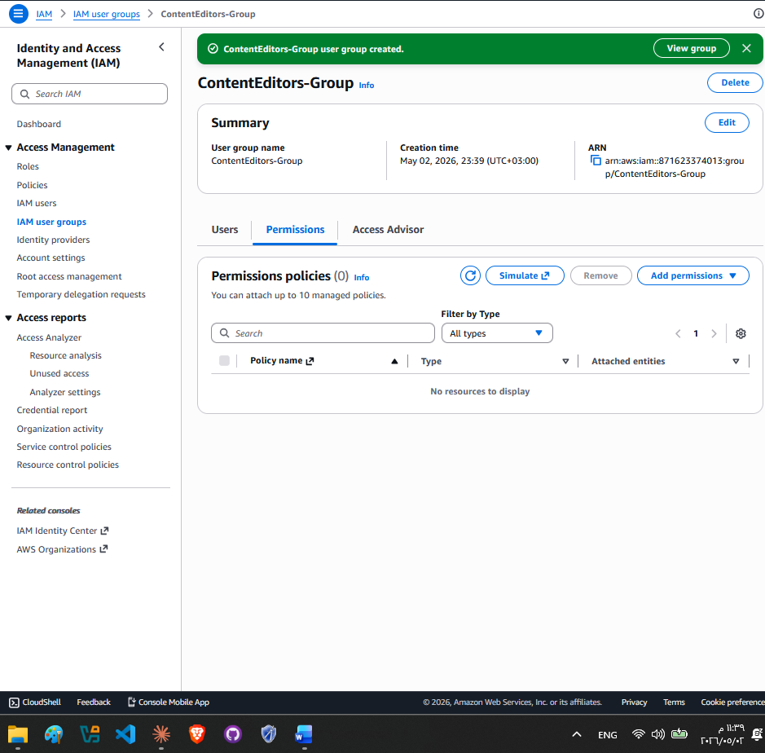

Task 1.4.2 — Create a Custom S3 Policy for Content Editors
Content Editors should only be able to upload and manage files within the HTUNews media bucket. A custom policy is created for this purpose.
Step 1: Navigate to Policies
In the IAM left panel, click 'Policies', then click 'Create policy'.
Step 2: Use JSON editor
Select the 'JSON' tab and paste the following policy. Replace 'htunews-media-bucket' with your actual S3 bucket name when created in Section 3:
{ "Version": "2012-10-17", "Statement": [{ "Effect": "Allow", "Action": [ "s3:PutObject", "s3:GetObject", "s3:DeleteObject", "s3:ListBucket" ], "Resource": [ "arn:aws:s3:::htunews-media-bucket", "arn:aws:s3:::htunews-media-bucket/*" ] }] }

NOTE: Note on the two Resource ARNs: (1) arn:aws:s3:::htunews-media-bucket is required for s3:ListBucket — a bucket-level operation that AWS evaluates against the bucket ARN. (2) arn:aws:s3:::htunews-media-bucket/* is required for GetObject, PutObject, and DeleteObject — object-level operations that AWS evaluates against object ARNs. AWS evaluates bucket actions and object actions against different ARNs. Omitting either ARN would silently break the corresponding operations. This bucket name must match EXACTLY the bucket created in Section 3.

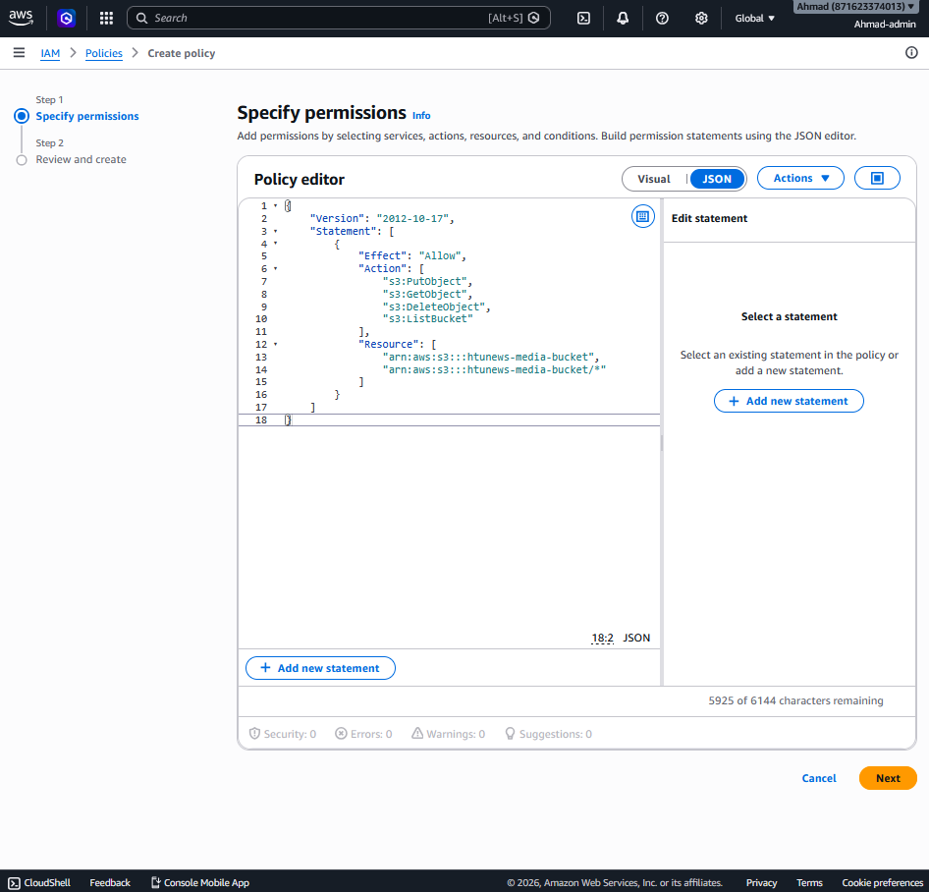

line | What It Does
"Effect": "Allow" | Grants permission (not denies)
s3:PutObject | Can upload files
s3:GetObject | Can download/read files
s3:DeleteObject | Can delete files
s3:ListBucket | Can see the list of files in the bucket
First Resource ARN | Applies ListBucket to the bucket itself
Second Resource ARN (with /*) | Applies Put/Get/Delete to files inside the bucket

What's NOT included (and why):
- No s3:CreateBucket — they can't create new buckets
- No s3:DeleteBucket — they can't delete the bucket
- No access to any other bucket — locked to htunews-media-bucket only
- No EC2, no IAM, no anything else

Step 3: Name and save
Click 'Next'. Name the policy: HTUNews-ContentEditors-S3Policy. Description: Allows content editors to upload and manage media files in the HTUNews S3 bucket. Click 'Create policy'.

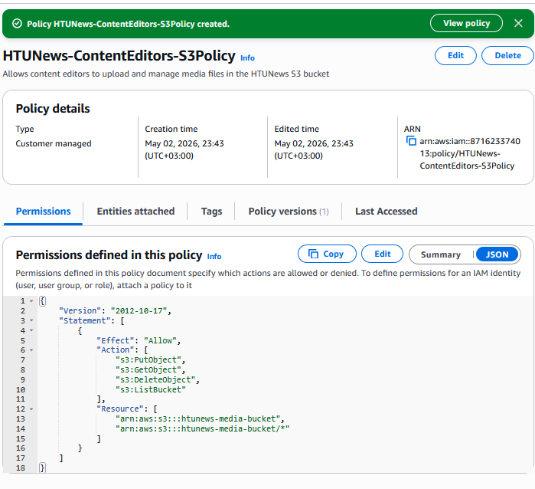

Step 4: Attach to group
Go to 'User groups', select 'ContentEditors-Group', click 'Add permissions', then 'Attach policies'. Search for 'HTUNews-ContentEditors-S3Policy' and attach it.

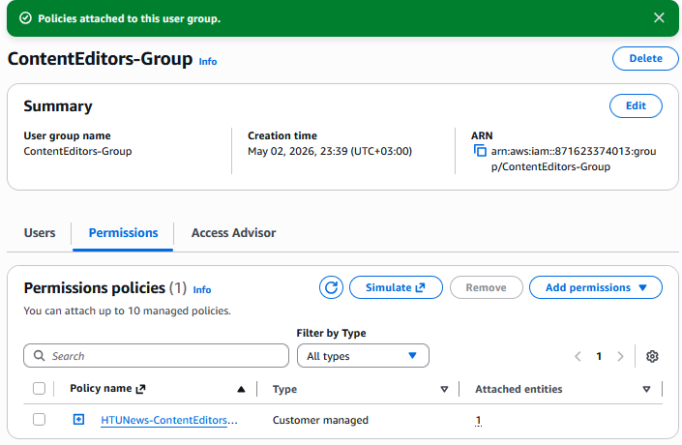

Task 1.4.3 — Create IAM Users and Assign to Groups
IMPORTANT: When creating users for this implementation: (1) Uncheck 'Users must create a new password at next sign-in' for this assignment environment to avoid login friction during testing. (2) Do NOT create access keys at this stage — access keys are for CLI/SDK access and will be configured separately if needed. (3) After all users are created, verify each group shows the correct members in the group detail page.

Step 1: Navigate to Users
IAM Console > Users > Create user.
Step 2: Create Admin users
Create user 'Yazan': Enter username 'Yazan', enable 'AWS Management Console access', set a custom password. On the permissions page, select 'Add user to group' and choose 'Admins-Group'. Click through to Create user. Repeat identically for user 'Ahmad'.

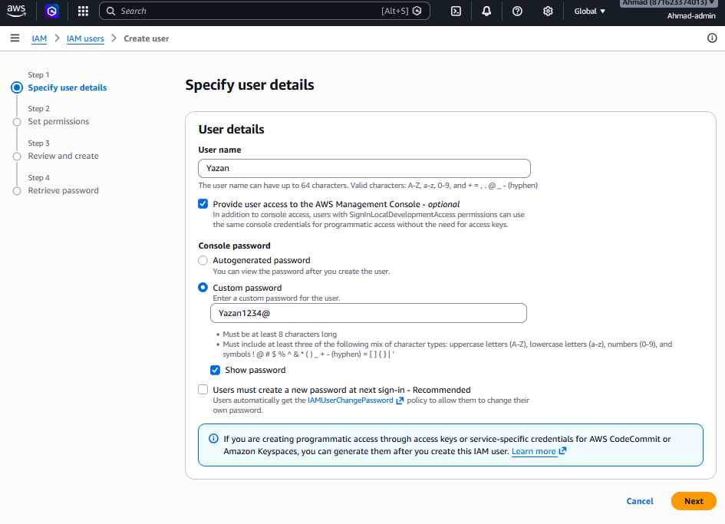
Yazan
Yazan1234@
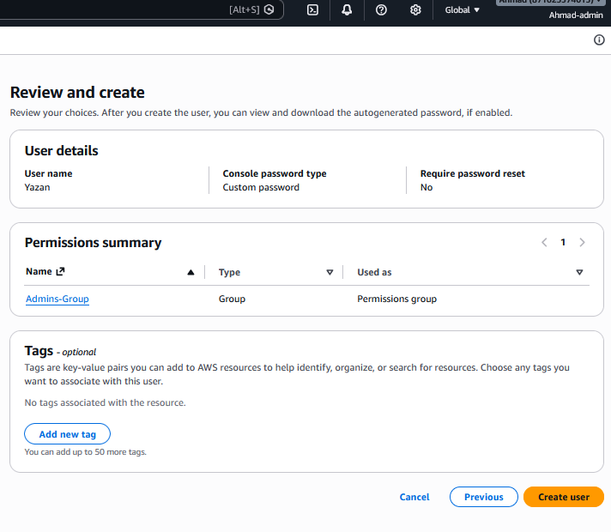
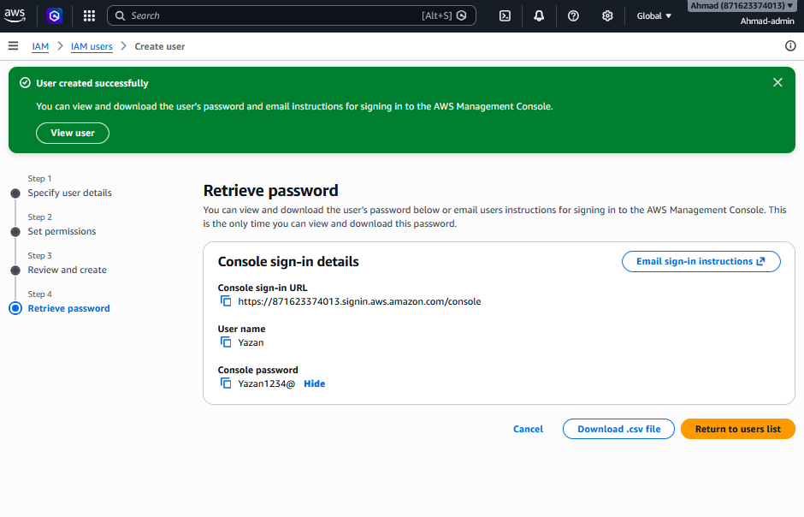

Ahmad (I changed it to Ahmed because my aws console username is ahmad which is my name ):
Note: Any screenshot has Ahmad-admin is changed to “ahmed” only
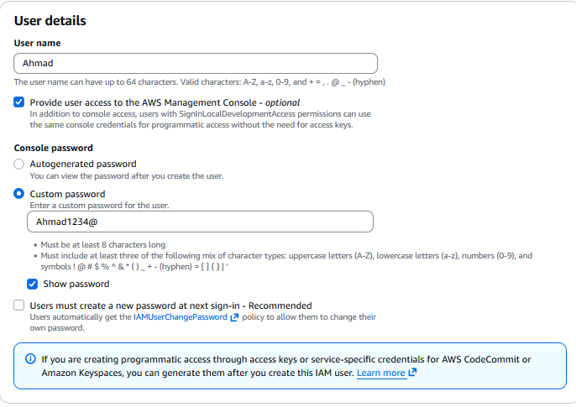
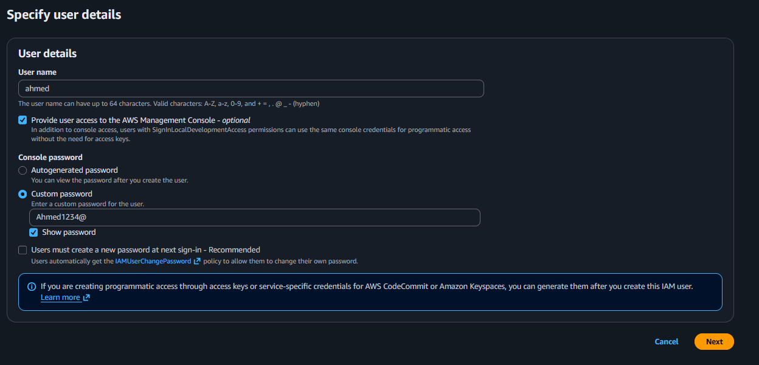
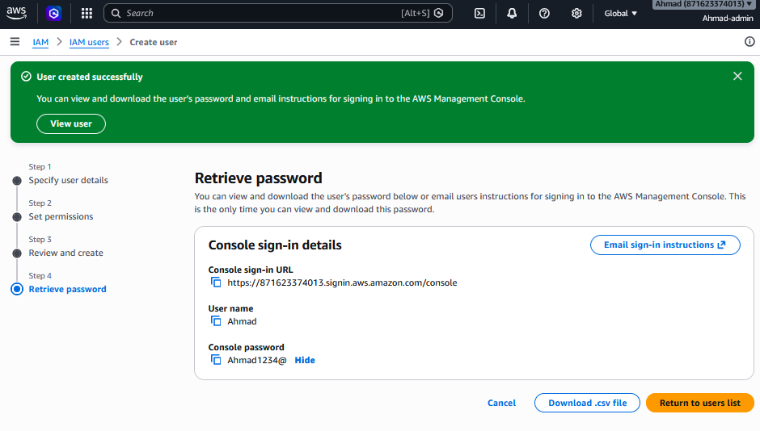
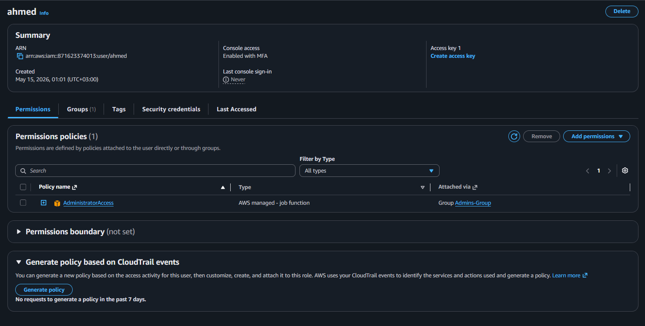
Step 3: Create Developer users
Create users 'Lina', 'Omar', and 'Khaled' using the same process, assigning each to 'Developers-Group'. All three must appear in the group member list.

Lina :
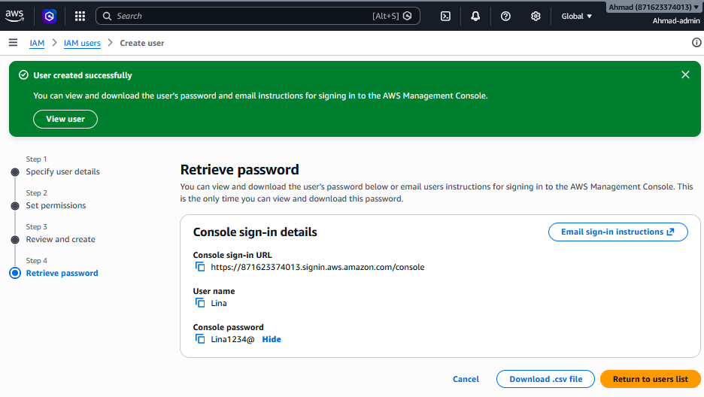

Omar:
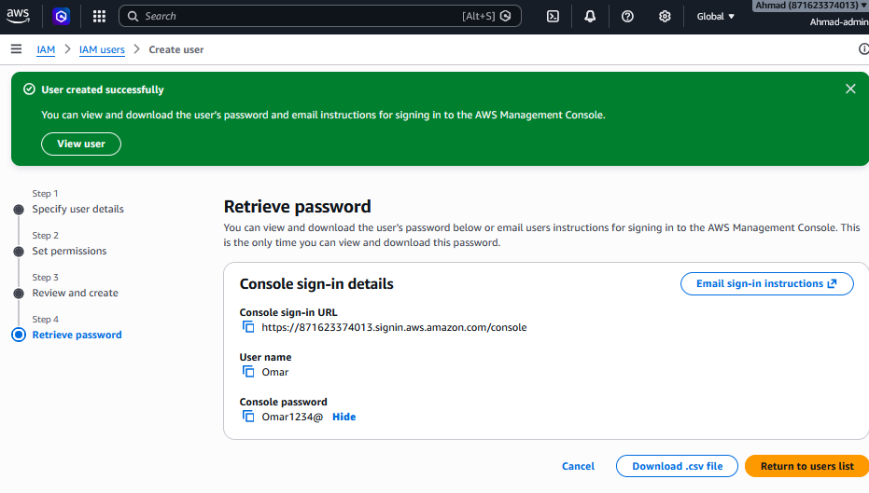

Khaled :
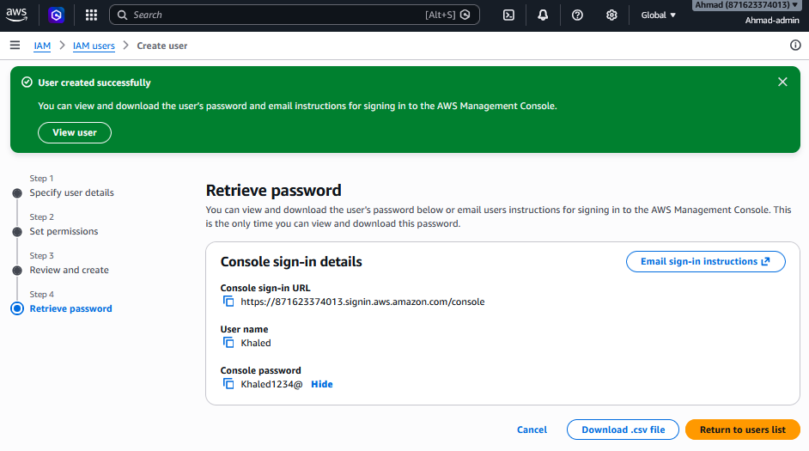

Step 4: Create Content Editor users
Create users 'Sara', 'Noor', 'Huda', and 'Ali', assigning each to 'ContentEditors-Group'. All four must appear in the group member list.

Sara:
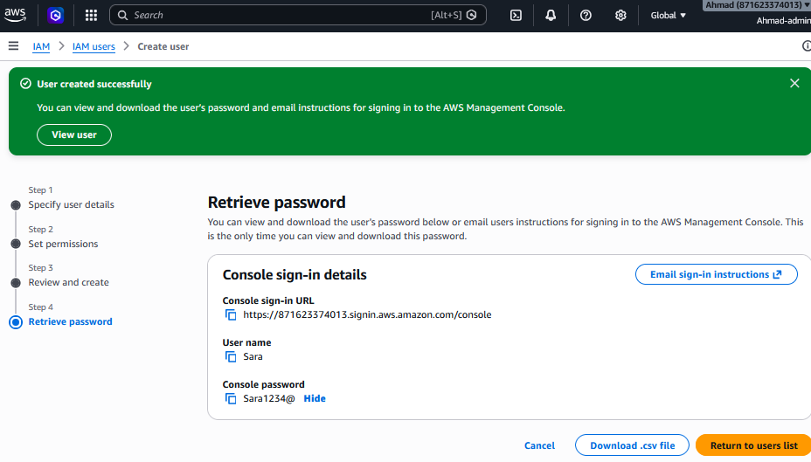
Noor:
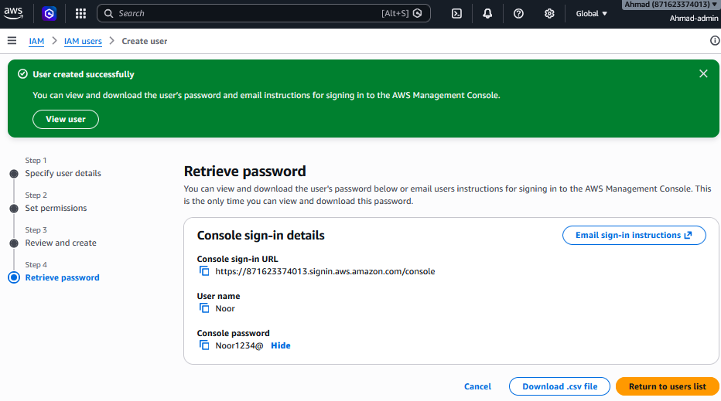

Huda:
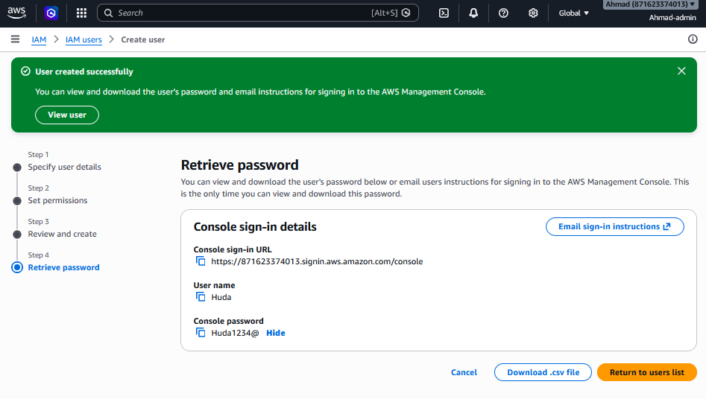

Ali:
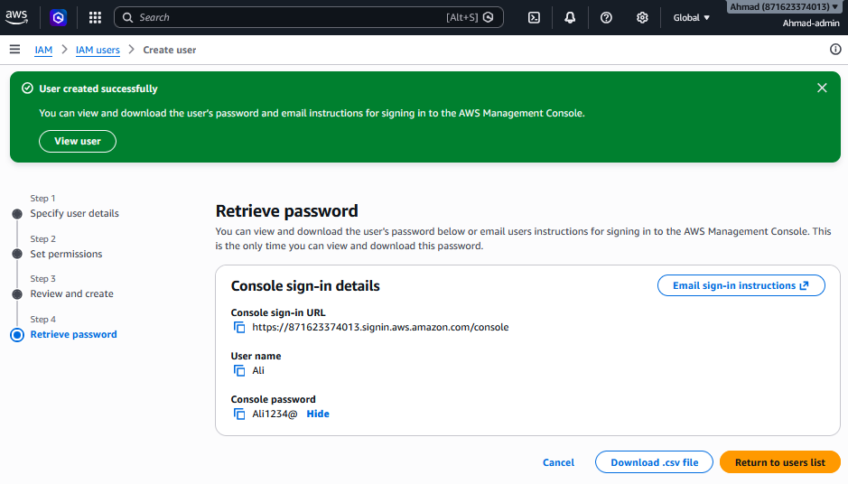

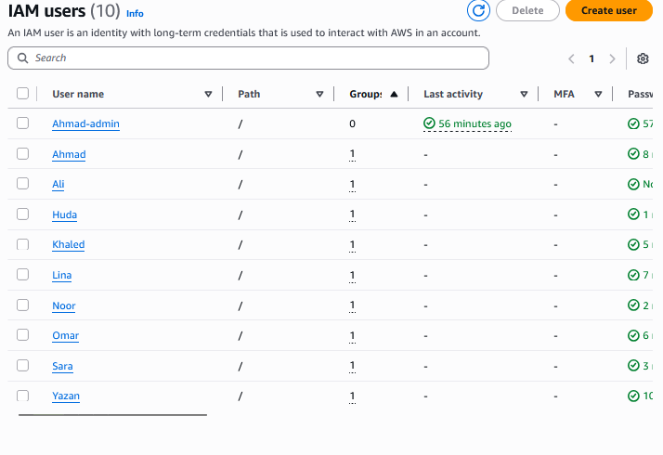

Group | Members
Admins-Group | Yazan, Ahmad
Developers-Group | Lina, Omar, Khaled
ContentEditors-Group | Sara, Noor, Huda, Ali

Task 1.4.4 — Enable MFA for Admin Accounts
Step 1: Select Admin user
IAM > Users > click ‘Yazan’.
Step 2: Security credentials tab
Click ‘Security credentials’ tab. Scroll to ‘Multi-factor authentication (MFA)’ and click ‘Assign MFA device’.
Step 3: Configure Virtual MFA
Select ‘Authenticator app’. Install Google Authenticator or Authy on your smartphone. Scan the QR code displayed in the AWS console. Enter two consecutive 6-digit MFA codes to verify synchronisation. Click ‘Add MFA’.

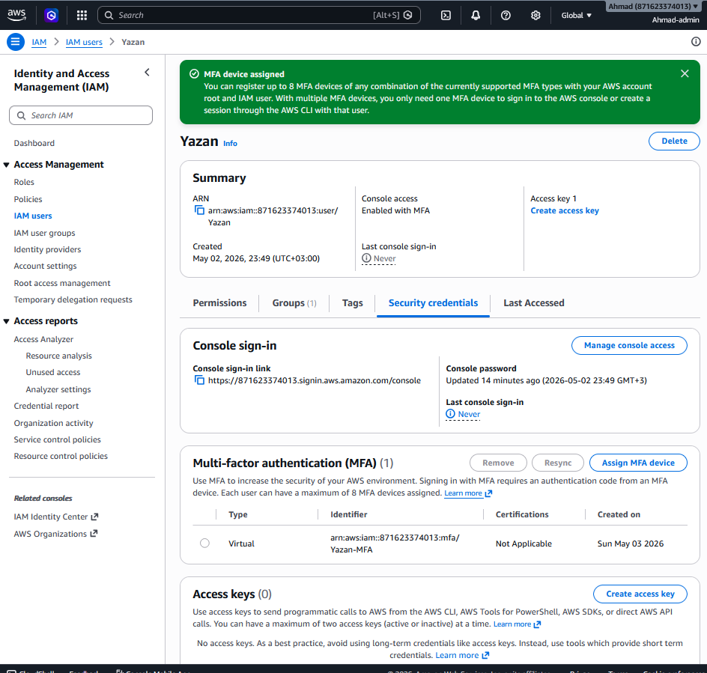

Step 4: Repeat for Ahmad
Perform the same steps for user 'Ahmad'. Both Admin users must have MFA devices assigned.

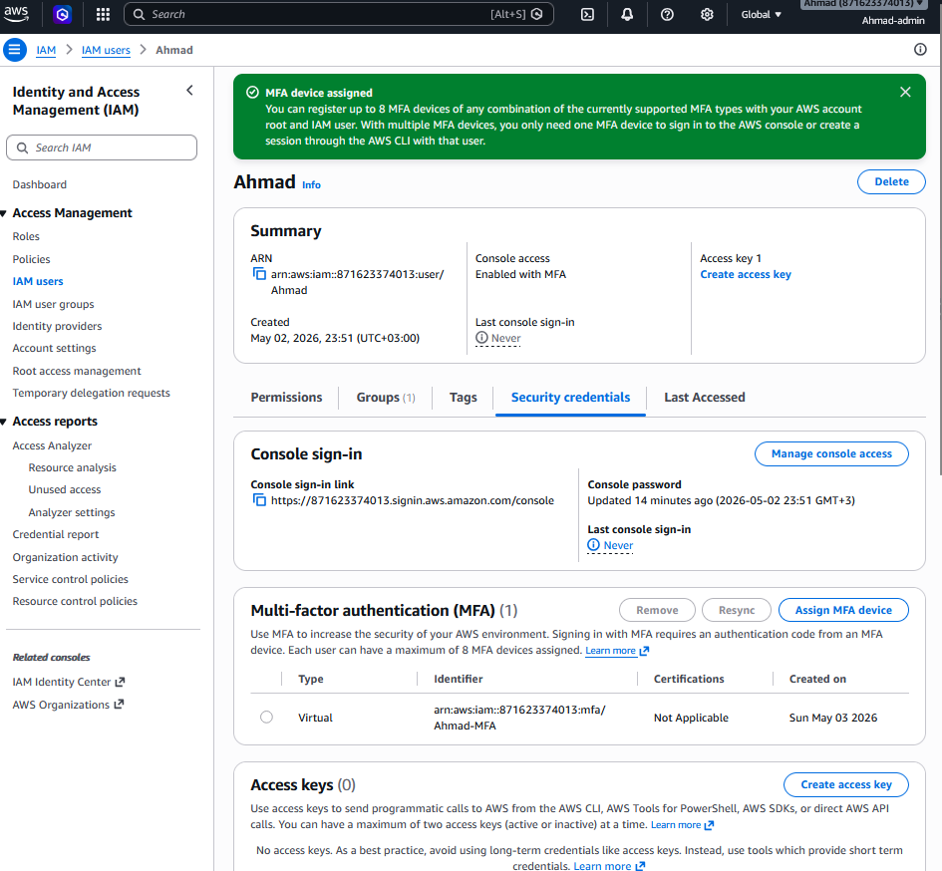

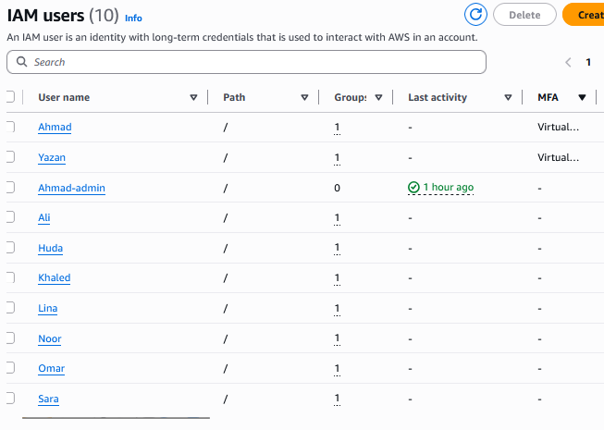

TIP: Best practice: Each admin should save their MFA seed QR code or secret key in a secure, offline location (e.g., a password manager or encrypted USB drive). If the MFA device is lost, AWS Support can remove MFA only after a rigorous identity verification process, which may cause administrative downtime of hours or days. For production environments, consider using multiple MFA devices per admin (up to 8 are supported) or hardware MFA tokens (YubiKey) with backup codes stored in a vault.

Resource | Count | Status
IAM Groups | 3 | Admins-Group, Developers-Group, ContentEditors-Group
Managed Policies Attached | 4 across groups | AdministratorAccess, EC2/S3/CloudWatch
Custom Policy | 1 | HTUNews-ContentEditors-S3Policy
IAM Users | 9 | All created and assigned to groups
MFA | 2 admins | Yazan and Ahmed both protected

I created three IAM groups matching the three HTUNews departments. Admins get AdministratorAccess with MFA enforced — they own the infrastructure. Developers get EC2 full access plus read-only on S3 and CloudWatch — they can deploy and monitor the app but can't touch IAM or security. Content Editors get a custom policy scoped to one S3 bucket — they can only upload and manage media files, nothing else. Users are added to groups rather than having permissions assigned directly, which means if someone changes role, I just move them between groups.
Task 1.4.5 — MFA Administration via AWS CLI
While all MFA configuration was performed through the AWS Management Console (Tasks 1.4.2–1.4.4), the same operations can be executed programmatically using the AWS Command Line Interface (CLI). This is essential for automation and infrastructure-as-code practices.

List MFA devices for an IAM user:

aws iam list-mfa-devices --user-name ahmad

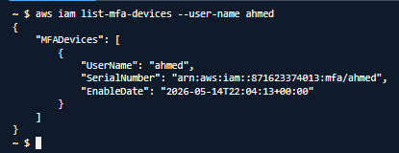

Enable a virtual MFA device:

aws iam enable-mfa-device \
--user-name ahmad \
--serial-number arn:aws:iam::871623374013:mfa/ahmad-MFA \
--authentication-code-1 123456 \
--authentication-code-2 654321

Deactivate an MFA device (if lost or replaced):

aws iam deactivate-mfa-device \
--user-name ahmad \
--serial-number arn:aws:iam::871623374013:mfa/ahmad-MFA

Attach the MFA enforcement policy to Admins-Group via CLI:

aws iam attach-group-policy \
--group-name Admins-Group \
--policy-arn arn:aws:iam::871623374013:policy/EnforceMFA-AdminPolicy

These CLI commands achieve the same results as the console-based configuration in Task 1.4.4. The CLI approach is preferred in production environments where infrastructure is managed through scripts, CI/CD pipelines, or Infrastructure as Code tools like Terraform or CloudFormation.

Section 2: Availability, Scalability, and Network Architecture

2.1 EC2 Instance Type Selection and Justification
HTUNews handles approximately 10,000 users per hour under normal conditions, surging to 80,000 users per hour during breaking news events. The instance type must balance performance, cost efficiency, and scalability across this 8× traffic range.

10,000 users per hour equals approximately 167 requests per minute if we assume one request per user. A t3.large at 2 vCPUs with 8 GB RAM running Node.js can comfortably handle that baseline. However, the actual capacity depends on application complexity, database queries per request, and payload sizes. In a real deployment, I'd run load tests using a tool like Artillery or wrk against the deployed application to determine the actual requests-per-instance limit and adjust the ASG maximum accordingly. The 10,000 figure is a planning assumption, not a tested benchmark.

Instance Type | vCPUs | RAM | Network (Gbps) | Use Case | Verdict for HTUNews
t3.micro | 2 | 1 GB | Up to 5 | Dev/test only | Too weak — fails at normal load
t3.medium | 2 | 4 GB | Up to 5 | Light workloads | Marginal — insufficient for 10K users/hr
t3.large | 2 | 8 GB | Up to 5 | Moderate web traffic | Recommended baseline — see justification below
m5.large | 2 | 8 GB | Up to 10 | Balanced compute/memory | Good but 40% costlier than t3 for equivalent specs
m5.xlarge | 4 | 16 GB | Up to 10 | High-traffic web apps | Over-provisioned for normal load; suited for peak only
c5.xlarge | 4 | 8 GB | Up to 10 | CPU-intensive tasks | Excess CPU, less memory — not optimal for web serving

Recommended Choice: t3.large as the baseline instance type within an Auto Scaling Group.
Justification: The t3.large provides burstable CPU performance using CPU credits, meaning it can burst above its baseline for short periods — critical during breaking news traffic spikes. At 2 vCPUs and 8 GB RAM, it comfortably handles 10,000 users/hour. The ASG horizontally scales instances during peaks. The t3 family costs approximately 40% less than equivalent m5 instances for variable web workloads, which is important for a startup. A minimum of 2 instances across 2 AZs ensures high availability.
NOTE: CPU Credit Balance is a critical monitoring metric for T3 instances. If a t3.large exhausts its CPU credit balance, performance degrades to the baseline CPU rate. The CloudWatch dashboard in Section 4 includes CPU credit balance monitoring to detect and respond to this condition. If sustained high-CPU workloads are expected, an m5.large provides consistent (non-burstable) performance as an alternative.

2.2 EC2 Pricing Model Recommendation
Pricing Model | Discount vs On-Demand | Commitment | Best For
On-Demand | 0% (baseline) | None | Unpredictable, short-term workloads
Reserved (1-year) | Up to 40% | 1 year | Steady-state baseline instances
Reserved (3-year) | Up to 60% | 3 years | Long-running databases and stable workloads
Savings Plans | Up to 72% | 1 or 3 years | Flexible instance family commitments
Spot Instances | Up to 90% | None (interruptible) | Batch jobs, fault-tolerant burst capacity
Dedicated Host | Highest cost | On-demand or Reserved | Compliance/licensing requirements

Recommended Production Strategy: Mixed pricing model.
- Reserve 2 baseline t3.large instances with 1-Year Reserved pricing — these always run to ensure minimum availability and cover normal load (10,000 users/hr), saving ~40% on always-on capacity.
- Use On-Demand instances for the ASG to automatically handle traffic spikes beyond the reserved baseline.
- Optionally configure Spot Instances in the ASG (with a fallback to On-Demand if Spot capacity is interrupted) for cost-efficient burst capacity.

NOTE: Reserved Instance pricing requires upfront commitment to a specific instance type, region, and operating system. For this assignment implementation, all resources will use On-Demand pricing to remain within the AWS Free Tier limits where possible. The pricing strategy discussed above represents the production recommendation and is included to satisfy the assignment's requirement to evaluate and justify pricing options.

2.3 VPC and Network Architecture Design
A secure, scalable VPC architecture follows AWS best practices: public subnets host internet-facing resources (Load Balancer only), while private subnets host application servers (EC2 instances) with no direct internet exposure. Multi-AZ placement ensures fault tolerance.

Architecture Component Overview
Component | Placement | CIDR / Details | Purpose
VPC | Region: us-east-1 | 10.0.0.0/16 | Isolated network environment for all HTUNews resources
Internet Gateway (IGW) | Attached to VPC | N/A | Provides internet connectivity to public subnets
Public Subnet A | AZ-1 (us-east-1a) | 10.0.1.0/24 | Hosts ALB and NAT Gateway — internet-facing only
Public Subnet B | AZ-2 (us-east-1b) | 10.0.2.0/24 | Hosts ALB (second AZ for HA) — internet-facing only
Private Subnet A | AZ-1 (us-east-1a) | 10.0.3.0/24 | EC2 web/app servers — not directly internet-accessible
Private Subnet B | AZ-2 (us-east-1b) | 10.0.4.0/24 | EC2 web/app servers — second AZ for fault tolerance
NAT Gateway | Public Subnet A | Elastic IP assigned | Allows private EC2 instances outbound internet for updates
Application Load Balancer | Public Subnets A + B | Port 80/443 | Distributes HTTP/HTTPS traffic to EC2 instances
Auto Scaling Group | Private Subnets A + B | Min 2, Max 4 | Manages EC2 fleet — scales automatically on demand

Route Table Configuration
Route Table | Destination | Target | Associated Subnets
Public Route Table | 10.0.0.0/16 | local | Public Subnet A, Public Subnet B
Public Route Table | 0.0.0.0/0 | Internet Gateway | Public Subnet A, Public Subnet B
Private Route Table A | 10.0.0.0/16 | local | Private Subnet A (AZ-1)
Private Route Table A | 0.0.0.0/0 | NAT Gateway (in Public Subnet A) | Private Subnet A (AZ-1)
Private Route Table B | 10.0.0.0/16 | local | Private Subnet B (AZ-2)
Private Route Table B | 0.0.0.0/0 | NAT Gateway (in Public Subnet A) | Private Subnet B (AZ-2)

NOTE: Both private route tables route internet-bound traffic through the single NAT Gateway in Public Subnet A. For maximum fault tolerance in production, a second NAT Gateway in Public Subnet B can be added, with Private Route Table B pointing to it. For this assignment, one NAT Gateway is sufficient and reduces cost.

Network ACLs (Defense in Depth)
While Security Groups provide stateful instance-level protection, Network ACLs (NACLs) add stateless subnet-level security as a defence-in-depth measure. Unlike Security Groups, NACLs evaluate rules in number order and must explicitly allow return traffic:
- Public Subnet NACL: Allow inbound HTTP (80) and HTTPS (443) from 0.0.0.0/0; allow ephemeral ports 1024–65535 for return traffic; deny all other inbound traffic.
- Private Subnet NACL: Allow inbound from VPC CIDR only (10.0.0.0/16) — restricts traffic to VPC-internal sources; deny all internet inbound; allow outbound to 0.0.0.0/0 for updates via NAT Gateway.
- The combination of Security Groups (stateful, instance-level) and NACLs (stateless, subnet-level) implements the AWS security best practice of defence in depth.

SSH Access Strategy
Instead of opening port 22 in the Security Group to an admin IP address (which requires EC2 instances to have public IPs or a bastion host), the recommended approach for private-subnet instances is AWS Systems Manager Session Manager (SSM). SSM advantages:
- Eliminates all inbound port 22 requirements — no SSH ports open on any Security Group.
- Sessions are fully logged and auditable in CloudWatch and S3.
- Works through the NAT Gateway without requiring instances to have public IP addresses.
- Access is controlled via IAM policies — integrating with the existing IAM model in Section 1.
NOTE: SSM Session Manager is configured by attaching the AmazonSSMManagedInstanceCore policy to the EC2 IAM role (HTUNews-EC2-S3Role) created in Section 3, and installing the SSM Agent (pre-installed on Amazon Linux 2023). No additional port rules are required in the Security Group.

2.4 Security Groups Configuration
Security Group | Inbound Rules | Outbound | Attached To
SG-ALB | Port 80 (HTTP) from 0.0.0.0/0; Port 443 (HTTPS) from 0.0.0.0/0 | All traffic allowed | Application Load Balancer
SG-WebServer | Port 8080 from SG-ALB (security group reference — not 0.0.0.0/0); No SSH port 22 open (use SSM) | All traffic allowed | EC2 instances via ASG Launch Template

IMPORTANT: Port 8080 on SG-WebServer must reference the SG-ALB Security Group ID as the source — not 0.0.0.0/0 or a CIDR range. This ensures only traffic arriving through the ALB reaches the EC2 instances, blocking any direct access attempts. Never open port 8080 to the internet.

2.5 Step-by-Step Implementation

Task 2.5.1 — Create the VPC
Step 1: Open VPC Console
AWS Console > search 'VPC' > 'Your VPCs' > 'Create VPC'.
Step 2: Use VPC and more wizard
Select 'VPC and more'. Configure: Name tag prefix = HTUNews-VPC; IPv4 CIDR = 10.0.0.0/16; Availability Zones = 2; Public subnets = 2; Private subnets = 2; NAT gateways = 1 (in 1 AZ). Leave all other defaults. Click 'Create VPC'.
VPC endpoints:None
We don't need S3 Gateway endpoints for this project. Instances will reach S3 through the NAT Gateway.

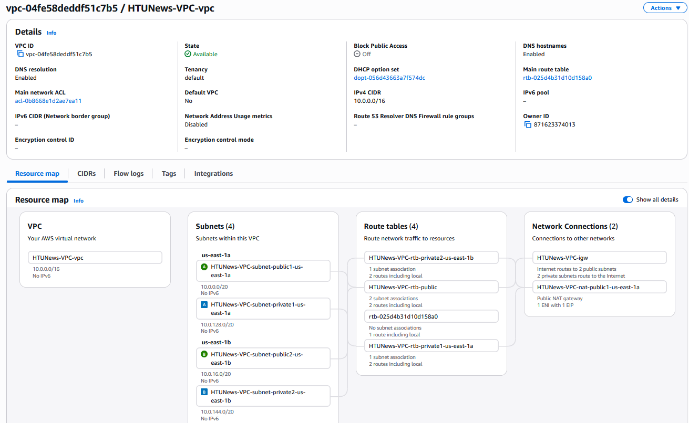

Step 3: Verify route tables
After creation, navigate to Route Tables. Confirm: one public route table associated to both public subnets (with 0.0.0.0/0 → IGW); two private route tables (one per AZ, each with 0.0.0.0/0 → NAT Gateway).

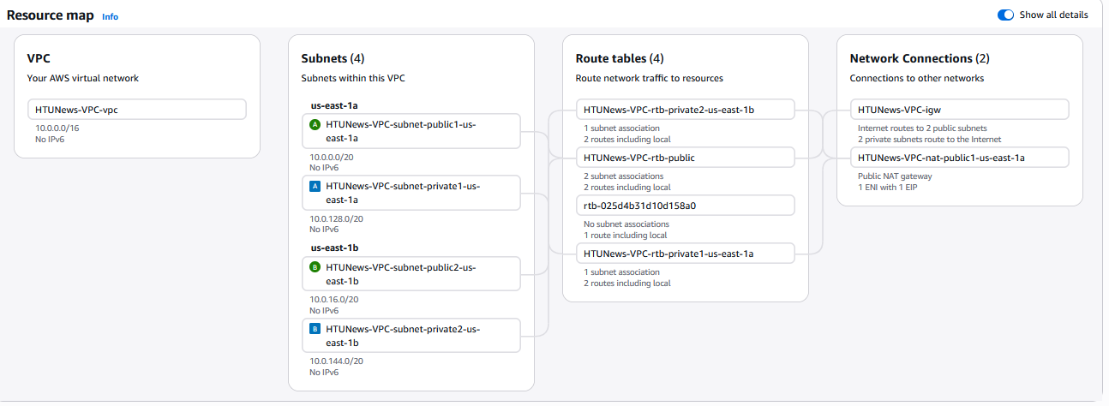

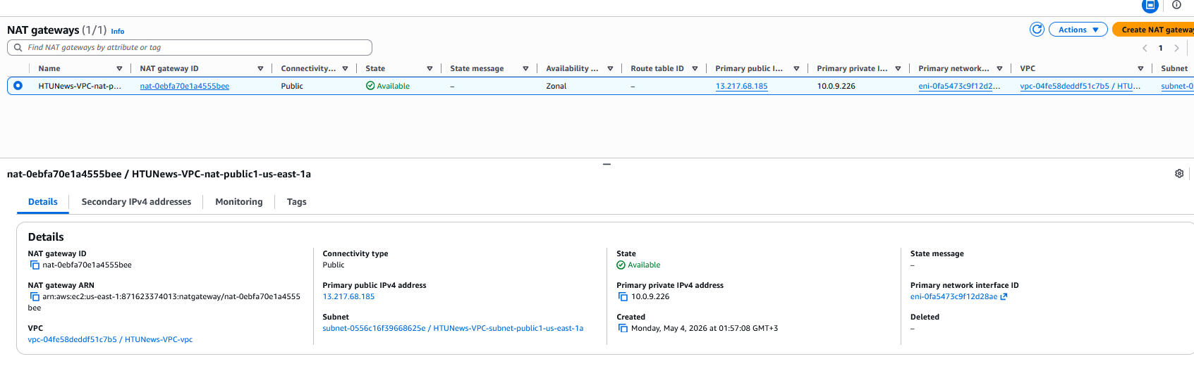

Task 2.5.2 — Create Security Groups
Step 1: Create ALB Security Group
VPC Console > Security Groups > Create security group. Name: SG-ALB; VPC: HTUNews-VPC. Inbound rules: HTTP (80) from 0.0.0.0/0; HTTPS (443) from 0.0.0.0/0. Click 'Create'.

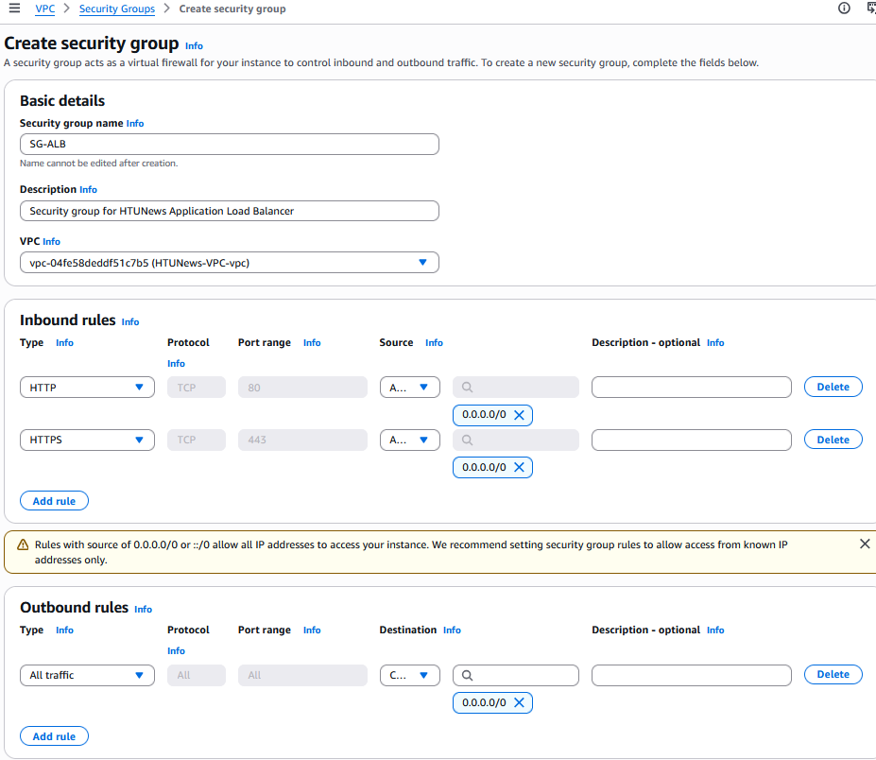

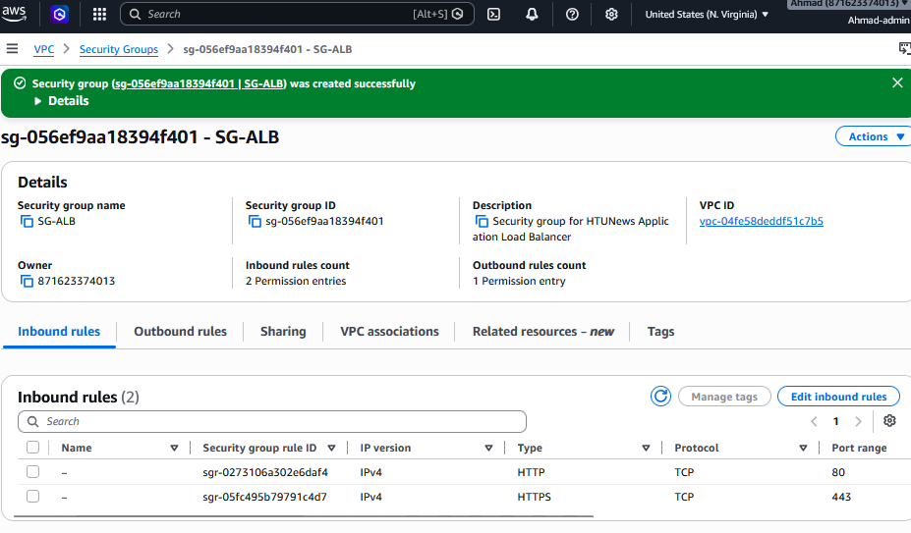

Step 2: Create Web Server Security Group
Create security group: Name: SG-WebServer; VPC: HTUNews-VPC. Inbound: Custom TCP, Port 8080, Source = SG-ALB (select from the security group dropdown — do NOT enter a CIDR). No SSH rule needed (SSM is used). Click 'Create'.

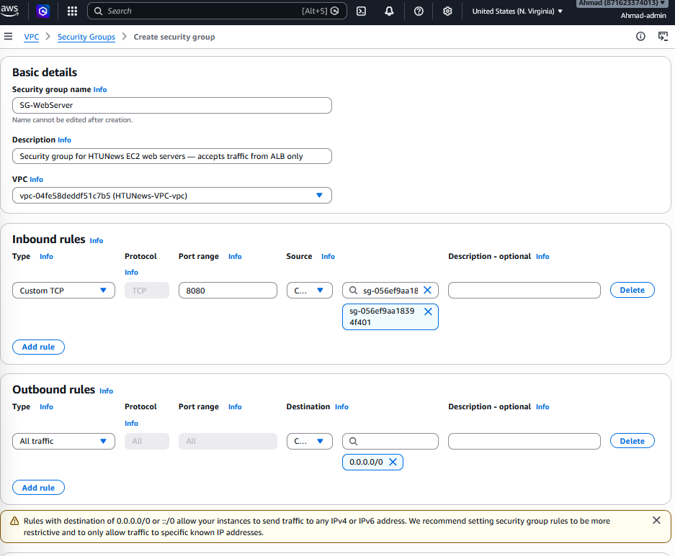

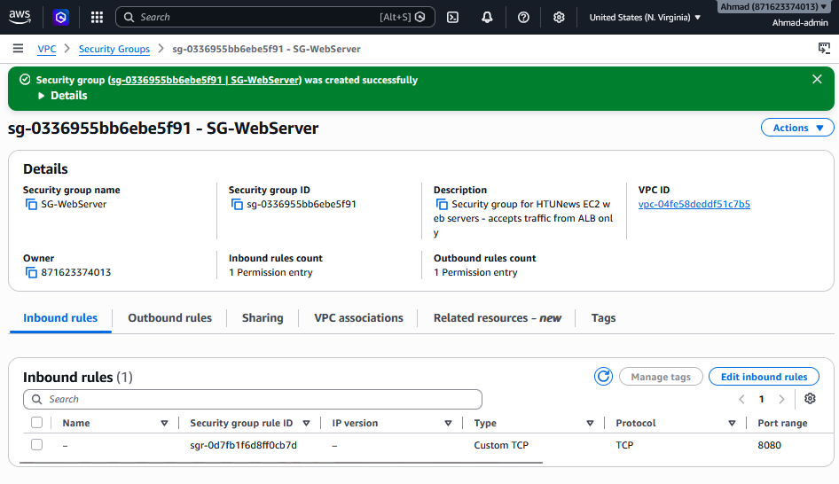

Task 2.5.3 — Create Launch Template for ASG
Step 1: Navigate to Launch Templates
EC2 Console > Instances > Launch Templates > Create launch template.
Step 2: Configure template
Name: HTUNews-LaunchTemplate. AMI: Amazon Linux 2023 (64-bit x86). Instance type: t3.large. Key pair: None (SSM is used for access). Network: Do not specify subnet (ASG controls placement). Security group: SG-WebServer.

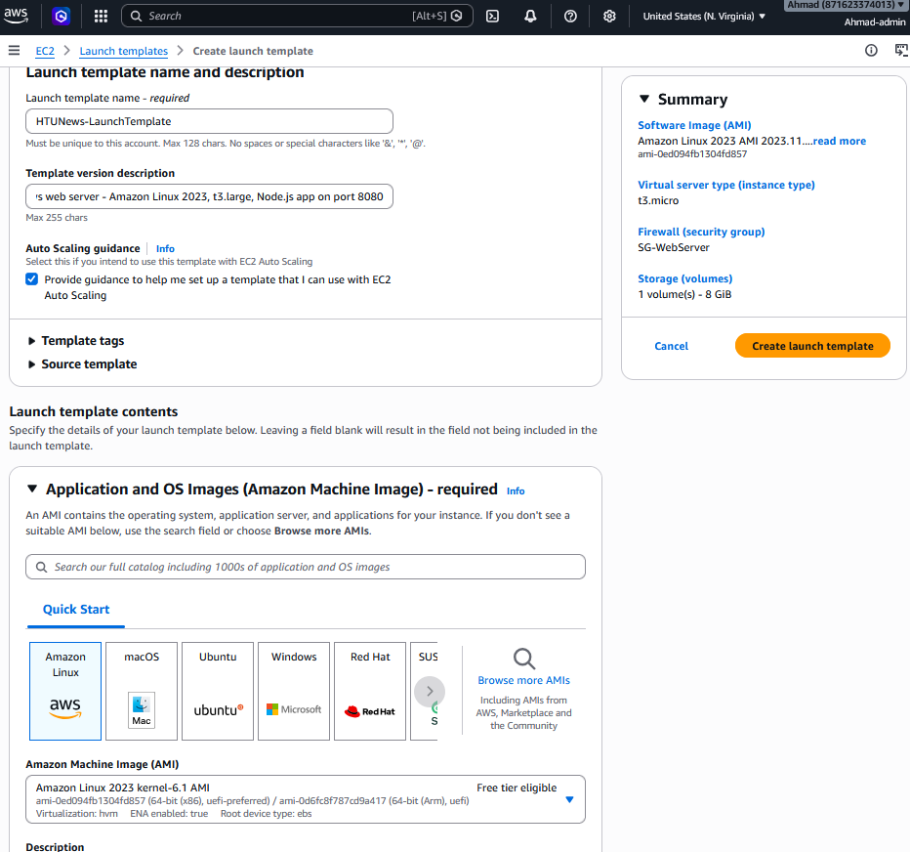

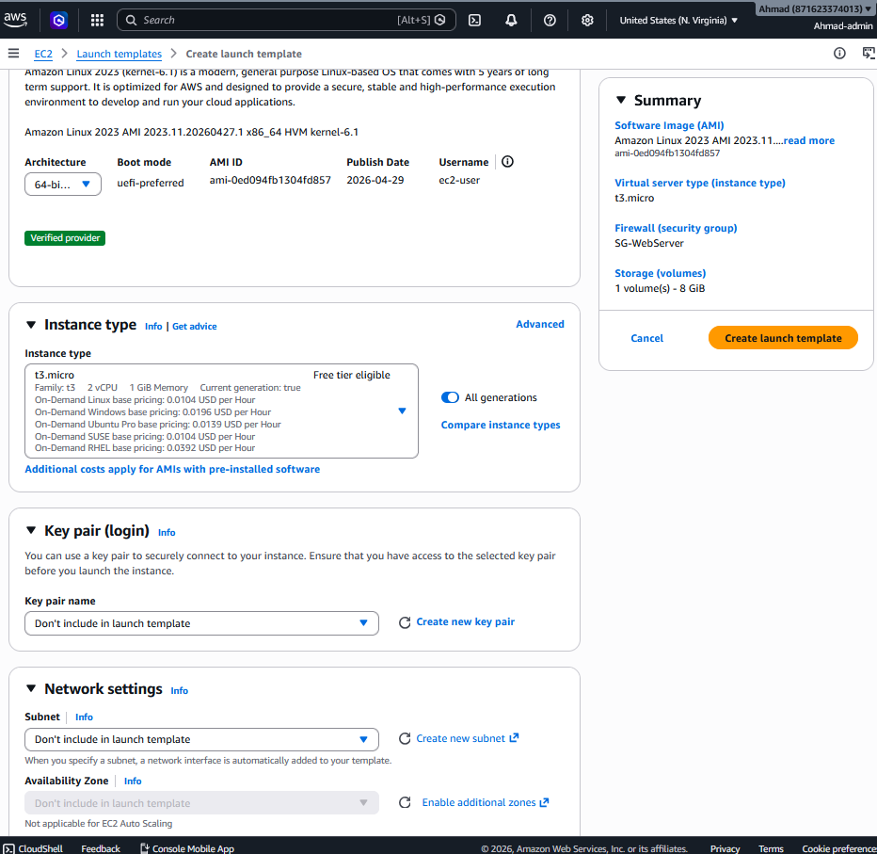

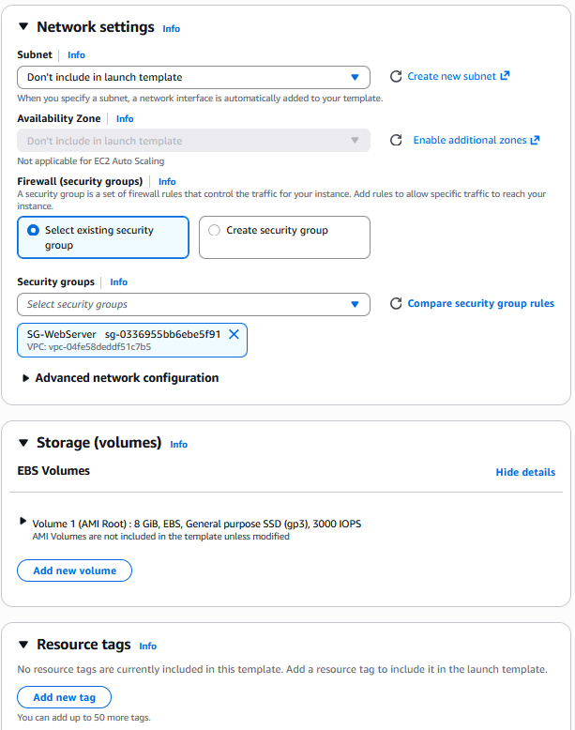

Step 3: Add User Data script
In 'Advanced details' > User data, paste the following bootstrap script. Note: Replace 'YOUR_ORG/htunews-app' with your actual repository path before deploying:
#!/bin/bash
# Update system packages
yum update -y

# Install Node.js 20.x LTS
curl -fsSL https://rpm.nodesource.com/setup_20.x -o /tmp/nodesource_setup.sh
bash /tmp/nodesource_setup.sh
yum install -y nodejs

# Verify installation
node --version
npm --version

# Install git and clone application
yum install -y git
git clone https://github.com/AhmadM962/htunews-app.git /opt/htunews || exit 1
cd /opt/htunews
npm install

# Create systemd service for persistence across reboots
cat > /etc/systemd/system/htunews.service << 'EOF'
[Unit]
Description=HTUNews Web Application
After=network.target

[Service]
Type=simple
User=ec2-user
WorkingDirectory=/opt/htunews
ExecStart=/usr/bin/node /opt/htunews/app.js
Restart=on-failure
RestartSec=10

[Install]
WantedBy=multi-user.target
EOF

# Enable and start the service
systemctl daemon-reload
systemctl enable htunews.service
systemctl start htunews.service

# Verify service is running
systemctl status htunews.service
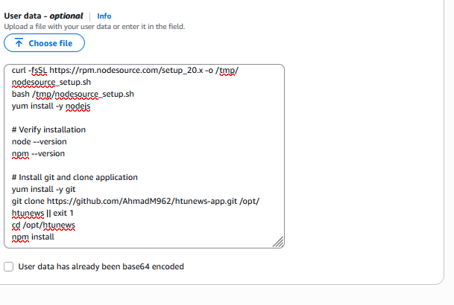

NOTE: This script uses systemd to manage the application process, ensuring it starts automatically on boot and restarts automatically if it crashes (Restart=on-failure). The script includes error checking (|| exit 1 on git clone) and verification steps. Node.js 20 LTS is selected for long-term support and stability in production workloads. Boot logs are available in /var/log/cloud-init-output.log for debugging.

Step 4: Save as default version
Click 'Create launch template'. This becomes the template used by the ASG.
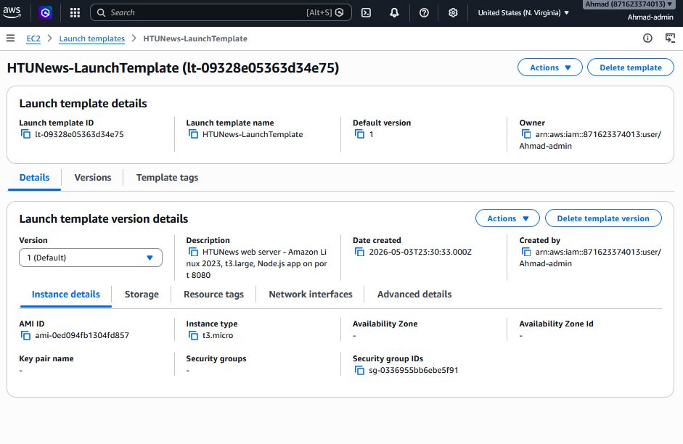

IMPLEMENTATION NOTE: For this assignment, t3.micro was used during
implementation to remain within AWS Free Tier limits (750 hours/month
of t3.micro compute). The t3.large recommendation above represents the
production configuration based on 8 GB RAM for 10,000 concurrent users.
The Launch Template can be updated to t3.large by creating a new
template version — no other infrastructure changes are required. This
demonstrates the flexibility of Infrastructure as Code: instance sizing
is a configuration parameter, not an architectural constraint.

Task 2.5.4 — Create the Application Load Balancer (ALB)
Step 1: Navigate to Load Balancers
EC2 Console > Load Balancing > Load Balancers > Create load balancer.
Step 2: Select ALB type
Click 'Create' under 'Application Load Balancer'. The ALB operates at OSI Layer 7 (HTTP/HTTPS), making it ideal for web applications — it inspects request content, performs path-based routing, handles SSL termination, and can redirect invalid paths.
Step 3: Configure ALB
Name: HTUNews-ALB. Scheme: Internet-facing. IP address type: IPv4. VPC: HTUNews-VPC. Mappings: select both public subnets (AZ-1 and AZ-2). Security group: SG-ALB (remove the default VPC security group).

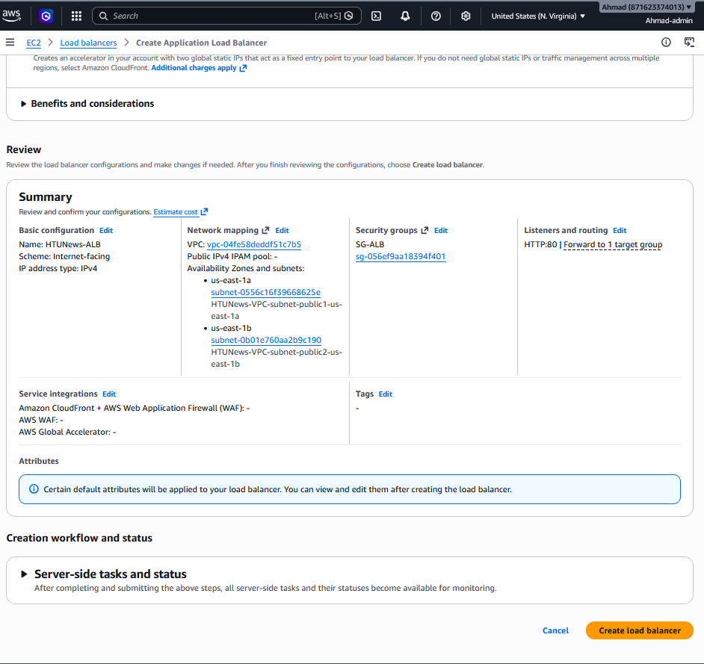
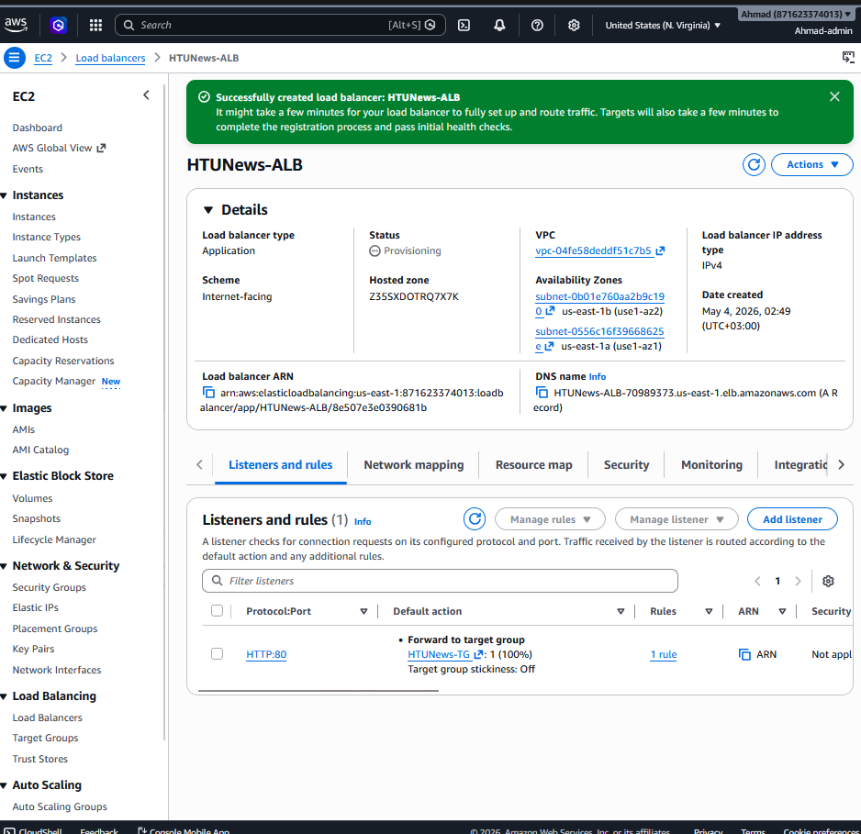
Step 4: Create Target Group
Click 'Create target group': Type = Instances; Name = HTUNews-TG; Protocol = HTTP; Port = 8080; VPC = HTUNews-VPC. Health check path = / (homepage). Healthy threshold = 2; Unhealthy threshold = 3; Timeout = 5s; Interval = 30s.

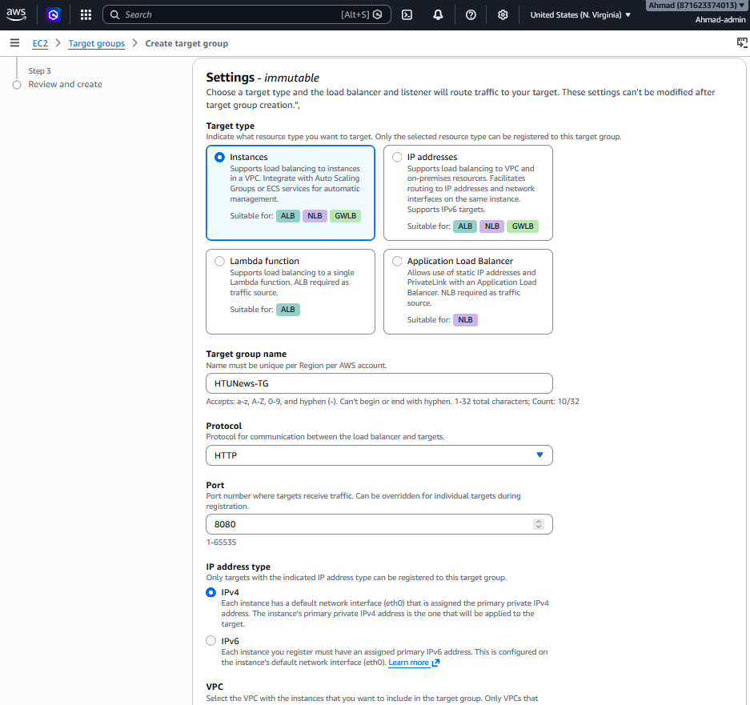
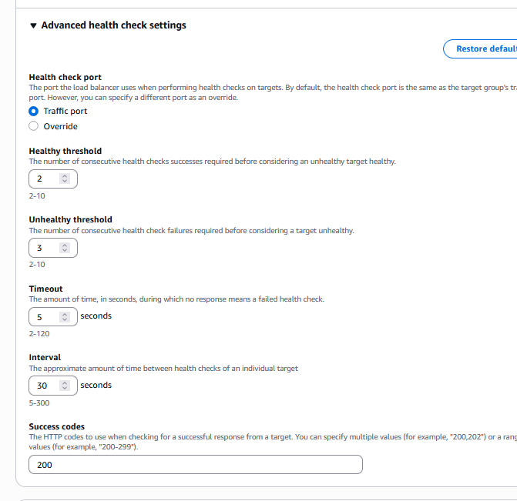

What these numbers mean:
- The ALB sends a GET request to / on port 8080 every 30 seconds
- If it gets a 200 OK response, the instance is healthy
- After 2 consecutive successes, it marks the instance healthy
- After 3 consecutive failures (90 seconds), it marks the instance unhealthy and stops sending traffic

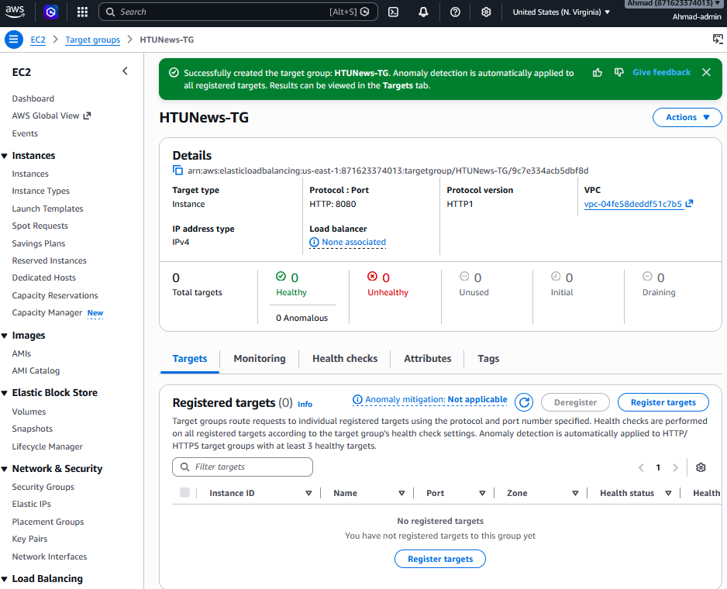

Step 5: Complete ALB
Select HTUNews-TG as the default action for the HTTP:80 listener. Click 'Create load balancer'. Wait for state to change from 'Provisioning' to 'Active'.

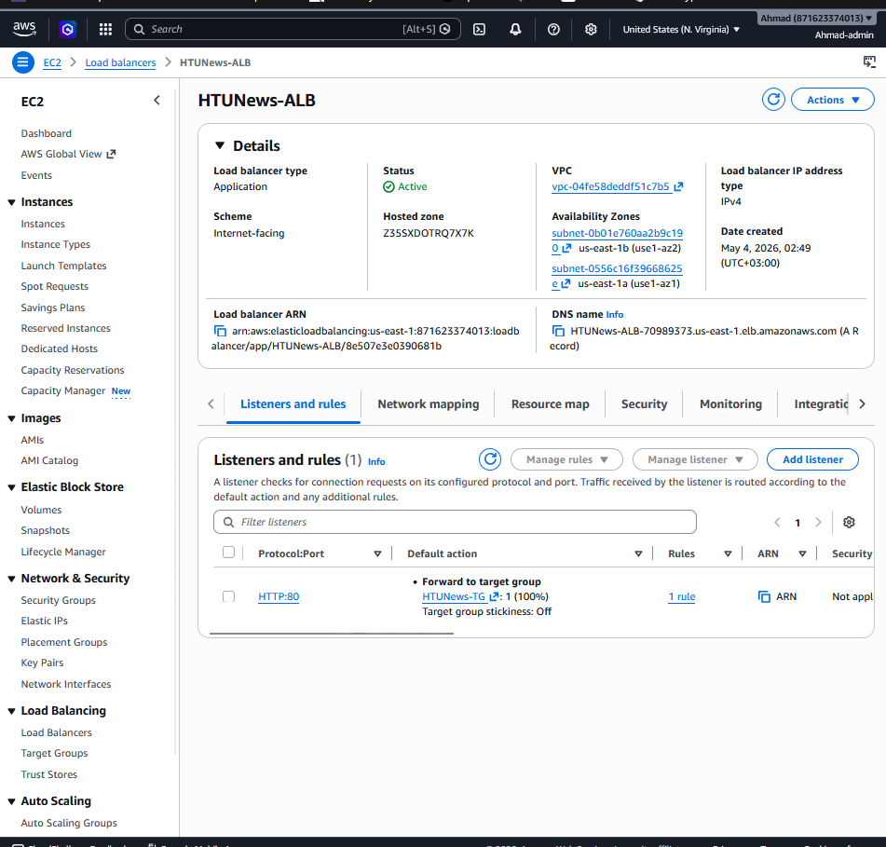

DNS name : HTUNews-ALB-70989373.us-east-1.elb.amazonaws.com
Step 6: Add redirect rule for invalid paths
Go to Listeners and rules > select HTTP:80 > Manage rules > Add rule. Condition: Path is not '/'. Action: Redirect to '/' with 302 status. This satisfies the requirement to redirect invalid paths to the homepage.

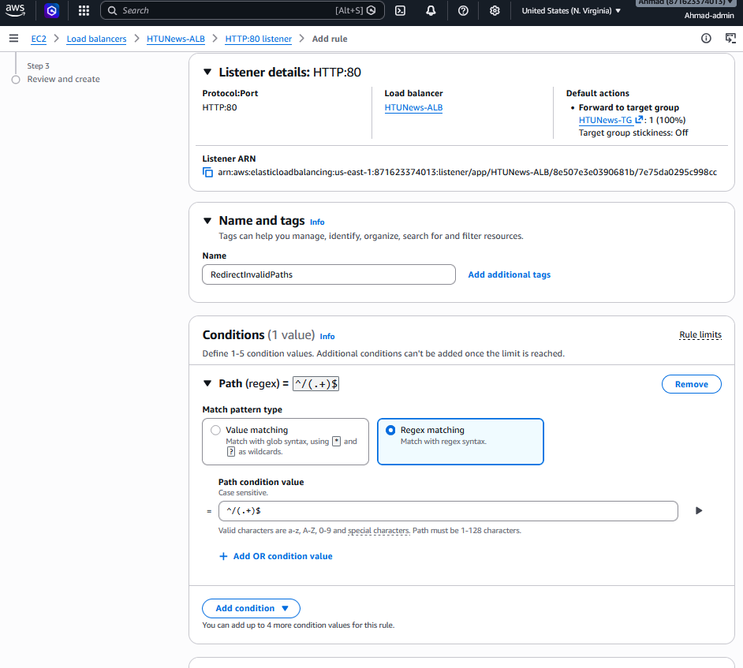

his regex means: "Matches any path starting with / that has at least one more character." So /anything, /page/about, etc. all match. But / alone does NOT match (because there's nothing after the slash).

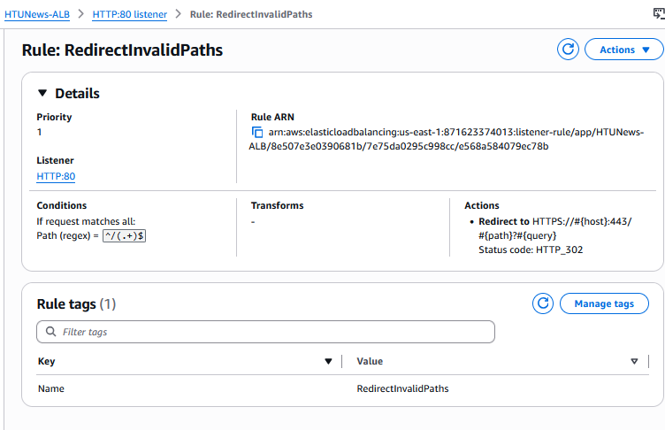

Task 2.5.5 — Create Auto Scaling Group (ASG)
Step 1: Navigate to ASG
EC2 Console > Auto Scaling > Auto Scaling Groups > Create Auto Scaling group.
Step 2: Name and template
Name: HTUNews-ASG. Launch template: HTUNews-LaunchTemplate (latest version). Click 'Next'.

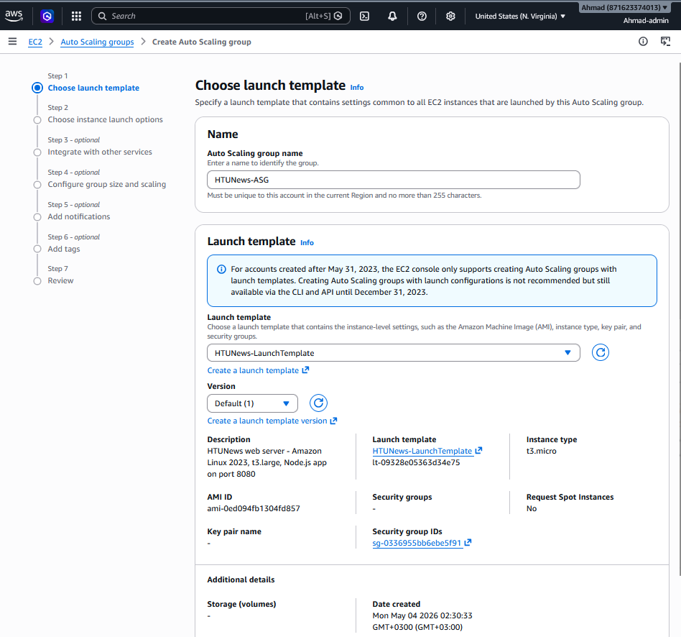

Step 3: Network configuration
VPC: HTUNews-VPC. Subnets: Private Subnet A (AZ-1) and Private Subnet B (AZ-2). Click 'Next'.

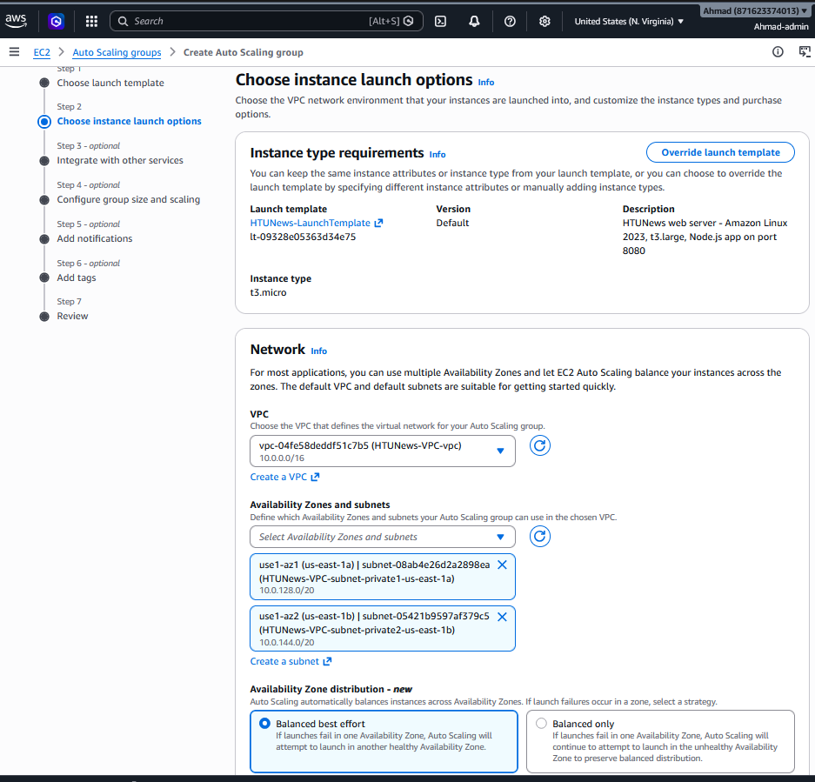
Step 4: Attach Load Balancer
Select 'Attach to an existing load balancer'. Choose from load balancer target groups: HTUNews-TG. Enable 'Turn on Elastic Load Balancing health checks' in addition to EC2 health checks. Click 'Next'.

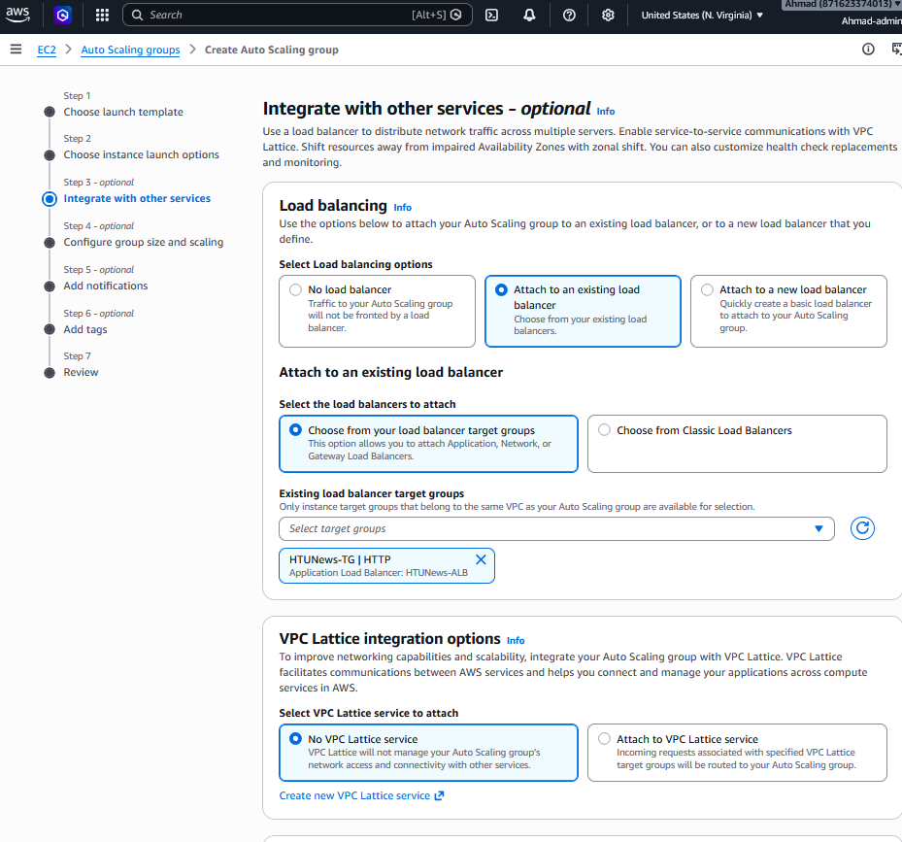

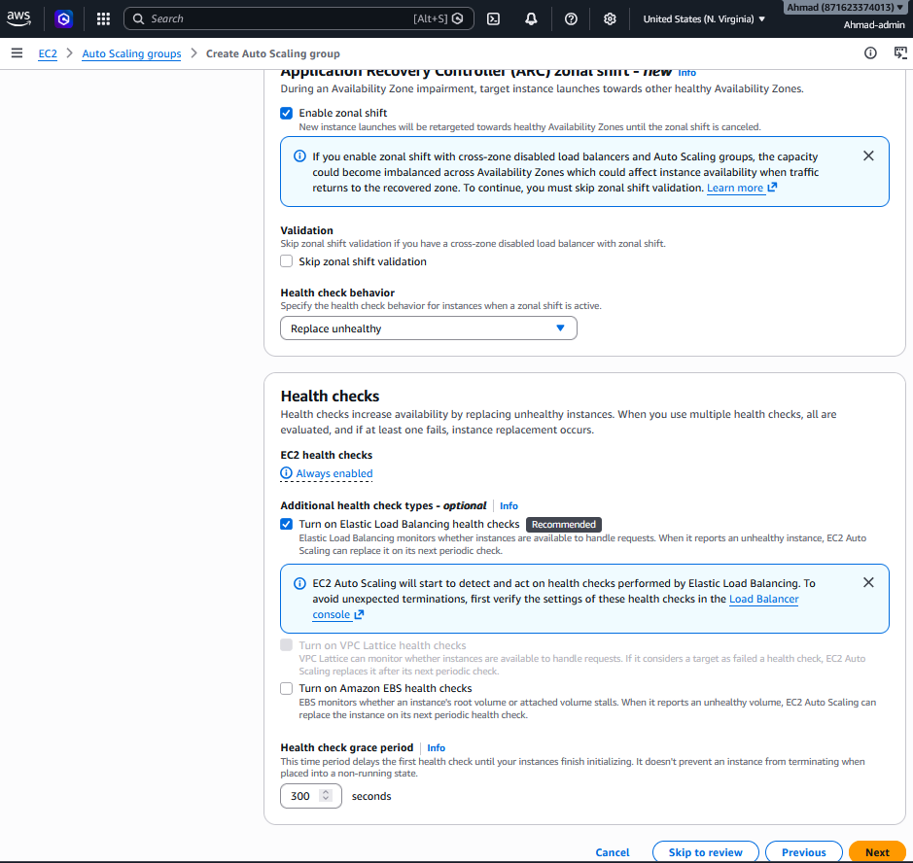

Step 5: Set scaling limits
Minimum capacity = 2 (ensures high availability if one instance fails). Desired capacity = 2. Maximum capacity = 8 (supports ~80,000 users/hr at approximately 10,000 per instance). Click 'Next'.

Due to AWS Free Tier limitations, the implementation uses t3.micro instances instead of the production-recommended t3.large. This requires recalibration of the Auto Scaling Group capacity:
A t3.micro provides 2 vCPUs (burstable) and 1 GB RAM. For a lightweight Node.js application returning simple HTML responses, a single t3.micro can conservatively handle 200–500 HTTP requests per second. The scenario's requirements translate to:
- Normal load: 10,000 users/hour ≈ 2.8 requests/second
- Peak load: 80,000 users/hour ≈ 22 requests/second
Under these calculations, two t3.micro instances (one per AZ) provide more than sufficient capacity for peak traffic while maintaining high availability. The maximum capacity is set to 4 instances to allow for burst headroom during extreme events, rather than the 8 instances calculated for t3.large. This ensures cost-conscious scaling appropriate for the micro instance's proportional capacity.
The updated ASG configuration:
- Min: 2 (high availability across AZs)
- Desired: 2 (handles baseline and typical peak)
- Max: 4 (extreme burst headroom)
- Scaling threshold: 80% average CPU utilization (optimized for T3 burstable instances)
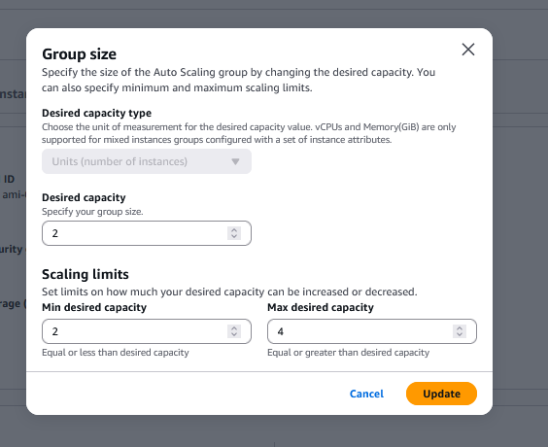

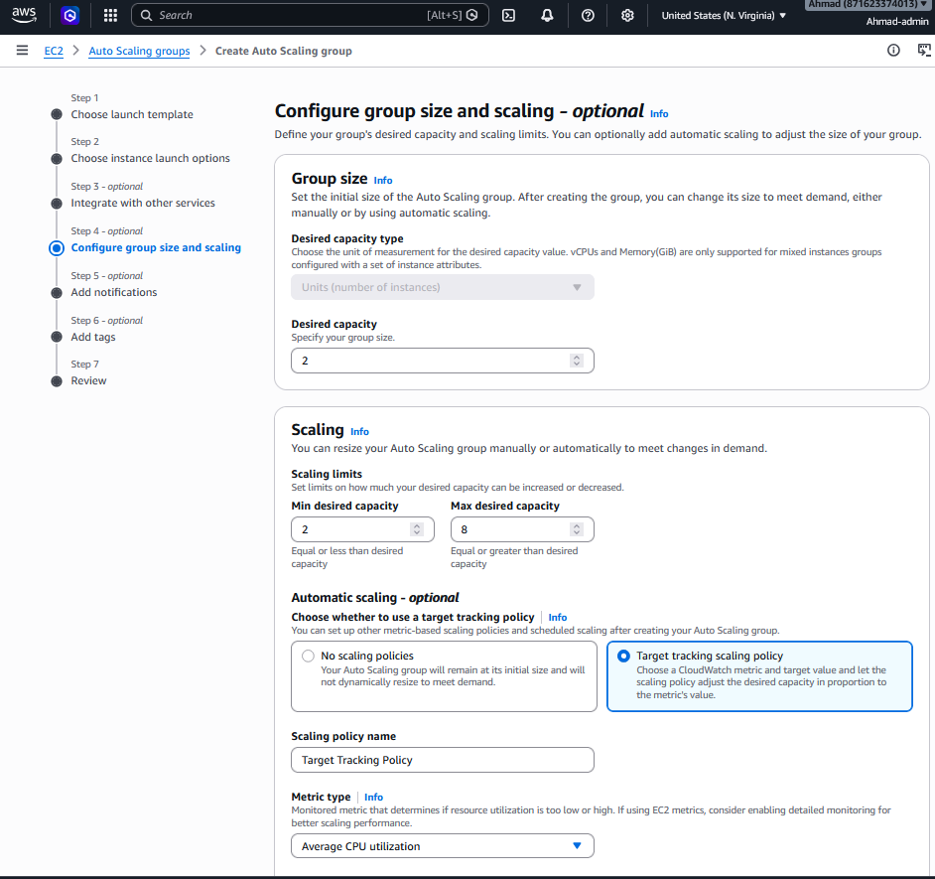
Updated : 2 not 8
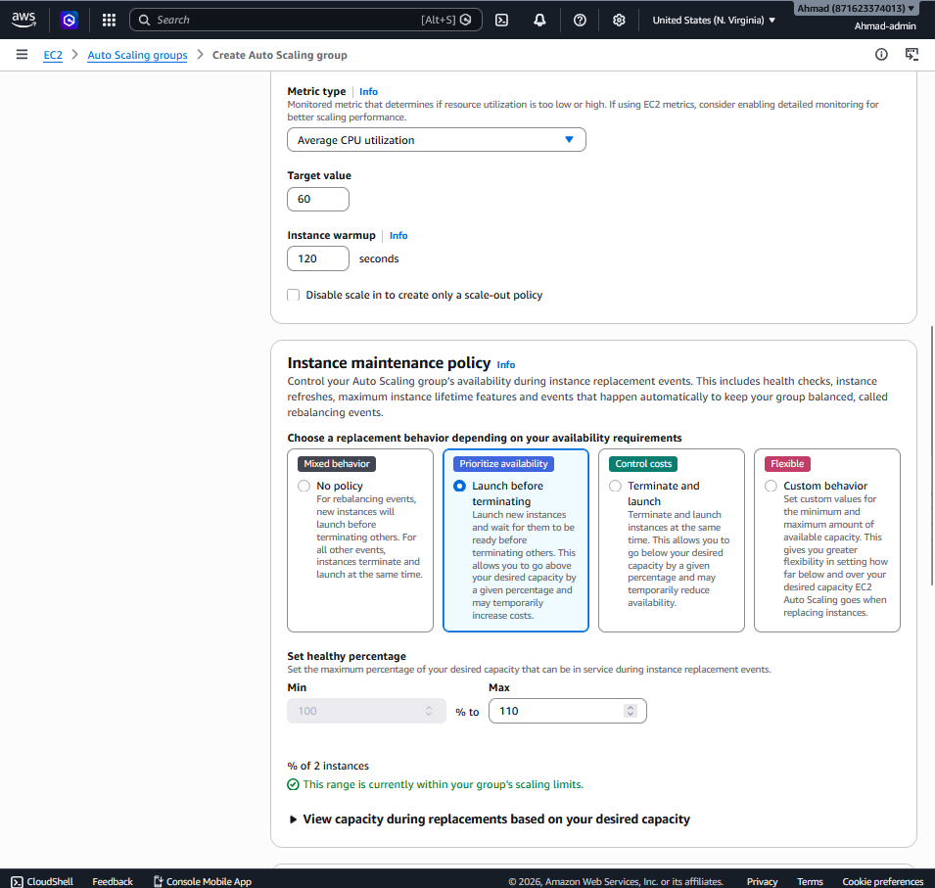
Updated , not 60% its now 80 %
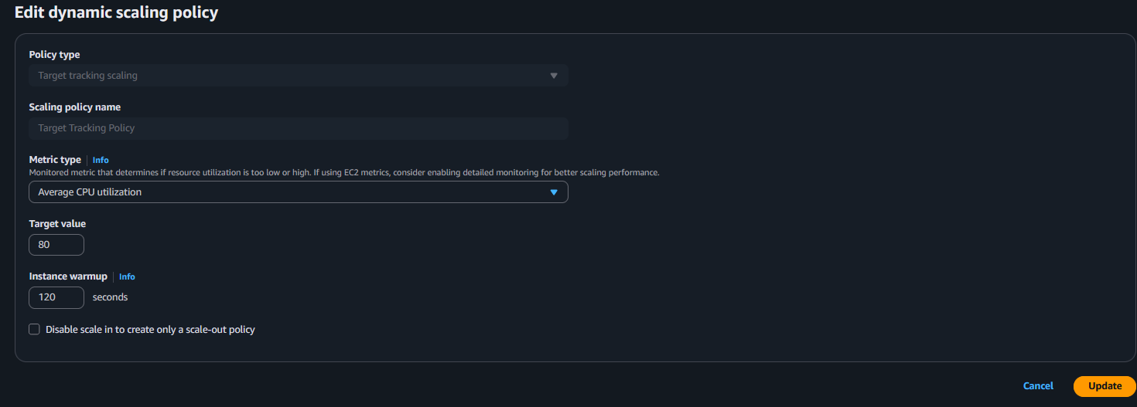
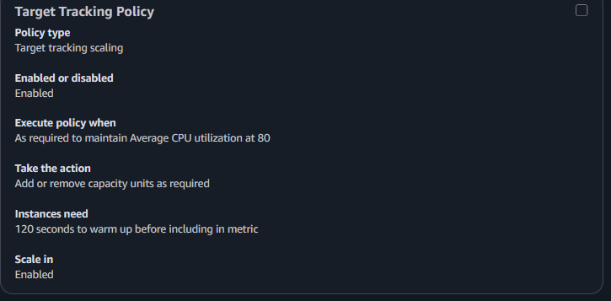
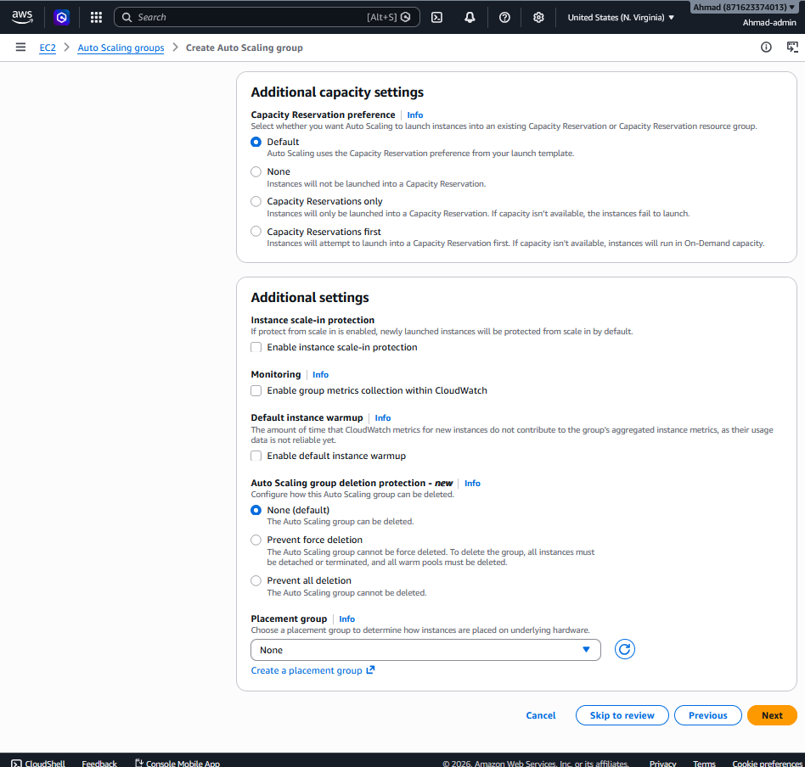

Step 6: Configure Target Tracking policy
Select 'Target tracking scaling policy'. Metric type: Average CPU Utilization. Target value: 80%. AWS automatically adds instances when average CPU exceeds 80% and removes them when sustained below 80%, maintaining performance headroom.



Step 7: Configure SNS notification
Click 'Add notification'. Create a new SNS topic: Name = HTUNews-ASG-Notifications; Email = your-admin-email@domain.com. Events: EC2 instance launch, EC2 instance terminate. Complete creation and confirm the email subscription.

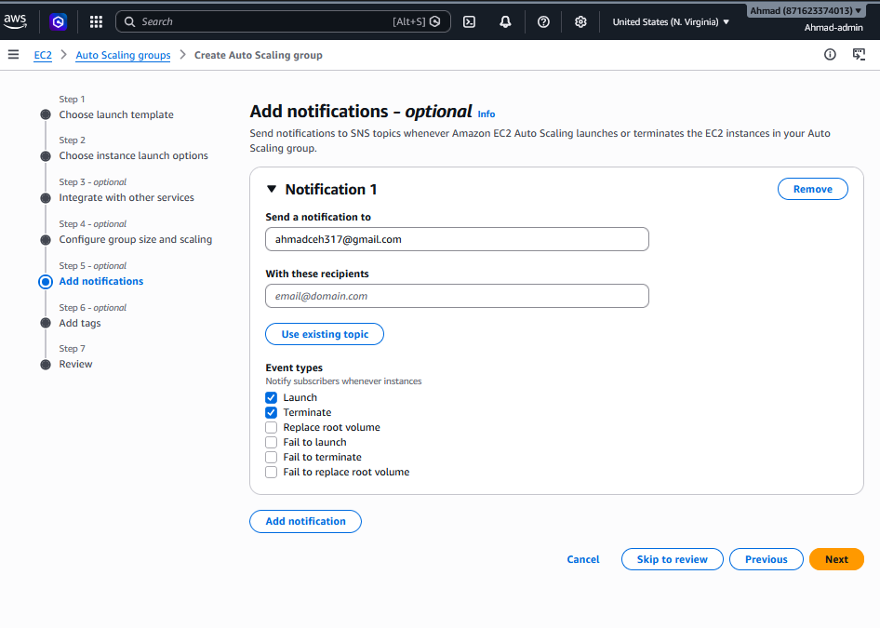
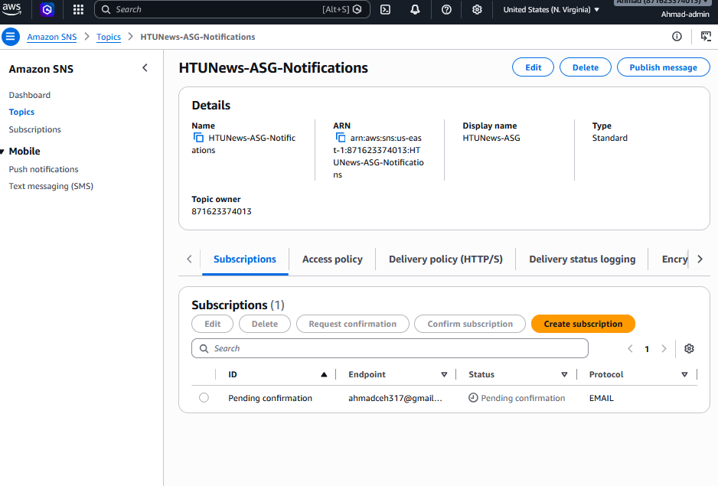
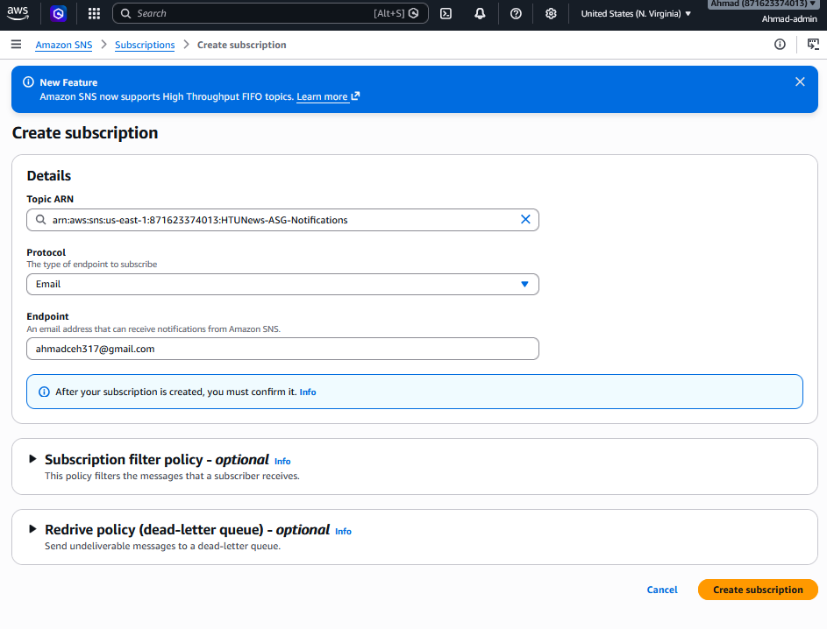
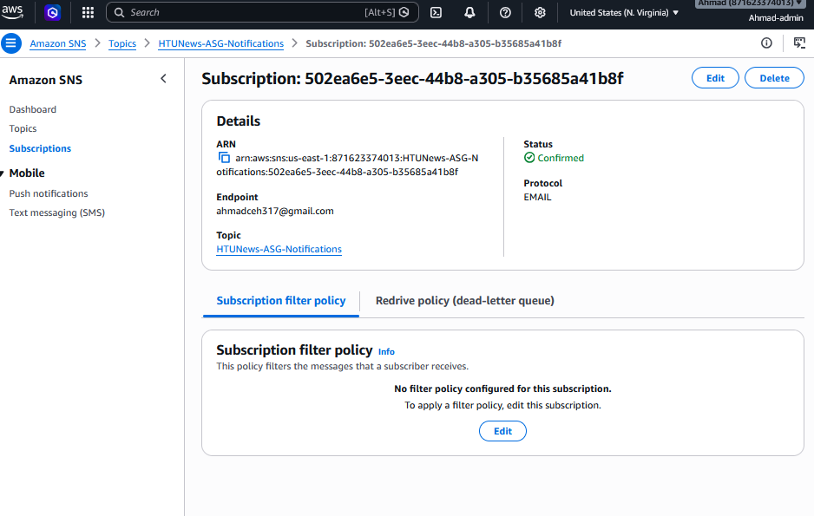

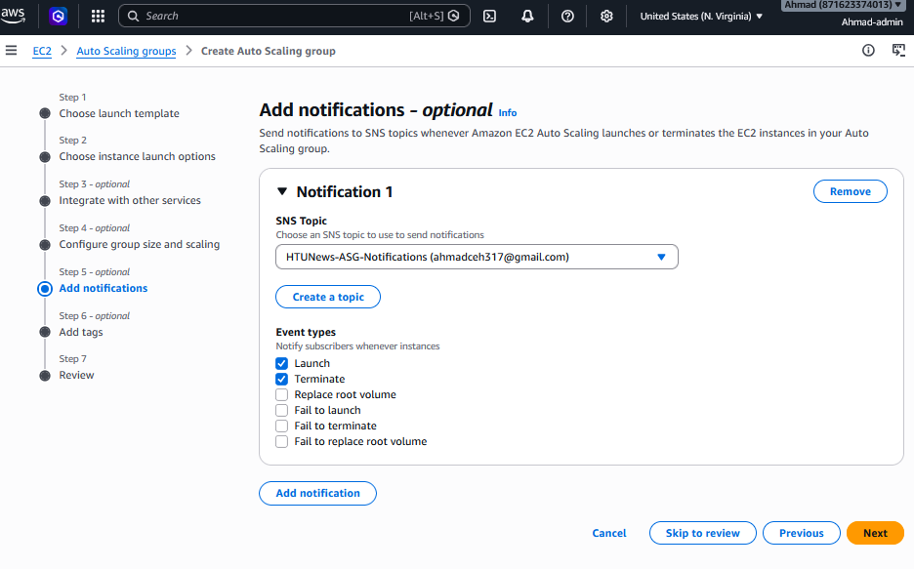

Step 8 verfy :
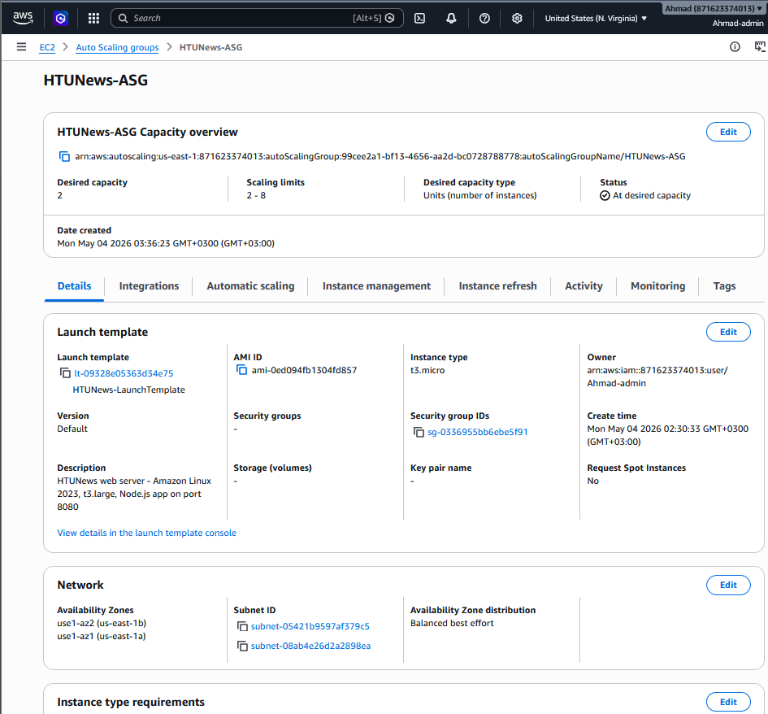
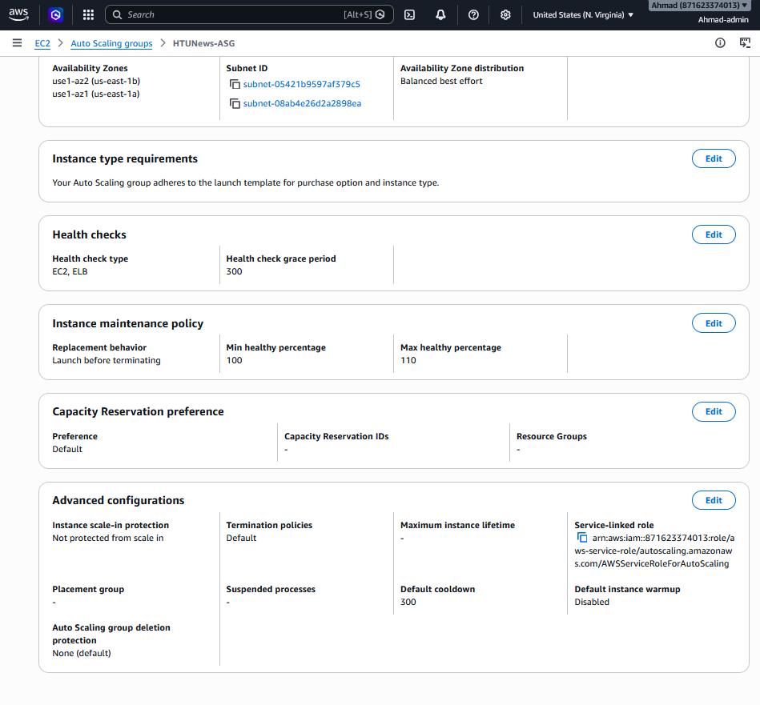

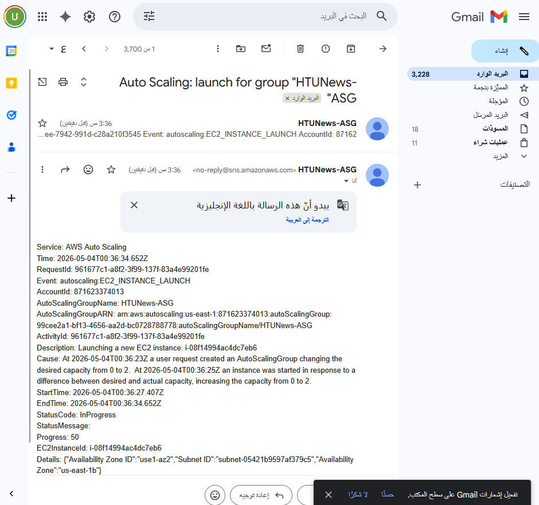

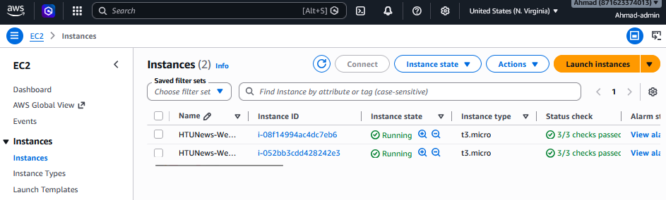

Test Application:

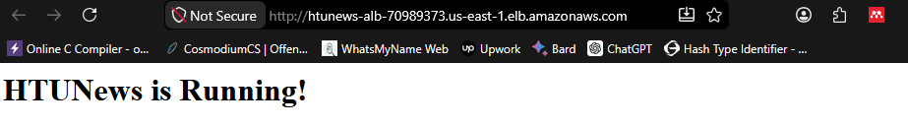

Test the Redirect :

https://htunews-alb-70989373.us-east-1.elb.amazonaws.com/invalid-page

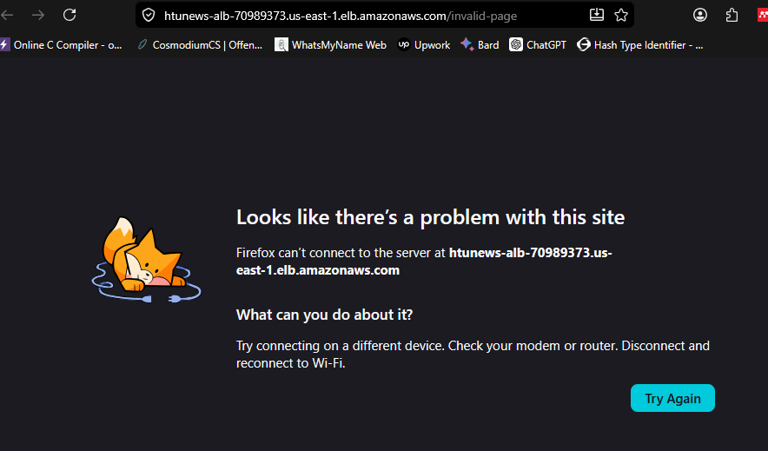

Fix: edit the Redirect Protocol on EC2 → Load Balancers → HTUNews-ALB → Listeners and rules tab

Change the Protocol from HTTPS to HTTP and port from 443 to 80:
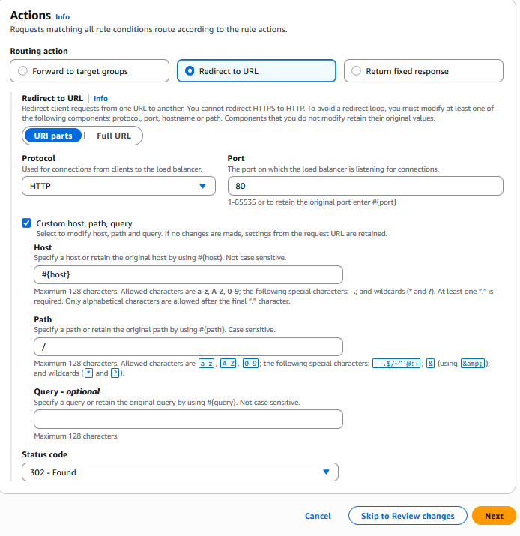

Test again :
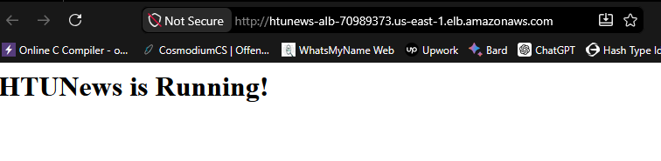

Done !

2.6 Design Justification — Section 2
This subsection provides a consolidated justification for every major design decision in Section 2: Availability, Scalability, and Network Architecture. Each justification is linked to specific functional or non-functional requirements from the assignment brief and follows AWS Well-Architected Framework principles.

2.6.1 Justification for t3.large as Baseline Instance Type
Requirement addressed: The platform must handle 10,000 users/hour normally and surge to 80,000 users/hour during breaking news events, while balancing performance, cost, and scalability.
The t3.large was selected over alternatives for four reasons:
Burstable CPU matches news traffic patterns. News websites exhibit sharp, time-limited traffic spikes during breaking events followed by periods of normal load. T3 instances use a CPU credit model: they accumulate credits during low-CPU periods and consume them during spikes. This matches the workload profile perfectly — the instances "save up" capacity during quiet hours and spend it during breaking news. In contrast, m5.large provides consistent non-burstable performance at a higher cost, which means paying for capacity that is unused during normal operation.
RAM capacity is appropriate for a Node.js application. The HTUNews application is built on Node.js, which is event-driven and primarily limited by memory for concurrent connections, not raw CPU cores. 8 GB RAM on t3.large is sufficient for web serving workloads. The t3.medium (4 GB) was rejected because 4 GB provides insufficient headroom for operating system processes, the Node.js runtime, and concurrent request handling during traffic spikes.
Cost efficiency matters for a startup. HTUNews is explicitly described as a startup. The t3.large costs approximately $0.0832perhour(on-demand,us-east-1),comparedtom5.largeat$0.096 per hour — a 15% cost premium for the same 2 vCPU/8 GB configuration. Over a year of always-on baseline instances (2 × 8,760 hours), this difference exceeds $200 per instance annually before considering ASG burst instances.
Horizontal scaling addresses the 8× traffic multiplier. The design does not expect one t3.large to handle 80,000 users. The Auto Scaling Group distributes peak load across up to 8 instances. The capacity assumption of approximately 10,000 users per instance is a planning figure that would be validated through load testing in a real deployment. If load testing reveals that one instance handles fewer users, the ASG maximum would be increased accordingly.
Risk acknowledged — CPU credit exhaustion. T3 instances maintain a CPU credit balance. If sustained high CPU exhausts this balance, performance drops to the baseline rate (10% of a vCPU for t3.large). This risk is mitigated by: (1) the ASG target tracking policy at 80% CPU utilization, which adds instances before credits are exhausted; (2) CloudWatch monitoring of CPUCreditBalance on the operations dashboard (Section 4). If monitoring reveals regular credit exhaustion, the recommendation shifts to m5.large for consistent performance.

2.6.2 Justification for the Mixed Pricing Strategy
Requirement addressed: The pricing models must be evaluated and a recommendation provided that fits this use case.
The recommended strategy combines Reserved Instances for predictable baseline capacity with On-Demand for variable spike capacity:
Reserved Instances for the baseline. Two t3.large instances must run continuously to ensure minimum availability across two Availability Zones. At $0.0832/houron-demand,twoinstancescostapproximately$1,458 annually. A 1-year Standard Reserved Instance at $0.050/hourreducesthistoapproximately$877 annually — a 40% saving on the non-negotiable always-on capacity. This saving directly benefits a startup's operating budget.
On-Demand for traffic spikes. Breaking news events are inherently unpredictable — some weeks have none, others have several. Committing to Reserved Instances for spike capacity would mean paying for capacity that sits idle. On-Demand pricing charges only for instances actually launched during spikes, aligning cost with actual usage.
Spot Instances are optional and supplementary. Spot Instances offer up to 90% savings but carry a two-minute termination warning. For a news website during breaking events, unexpected instance termination during peak traffic would degrade user experience. Therefore, Spot is positioned as an optional cost-optimization layer with On-Demand fallback, not as the primary spike-handling strategy.
Implementation note. For this assignment, all resources use On-Demand pricing to remain within AWS Free Tier limits. The Reserved Instance recommendation is documented as the production strategy to satisfy the assignment's requirement to evaluate pricing options.

2.6.3 Justification for the VPC Architecture
Requirement addressed: A secure and scalable cloud network architecture must be designed in accordance with best practices, ensuring resource isolation, controlled communication, minimal exposure of internal services, and efficient scalability.
Private subnets for application servers. EC2 instances are placed in private subnets with no public IP addresses. This means they cannot be reached directly from the internet — all inbound traffic must pass through the Application Load Balancer. This reduces the attack surface significantly: even if an attacker discovers an instance's IP address, no route exists from the internet to the private subnet. Only the ALB, which sits in public subnets, accepts internet traffic.
Multi-AZ placement for fault tolerance. Subnets are distributed across two Availability Zones. If us-east-1a fails entirely, us-east-1b continues serving traffic. Both the ALB and the ASG span both AZs, so the failure of one AZ does not cause a complete outage. This directly addresses the assignment requirement that "the website should remain accessible even if one of the servers fails."
Single NAT Gateway — cost vs. fault tolerance tradeoff. Both private route tables route internet-bound traffic through one NAT Gateway in Public Subnet A. This is a deliberate cost optimization: a second NAT Gateway would add approximately $33/month. The acknowledged tradeoff is that failure of AZ-1 (where the NAT resides) would cause private instances to lose outbound internet access, though they would continue serving traffic through the ALB. For a startup, this tradeoff is acceptable. For a production system with critical external dependencies, a second NAT Gateway in AZ-2 is recommended and is documented in the route table configuration.
CIDR sizing allows for future growth. 10.0.0.0/16 provides 65,536 IP addresses. With four /24 subnets currently using approximately 1,004 addresses, there is substantial room for additional subnets, VPC peering, or service expansion without re-addressing.

2.6.4 Justification for the Application Load Balancer (ALB)
Requirement addressed: HTTPS termination, health checks on the homepage, invalid path redirection, and traffic distribution across instances.
The Application Load Balancer was selected over the Network Load Balancer (NLB) for three reasons:
Layer 7 routing is required. The assignment requires redirecting invalid paths to the homepage (/). This requires inspecting the HTTP request path — a Layer 7 capability exclusive to ALB. NLB operates at Layer 4 (TCP) and cannot inspect HTTP content.
Health checks require HTTP-level awareness. The ALB health check is configured to send GET requests to / and expect a 200 response. This verifies not just that the instance is reachable (which an NLB TCP health check would confirm), but that the Node.js application is actually running and serving content. This is critical for the requirement that traffic be routed away from unhealthy instances.
SSL termination at the load balancer. The ALB handles HTTPS termination, offloading TLS encryption/decryption from EC2 instances. This reduces CPU load on the application servers and centralizes certificate management — ACM certificates are attached to the ALB listener, not distributed to individual instances.

2.6.5 Justification for Security Group Design
Requirement addressed: Controlled communication between components and minimal exposure of internal services.
The two-security-group design implements the principle of least privilege at the network level:
SG-ALB accepts only HTTP and HTTPS from the internet. Ports 80 and 443 are the only inbound ports exposed to 0.0.0.0/0. No SSH (port 22), no database ports, no application ports — only what users' browsers need to reach the website.
SG-WebServer accepts port 8080 only from SG-ALB. This is the most critical security configuration. By referencing the SG-ALB security group ID as the source (rather than a CIDR range or 0.0.0.0/0), the rule semantically states: "Allow traffic on port 8080 only if it originated from the Application Load Balancer." This means:
- Traffic that passes through the ALB (internet → ALB → EC2) is permitted.
- Traffic attempting to reach EC2 directly is denied, even if the attacker knows the instance's private IP address.
- If a new service or instance is added and attached to SG-ALB, it automatically inherits the permission — no rule updates needed.
No SSH port open — SSM instead. No inbound port 22 is configured on any security group. Access to EC2 instances for administration is provided through AWS Systems Manager Session Manager, which uses the SSM Agent to create a secure, IAM-authenticated session through the NAT Gateway. This eliminates: SSH brute-force attack surface, SSH key management complexity, and the need for instances to carry public IP addresses. All SSM sessions are logged to CloudTrail for auditability.

2.6.6 Justification for Auto Scaling Group Configuration
Requirement addressed: Traffic surges during breaking news, health-based routing, and automated capacity adjustment.
Minimum of 2 instances ensures baseline high availability. With one instance in each AZ, the failure of a single instance or an entire AZ leaves at least one instance serving traffic. The ALB health check (30-second interval, 3 unhealthy threshold = 90 seconds to detect failure) ensures traffic is routed away from failed instances within approximately 90 seconds. The ASG launches a replacement instance automatically, restoring the desired count.
Maximum of 8 instances supports the 8× traffic range. Normal load: 2 instances × ~10,000 users = ~20,000 users/hour capacity (exceeding the 10,000 requirement with headroom). Peak load: 8 instances × ~10,000 users = ~80,000 users/hour capacity. The actual per-instance capacity assumption would be validated through load testing.
SNS notifications provide operational visibility. Launch and terminate events trigger email notifications, enabling the operations team to track scaling activity. This satisfies the assignment's requirement for notifications when instances are launched or terminated.

2.6.7 Summary of Key Tradeoffs
Decision | Option Taken | Rejected Alternative | Reason
Instance type | t3.large (burstable) | m5.large (consistent) | Cost saving with burst match; fallback if credits exhaust
Pricing | Reserved + On-Demand | All On-Demand or All Reserved | Optimize known baseline, maintain spike flexibility
Subnet placement | EC2 in private subnets | EC2 in public subnets | Reduced attack surface; only ALB exposed
NAT Gateway count | One NAT Gateway | Two NAT Gateways (one per AZ) | Cost optimization for startup; documented production alternative
Load balancer type | Application Load Balancer | Network Load Balancer | Layer 7 routing required for path-based redirects and health checks
Server access | SSM Session Manager | SSH on port 22 | No open ports, IAM-controlled, fully audited
Security Group source | SG-ALB security group ID | 0.0.0.0/0 CIDR | Defense in depth; only ALB-originated traffic permitted

Section 3: Storage and Data Management (Amazon S3)

3.1 Storage Solution Justification
Currently, HTUNews stores all media files on EC2 web server instances. This creates three critical problems: (1) EC2 EBS storage limits are reached quickly with several GB added daily; (2) media file I/O competes with web request processing, degrading performance; (3) files stored on EC2 instances are lost when the ASG terminates instances during scale-in events.
Amazon S3 is the correct solution because it provides: virtually unlimited scalability; storage fully decoupled from EC2 (instances do not lose data when terminated); 11 nines of durability (99.999999999%) through automatic replication across multiple AZs; native lifecycle management for cost optimisation; and built-in versioning and object protection for data recovery.

3.1.1 Storage Solution Evaluation
Amazon S3 was selected over alternative AWS storage services after evaluation against HTUNews's specific requirements:
Requirement | S3 | EBS | EFS | Verdict
Virtually unlimited capacity | ✅ Scales automatically | ❌ Fixed volume size (max 16 TB) | ❌ Scales but requires management | S3 is the only truly unlimited option
Decoupled from EC2 lifecycle | ✅ Data survives instance termination | ❌ Volumes must be manually detached/reattached | ✅ Persistent | S3 requires no EC2 attachment at all
Performance for infrequent media access | ✅ Sufficient for image serving | ✅ Lower latency but instance-attached | ✅ Shared file system performance | S3 meets the access pattern requirement
Automated lifecycle management | ✅ Native S3 Lifecycle policies | ❌ Manual snapshot management | ❌ No native tiering | S3 lifecycle policies directly match the 30/90-day pattern
Data durability | ✅ 99.999999999% (11 nines) | ✅ 99.999% | ✅ 99.999999999% | All adequate; S3 is industry-leading
Cost for archival data | ✅ Glacier Instant Retrieval ~68% cheaper | ❌ gp3 volume same price regardless of access frequency | ❌ No archival tiering | S3 lifecycle saves costs on rarely accessed media
Versioning and recovery | ✅ Native versioning, delete markers, Object Lock | ❌ Requires manual snapshots | ❌ Requires backup replication | S3 provides the simplest recovery from accidental deletion
Selection Decision: Amazon S3 is the only service that meets all requirements simultaneously — unlimited scalable capacity for several GB of daily growth, native lifecycle policies matching the 30/90-day access pattern, built-in versioning for recovery from accidental deletion, and Object Lock for protection against permanent data loss. EBS was rejected because it is instance-attached and does not survive ASG scale-in events. EFS was rejected because it lacks native lifecycle tiering for cost optimization.

3.2 S3 Lifecycle Policy Design
HTUNews media follows a predictable access pattern. A lifecycle policy automates class transitions to reduce storage cost:
Days After Upload | Access Pattern | S3 Storage Class | Cost Reduction
Day 0–30 | High frequency — active news | S3 Standard | Baseline (full price for instant access)
Day 31–90 | Infrequent access — older articles | S3 Standard-IA | ~45% cheaper than Standard; 30-day minimum billing applies
Day 91+ | Archival — historical content | S3 Glacier Instant Retrieval | ~68% cheaper than Standard; millisecond retrieval maintained
Noncurrent versions after 45 days | Previous file versions | Expire (permanently deleted) | Eliminates cost for outdated file versions

3.3 Data Protection Mechanisms
A recent incident saw critical images permanently deleted with no recovery path. Two S3 mechanisms address this:
- S3 Versioning: Every upload creates a new object version. A deletion creates a delete marker (not permanent removal). Accidental deletions are recoverable by removing the delete marker. Accidental overwrites are recoverable by restoring a previous version.
- S3 Object Lock (Governance Mode): Prevents permanent deletion for a defined retention period (90 days recommended). Only users with the s3:BypassGovernanceRetention IAM permission can override the lock — creating an auditable override process. In Compliance Mode (stricter), even the root account cannot delete locked objects before the retention period.

3.4 Step-by-Step Implementation

Task 3.4.1 — Create the S3 Bucket
Step 1: Open S3 Console
AWS Console > S3 > Create bucket.
Step 2: Name and region
Bucket name: htunews-media-bucket (globally unique — add initials if needed, e.g., htunews-media-bucket-yz). Region: same as EC2 (e.g., us-east-1). Keep 'Block all public access' ENABLED — instances access S3 via IAM roles, not public URLs.
Step 3: Enable versioning
Bucket Versioning: Enable.
Step 4: Enable Object Lock
Object Lock: Enable. Mode: Governance. Retention period: 90 days. Click 'Create bucket'.

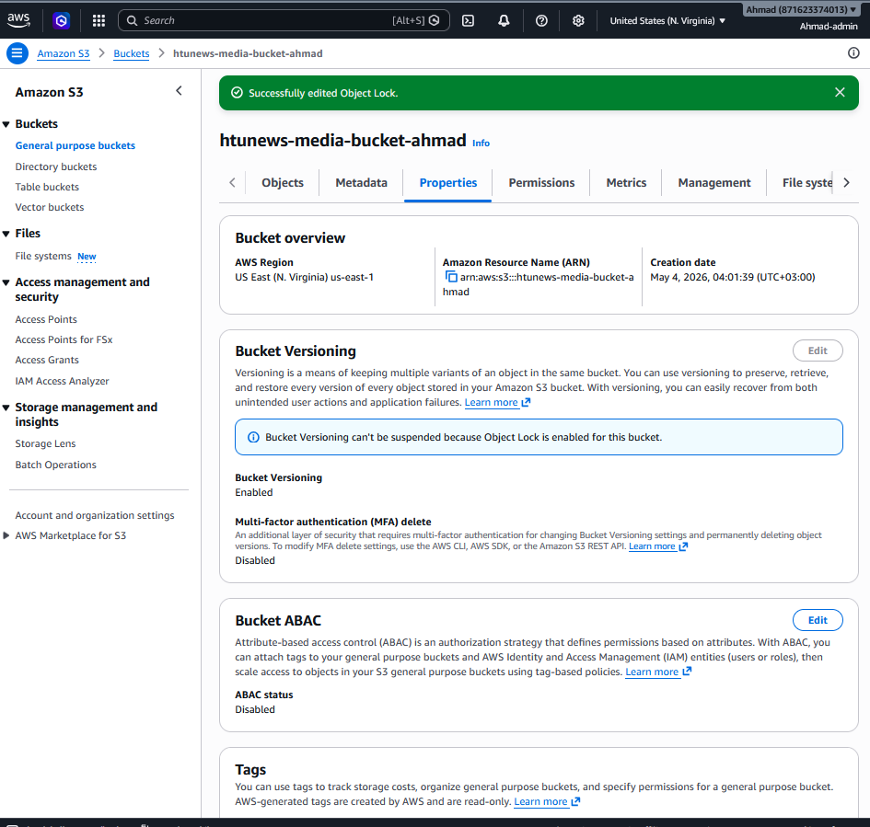
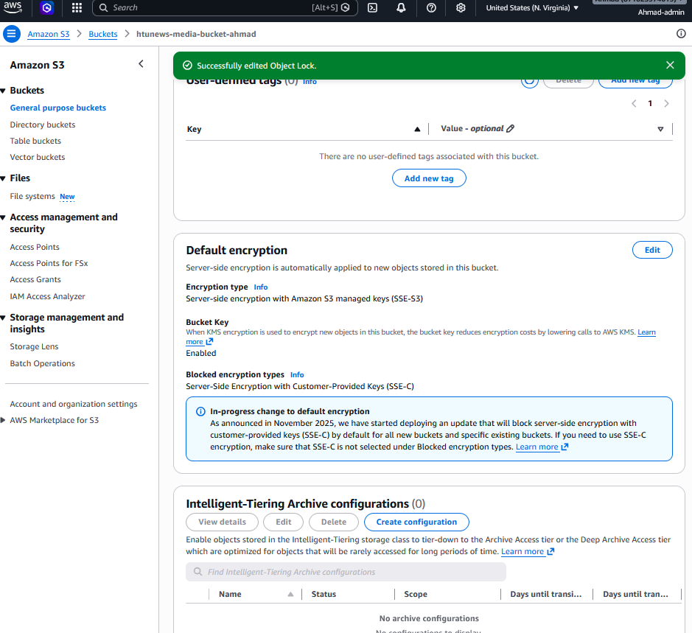
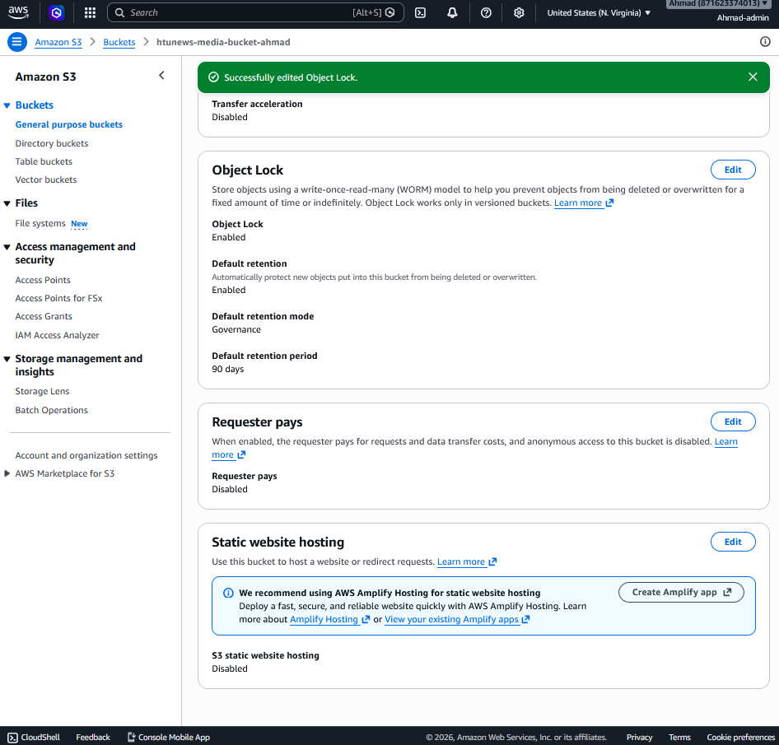

Task 3.4.2 — Configure Lifecycle Policy
Step 1: Open Management tab
Click bucket name > Management tab > Create lifecycle rule.
Step 2: Storage class transitions
Rule name: HTUNews-MediaLifecycle. Apply to all objects. Transitions for current versions: after 30 days → Standard-IA; after 90 days → Glacier Instant Retrieval.
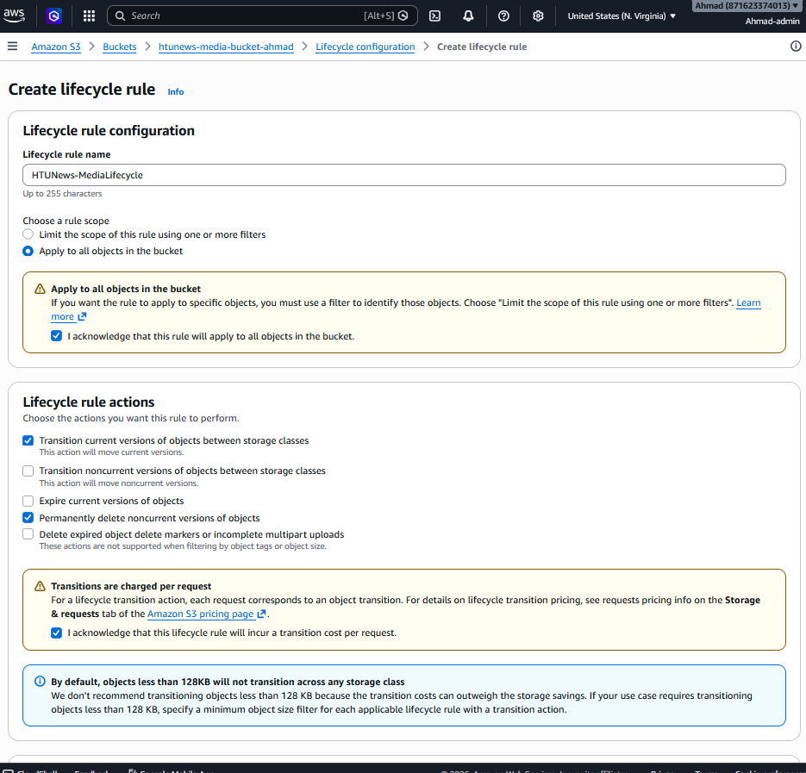
Step 3: Version expiration
In the same rule, enable 'Permanently delete noncurrent versions of objects'. Days after objects become noncurrent: 45.
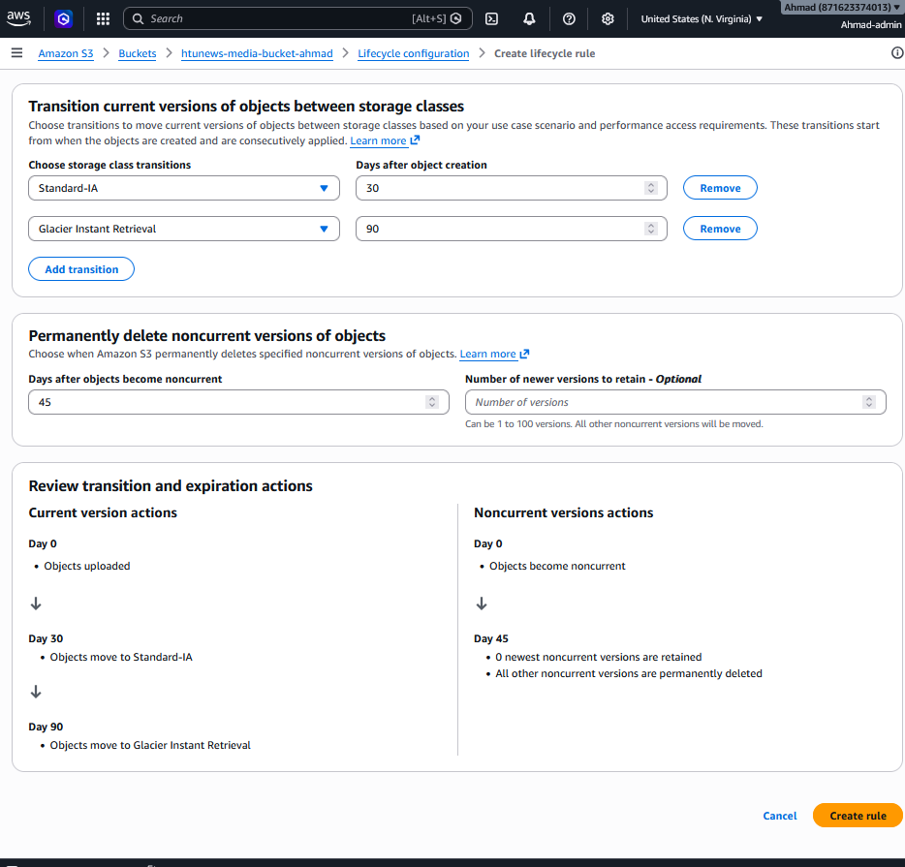
Step 4: Save
Create rule.

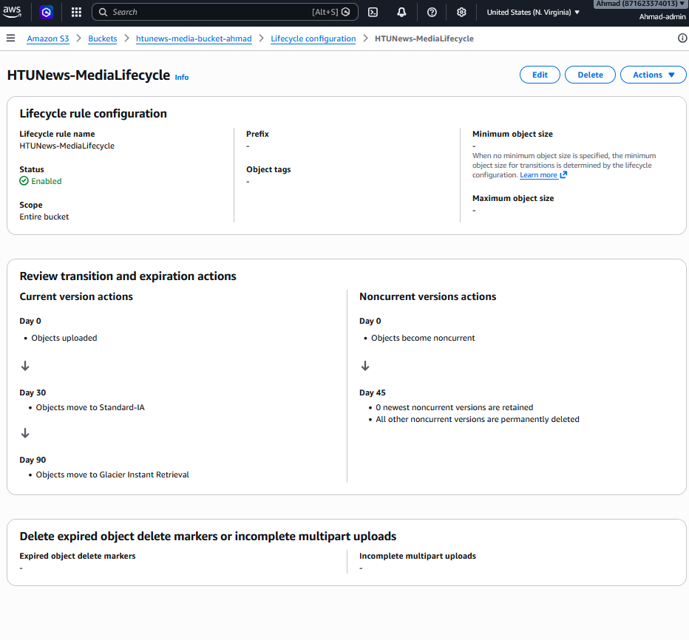

Task 3.4.3 — Create IAM Role for EC2 and Attach to Launch Template
Step 1: Create EC2 IAM Role
IAM > Roles > Create role. Trusted entity: AWS service / EC2. Attach policies: AmazonS3FullAccess (media read/write); AmazonSSMManagedInstanceCore (enables SSM Session Manager — no SSH needed). Name: HTUNews-EC2-S3Role.

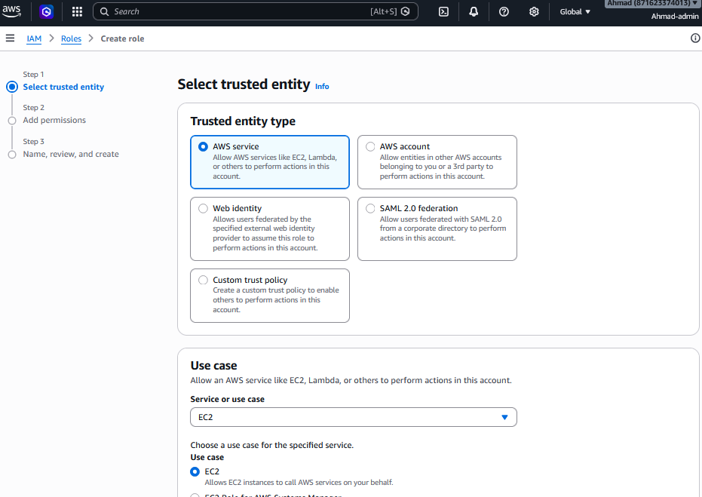

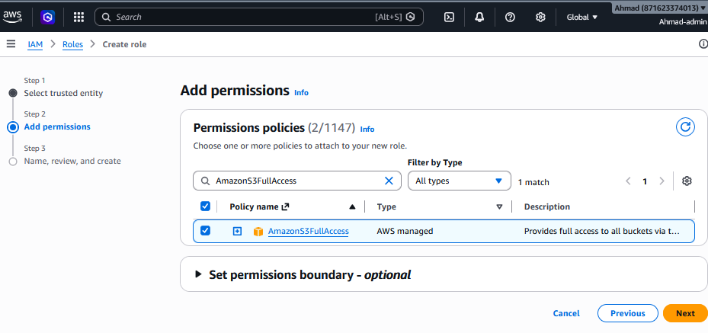
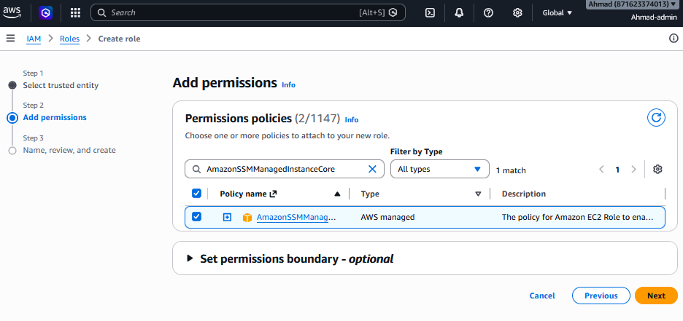
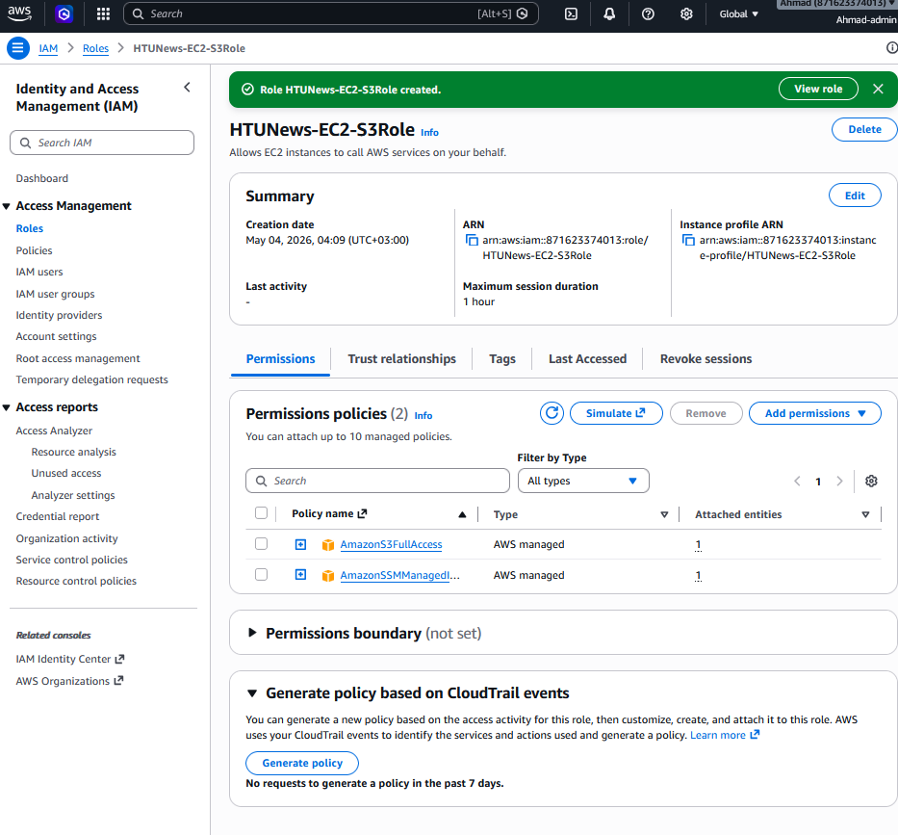
Step 2: Add PassRole for Developers
Create a second custom policy: Name = HTUNews-Developers-PassRole. JSON: {"Version":"2012-10-17","Statement":[{"Effect":"Allow","Action":"iam:PassRole","Resource":"arn:aws:iam::*:role/HTUNews-EC2-S3Role"}]}. Attach this policy to Developers-Group in IAM.

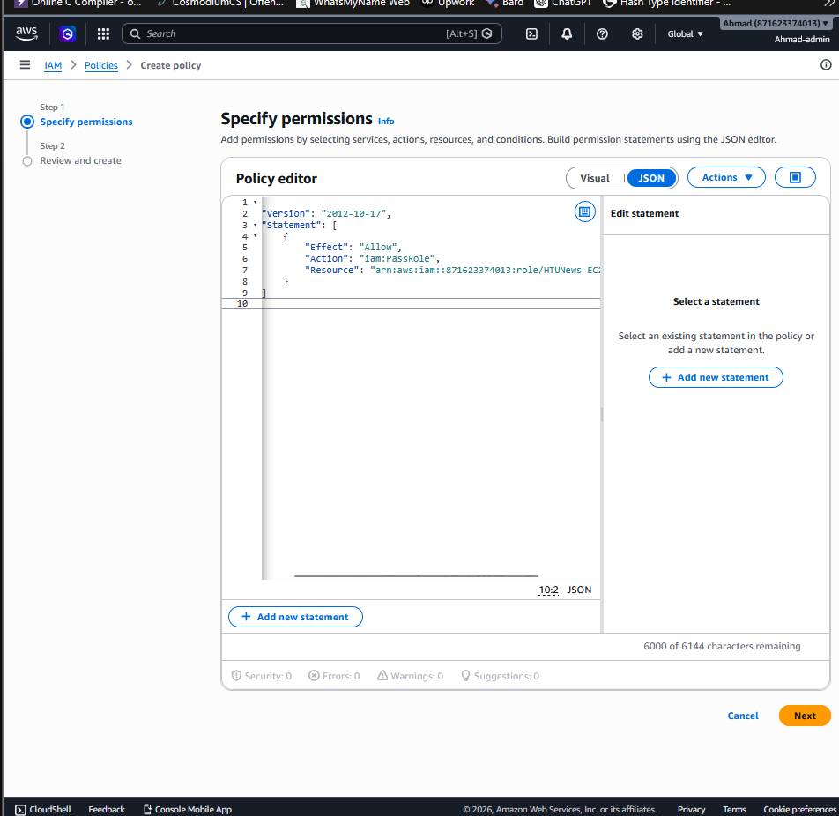

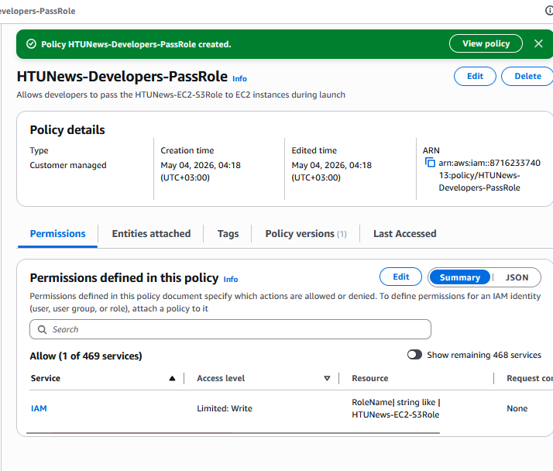
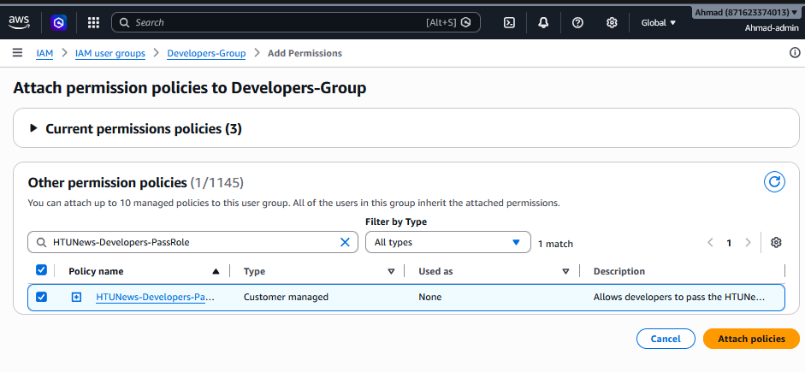
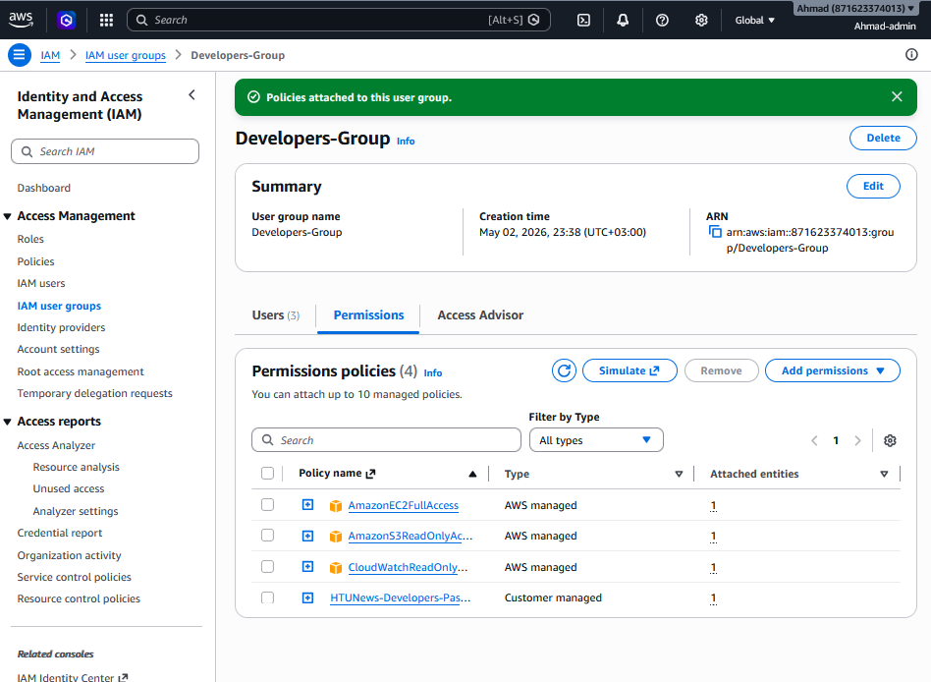

Step 3: Update Launch Template
EC2 > Launch Templates > HTUNews-LaunchTemplate > Actions > Modify template (Create new version). In 'Advanced details' > IAM instance profile: select HTUNews-EC2-S3Role. Set as default version.

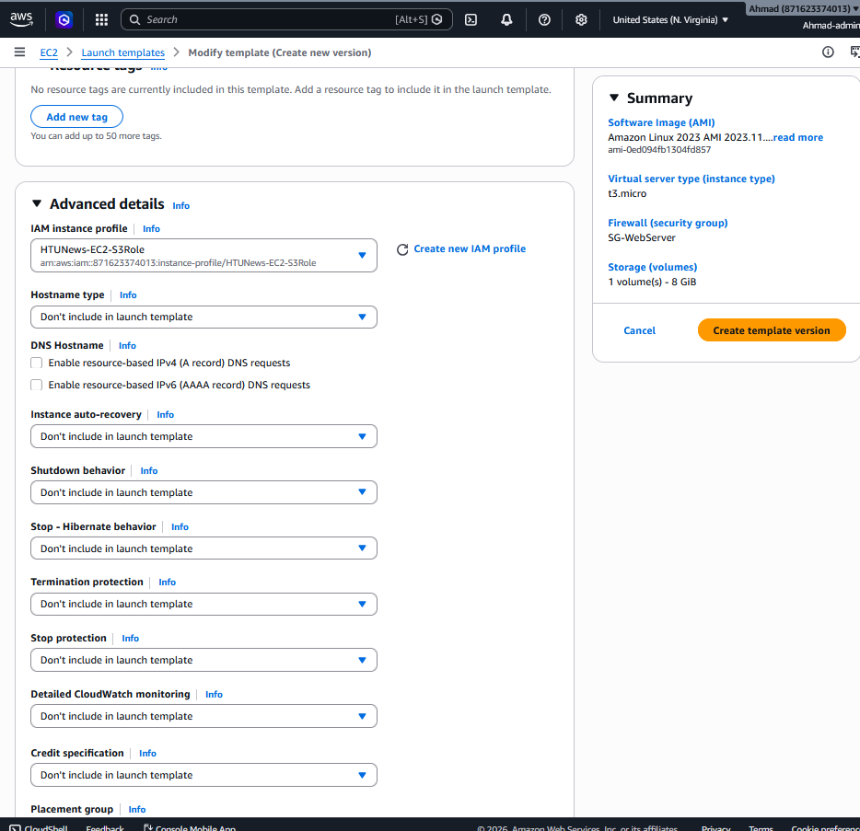

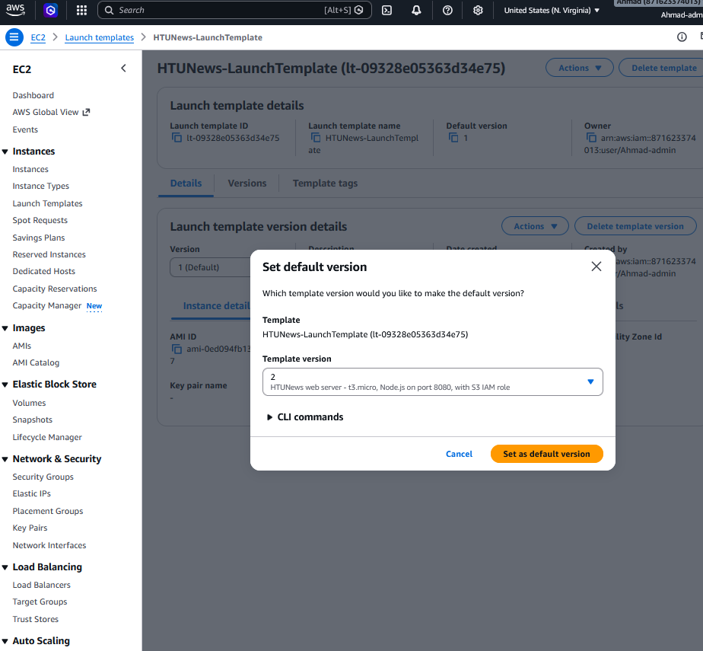

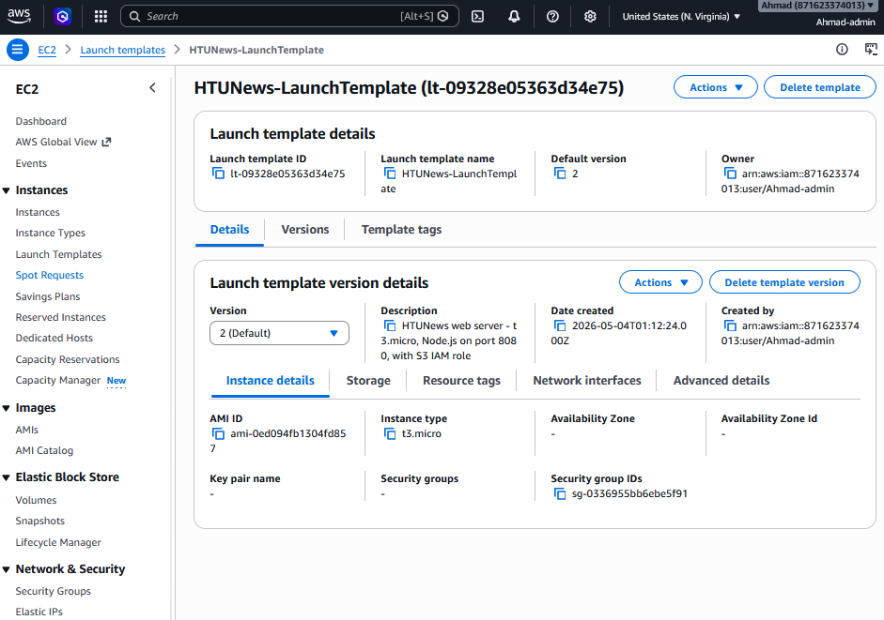

Section 4: Monitoring, Alerting, and Operational Visibility

4.1 Monitoring Architecture Overview
The complete monitoring architecture for HTUNews includes five integrated components providing full operational visibility:
- ASG Instance Lifecycle Notifications — SNS alerts for EC2 launch and terminate events, enabling real-time tracking of scaling activity during normal operation and traffic spikes.
- S3 Bucket Activity Monitoring — CloudTrail audit logs combined with S3 Event Notifications for all object create, delete, and restore operations, ensuring all storage changes are tracked and auditable.
- EC2 Instance Health Monitoring — CPU utilisation, CPU credit balance (critical for T3 burstable instances), network throughput (NetworkIn/NetworkOut), and EC2 status checks provide instance-level performance visibility.
- ALB Performance Monitoring — Request count, HTTP 4XX/5XX error rates, target response time, and healthy host count provide application-layer traffic visibility and early error detection.
- Capacity Warning System — CloudWatch Alarm triggers an email alert when running instances approach the ASG maximum capacity (7 of 8), enabling proactive capacity management before performance degrades.

A unified CloudWatch Dashboard (Task 4.2.4) presents all metrics in a single operational view, enabling rapid issue identification during traffic spikes.

4.2 Step-by-Step Implementation

Task 4.2.1 — Verify ASG SNS Notifications
SNS notifications for ASG scale-out and scale-in were configured in Section 2, Task 2.5.5, Step 7. Verify they are active and confirmed:
Step 1: Check SNS Topic
SNS Console > Topics. Confirm 'HTUNews-ASG-Notifications' exists. Click it and verify email subscription status shows 'Confirmed' (not 'PendingConfirmation' — check email inbox and click the confirmation link if needed).

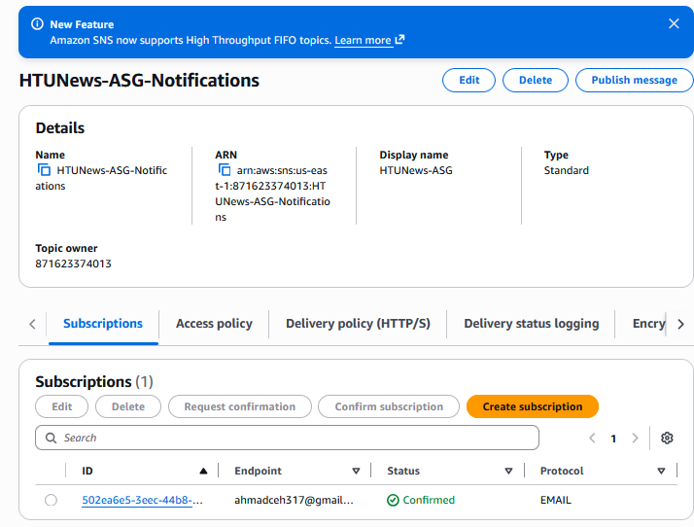

Step 2: Test the notification
Temporarily set ASG Desired Capacity to 1 (from 2) to trigger a terminate event, then restore to 2 to trigger a launch event. Verify email notifications are received for both events.

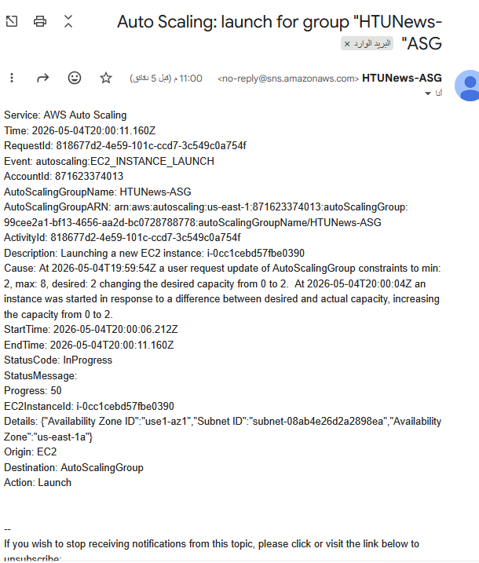

Task 4.2.2 — Enable S3 Event Notifications
Step 1: Create SNS Topic for S3
SNS > Create topic. Type: Standard. Name: HTUNews-S3-Events. Create an email subscription and confirm it.

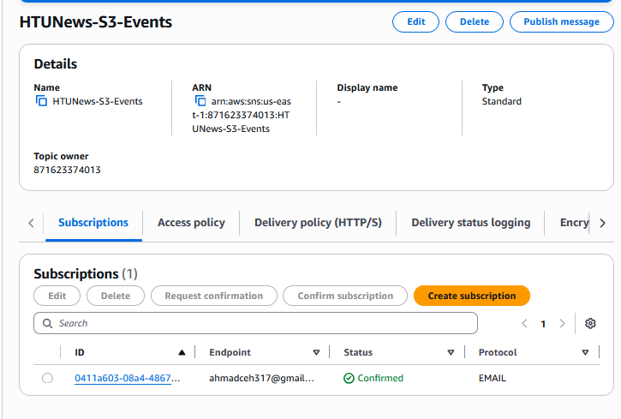

Step 2: Update SNS access policy
SNS > HTUNews-S3-Events > Access policy > Edit. Add a statement allowing the S3 service principal (s3.amazonaws.com) to publish to the topic, with a condition limiting the source to your bucket ARN. AWS provides the exact policy statement in the S3 console notification wizard.

Step 1: Get Your SNS Topic ARN
Go to SNS → Topics → HTUNews-S3-Events.
Copy the ARN arn:aws:sns:us-east-1:871623374013:HTUNews-S3-Events

Step 2: Get Your S3 Bucket ARN
Go to S3 → htunews-media-bucket-ahmad → Properties.
Copy the ARN arn:aws:s3:::htunews-media-bucket-ahmad

Step 3: Edit SNS Access Policy
Go back to SNS → HTUNews-S3-Events → Access policy tab.
Click Edit.
json
{
"Version": "2012-10-17",
"Id": "S3-Publish-Policy",
"Statement": [
{
"Sid": "Allow-S3-To-Publish",
"Effect": "Allow",
"Principal": {
"Service": "s3.amazonaws.com"
},
"Action": "SNS:Publish",
"Resource": "arn:aws:sns:us-east-1:871623374013:HTUNews-S3-Events",
"Condition": {
"ArnLike": {
"aws:SourceArn": "arn:aws:s3:::htunews-media-bucket-ahmad"
}
}
}
]
}

Click Save changes.

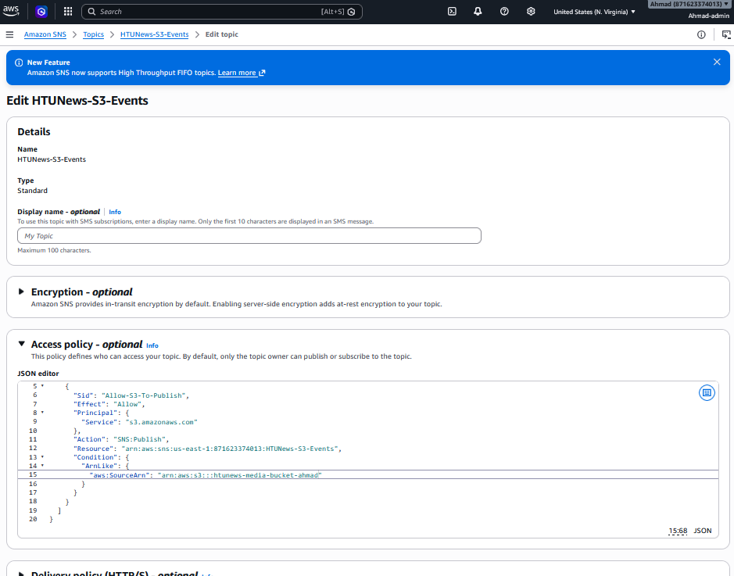

Step 3: Configure S3 event notification
S3 > htunews-media-bucket > Properties > Event notifications > Create event notification. Name: HTUNews-S3-Monitoring. Event types: All object create events (s3:ObjectCreated:*) and All object delete events (s3:ObjectRemoved:*). Destination: SNS topic — select HTUNews-S3-Events.

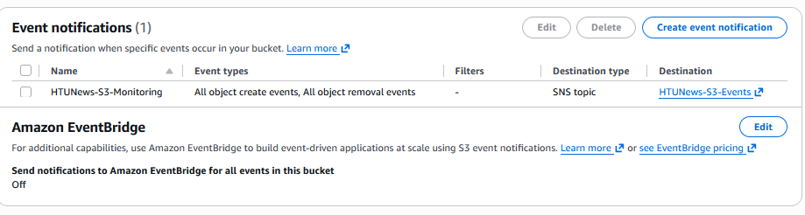

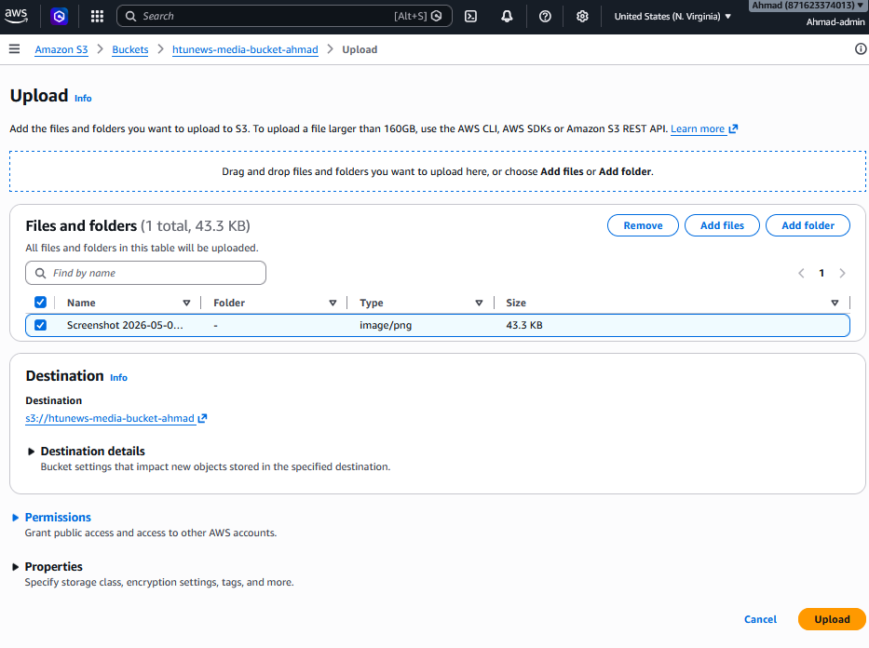
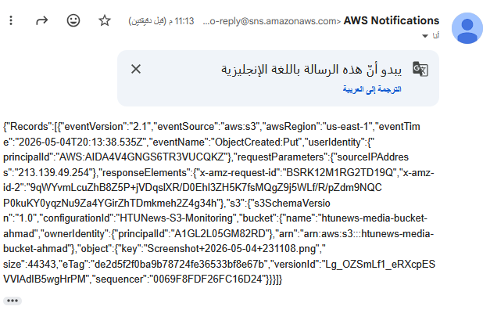
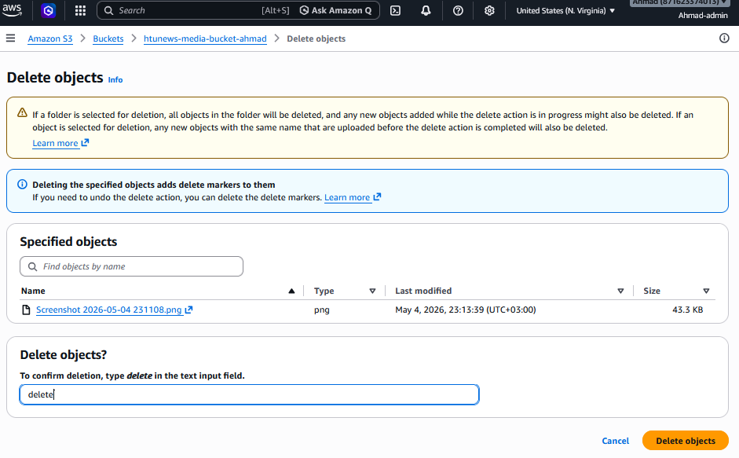
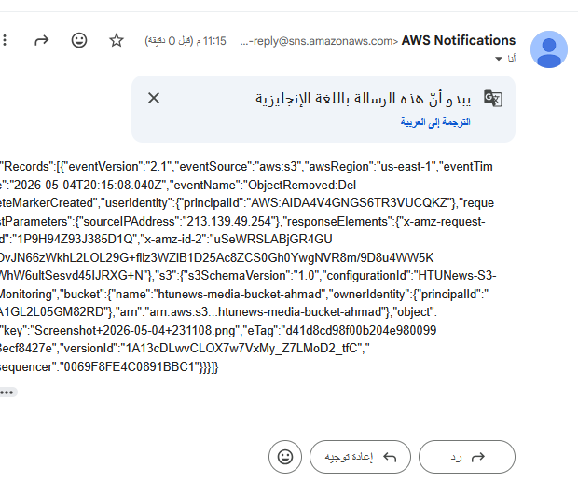

Task 4.2.3 — CloudWatch Alarm for ASG Capacity
This alarm triggers when running instances reach 7 (of maximum 8), providing early warning at 87.5% capacity utilisation before the ceiling is hit.
Step 1: Open CloudWatch
CloudWatch > Alarms > All alarms > Create alarm.
Step 2: Select metric
Select metric > EC2 > Auto Scaling > by Auto Scaling Group > GroupInServiceInstances for HTUNews-ASG. Period: 1 minute.

First we need to Enable group metrics collection
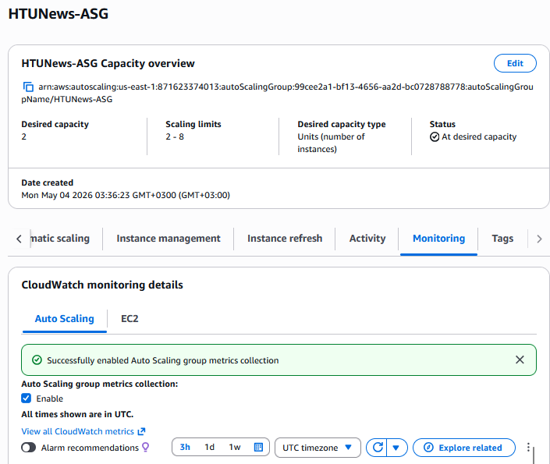

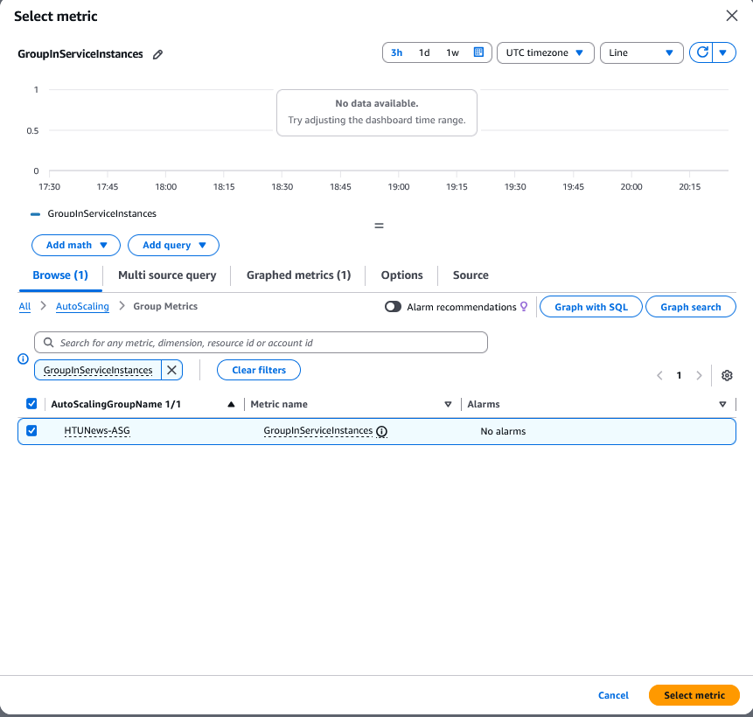

Step 3: Set threshold
Condition: Greater than or equal to 3.

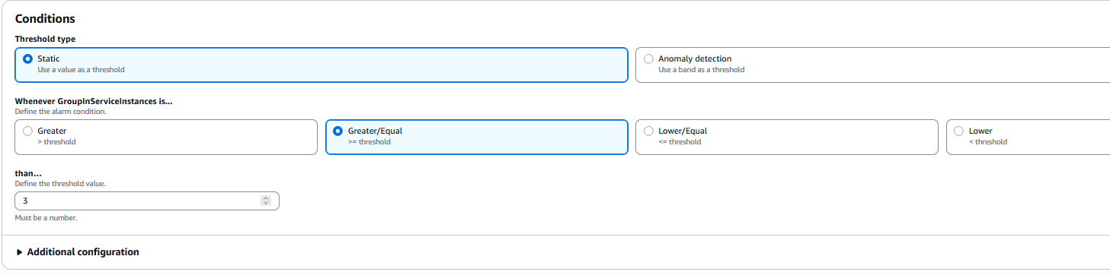
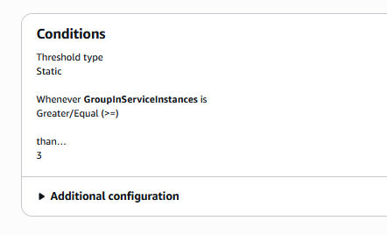
This triggers at 87.5% capacity — giving you warning before hitting the max of 8.

Step 4: Configure SNS action
In alarm state: send notification to HTUNews-ASG-Notifications (or create a new topic). Click 'Next'.

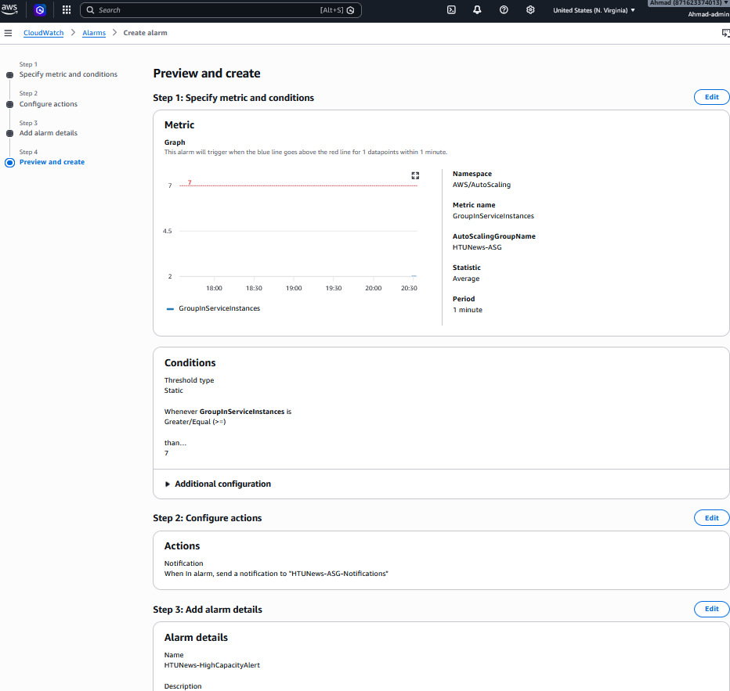

Step 5: Name and create
Name: HTUNews-HighCapacityAlert. Description: Alert when running instances approach maximum ASG capacity of 8. Create alarm.

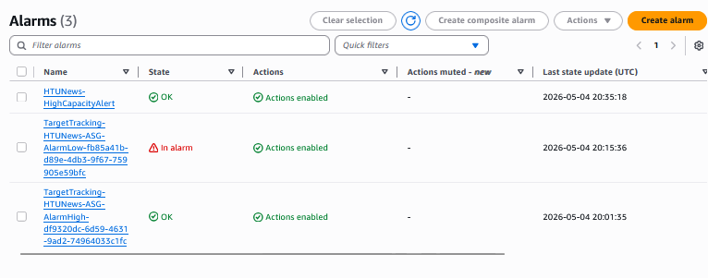

Task 4.2.4 — Create CloudWatch Operations Dashboard
Step 1: Open CloudWatch Dashboards
CloudWatch > Dashboards > Create dashboard. Name: HTUNews-OperationsDashboard.
Step 2: Add EC2 / ASG metrics widget
Add widget > Line chart. Metrics: EC2 > By Auto Scaling Group > HTUNews-ASG. Select: CPUUtilization (watch for sustained high values), CPUCreditBalance (critical for T3 — alerts to credit exhaustion), NetworkIn, NetworkOut. Label this widget 'EC2 Instance Performance'. Click 'Create widget'.
Step 3: Add ALB metrics widget
Add widget > Line chart. Metrics: ApplicationELB > By Load Balancer > HTUNews-ALB. Select: RequestCount, HTTPCode_Target_4XX_Count, HTTPCode_Target_5XX_Count, TargetResponseTime. Label: 'ALB Traffic and Errors'. Click 'Create widget'.

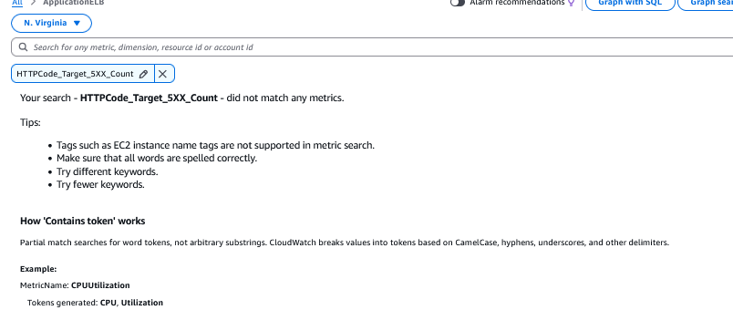
There is an error I cant find it , I think that because there is no trafic , so the metric doesn’t show up
Step 4: Add ASG capacity number widget
Add widget > Number. Metrics: Auto Scaling > GroupInServiceInstances for HTUNews-ASG. Label: 'Running Instances'. This displays the current live instance count prominently.
Step 5: Add alarm status widget
Add widget > Alarm status. Select HTUNews-HighCapacityAlert. This shows the alarm state (OK / ALARM / INSUFFICIENT_DATA) directly on the dashboard for immediate awareness.
Step 6: Save dashboard
Click 'Save dashboard'. The HTUNews-OperationsDashboard now provides a unified operational view addressing all five monitoring requirements defined in Section 4.1.

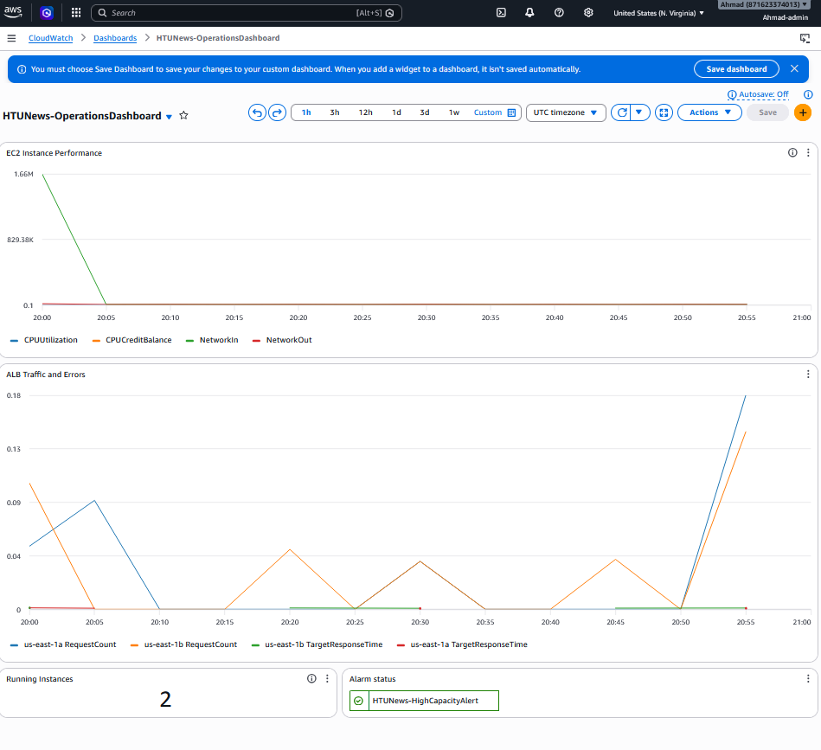

Dashboard Review
Widget | What It Shows | Status
EC2 Instance Performance | CPUUtilization, CPUCreditBalance, NetworkIn, NetworkOut | CPU + credit balance is critical for T3 burstable instances
ALB Traffic and Errors | RequestCount per AZ, TargetResponseTime | Shows traffic distribution and latency
Running Instances | GroupInServiceInstances = 2 | Current count at a glance
Alarm Status | HTUNews-HighCapacityAlert | Quick visual of alarm state

Section 5: DNS Routing and Application Security (Route 53 and ACM)

5.1 DNS Strategy: Weighted Routing in Route 53
HTUNews uses a domain registered with Namecheap. During the phased migration, traffic must be split between the existing on-premise environment and the new AWS environment. Amazon Route 53 Weighted Routing is the appropriate strategy:
Routing Policy | How It Works | Suitability for HTUNews
Simple | Always routes 100% to one endpoint | Not suitable — cannot split traffic
Weighted | Distributes traffic by configurable weights (e.g., 90% old / 10% new) | RECOMMENDED — enables safe, incremental traffic migration
Failover | Routes to secondary only if primary fails health check | For disaster recovery, not phased migration
Latency-based | Routes to lowest-latency AWS region | For multi-region global deployments
Geolocation | Routes based on user geographic location | For region-specific content delivery

Weighted routing allows HTUNews to initially direct 10% of traffic to the new AWS ALB while maintaining 90% on the old environment. As confidence in the new platform grows, weights are adjusted (50/50, then 0/100) until migration is complete. This directly satisfies the assignment requirement for 'controlled percentage of traffic' routing.

5.2 AWS Certificate Manager (ACM) for HTTPS
ACM provides free, automatically renewing SSL/TLS certificates that enable HTTPS on the HTUNews domain. Key characteristics:
- Zero cost: ACM public certificates are free — no renewal fees.
- Automatic renewal: Certificates renew automatically before expiry, eliminating manual certificate management.
- Browser-trusted: ACM certificates are issued by Amazon's trusted Certificate Authority (CA), trusted by all major browsers.
- ALB integration: The certificate is attached to the ALB HTTPS listener (port 443) — not to individual EC2 instances — centralising TLS termination and reducing EC2 load.
- HTTPS enforced: HTTP:80 listeners are configured to redirect all traffic to HTTPS:443, ensuring encrypted communication for all users.

5.3 Step-by-Step Implementation

Task 5.3.1 — Create Route 53 Hosted Zone and Update Namecheap
Step 1: Create Hosted Zone
Route 53 Console > Hosted zones > Create hosted zone. Domain: yourdomain.com. Type: Public hosted zone. Create.
The instructor provided access to the htunews.com hosted zone in
Route 53. Instead of registering a personal domain, a subdomain
(ahmadm.htunews.com) was created within the instructor's existing
hosted zone. This demonstrates the same weighted routing configuration
without requiring a separate domain purchase.

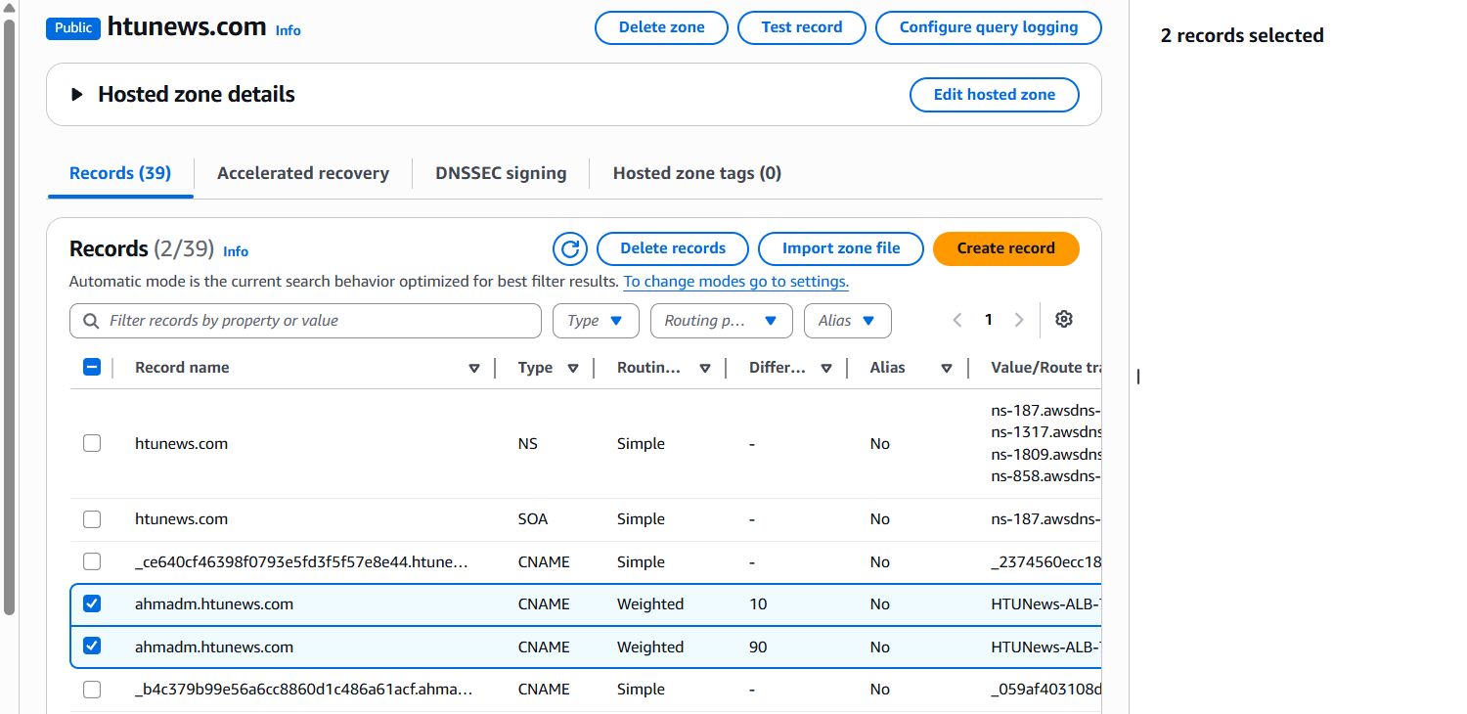

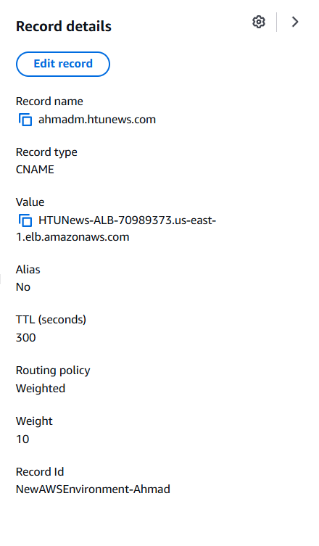
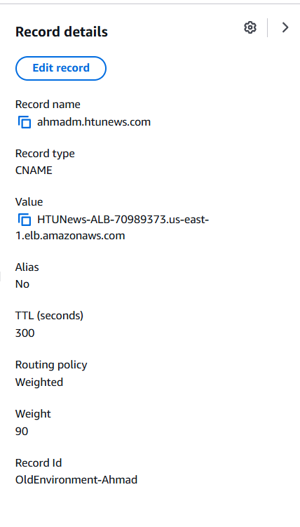

Task 5.3.2 — Request SSL Certificate via ACM
Step 1: Open ACM
ACM Console > Request certificate > Request a public certificate.

Step 2: Domain names
Enter: yourdomain.com and *.yourdomain.com (wildcard). Validation: DNS validation.

Step 3: Validate
Click 'Create records in Route 53' — ACM automatically adds CNAME validation records. Wait for status: Issued (typically 5–10 minutes).

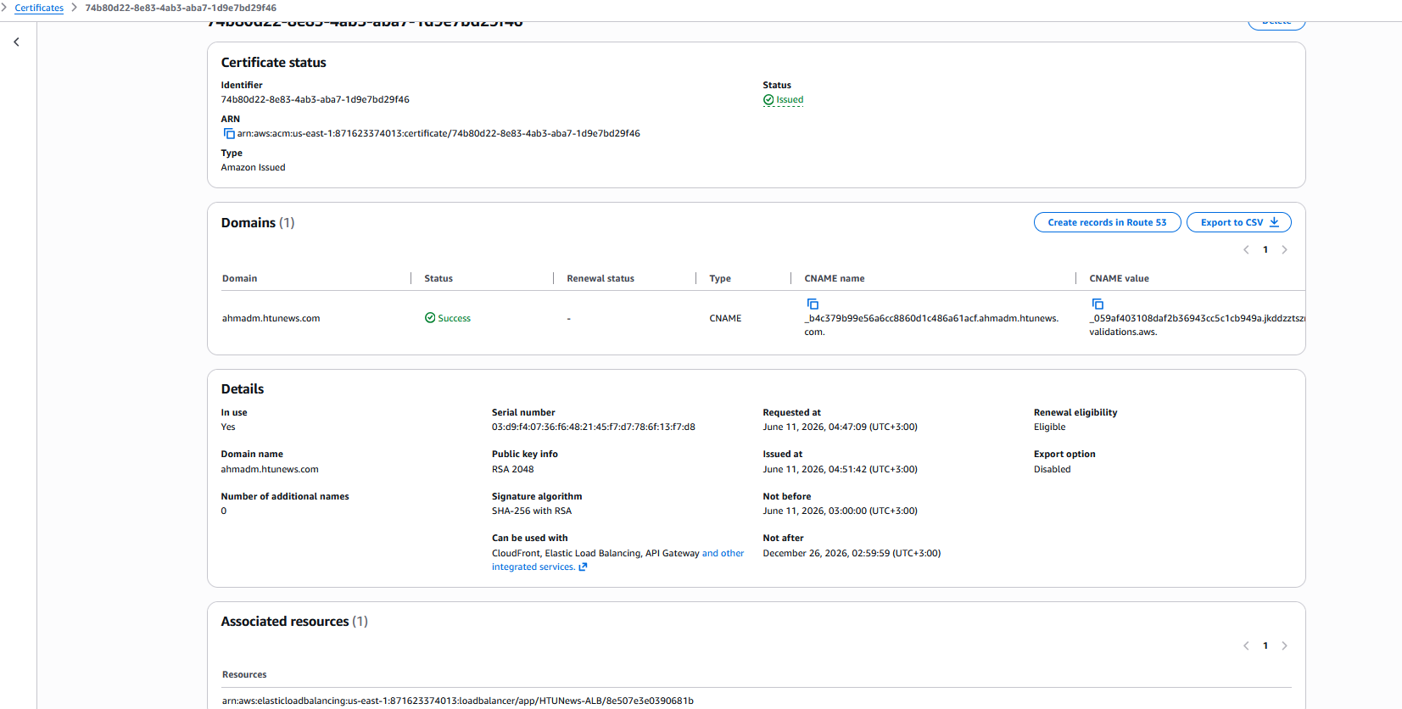

Task 5.3.3 — Add HTTPS Listener to ALB
Step 1: Add HTTPS listener
EC2 > Load Balancers > HTUNews-ALB > Listeners > Add listener. Protocol: HTTPS. Port: 443. Action: Forward to HTUNews-TG. SSL Certificate: select the ACM certificate. Security policy: ELBSecurityPolicy-TLS13-1-2-2021-06. Add.

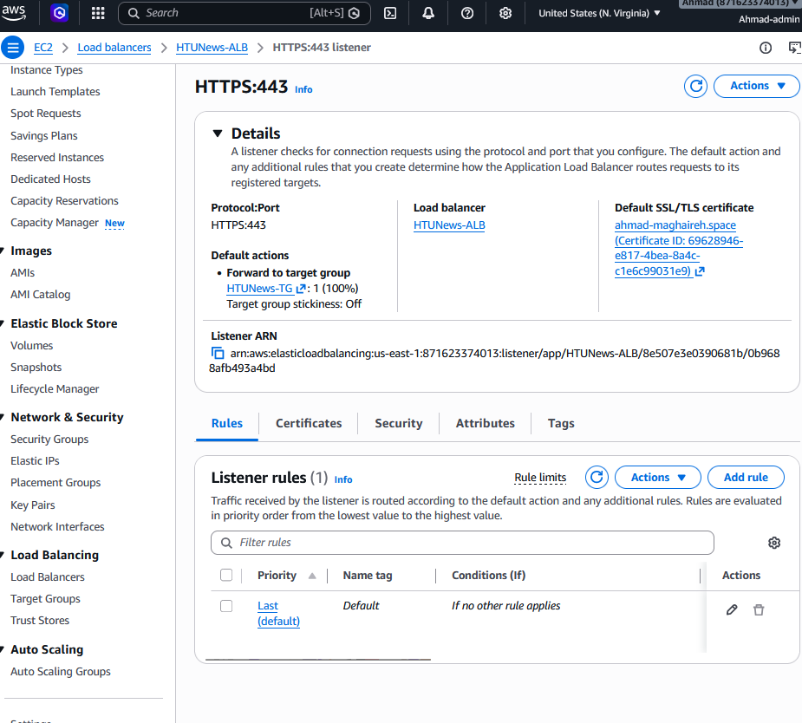

Step 2: Redirect HTTP to HTTPS
Edit the HTTP:80 listener. Default action: Redirect to HTTPS:443 (301 Permanent Redirect).

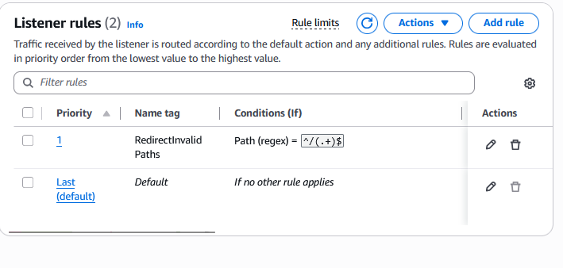

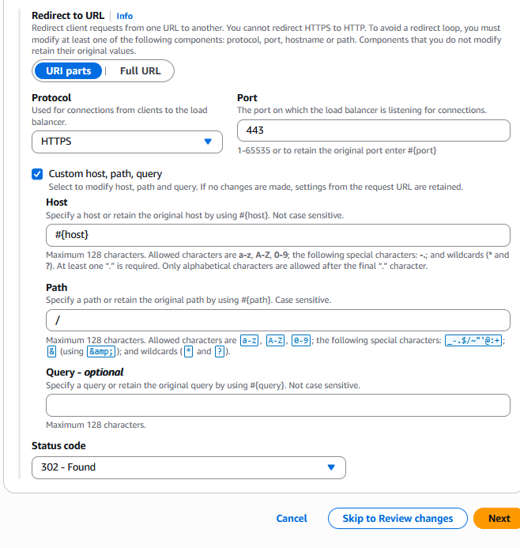

Back in the Listeners and rules tab, click the HTTP:80 listener.
Find the Default rule (last priority) → Click Edit.
Change the action from Forward to HTUNews-TG to:

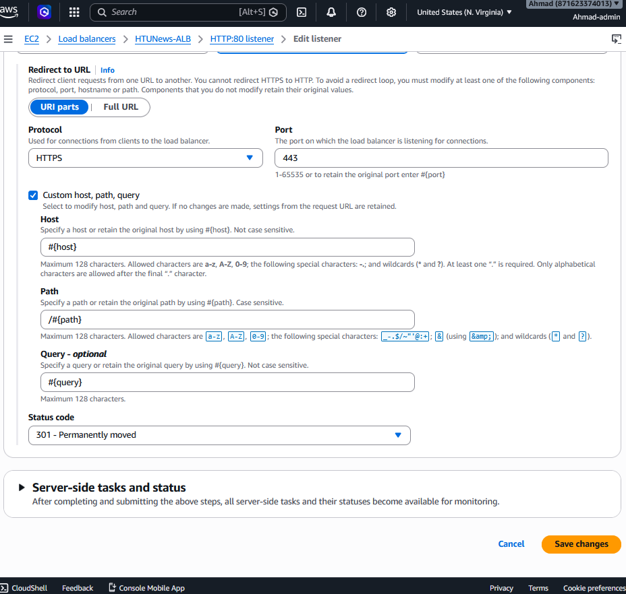
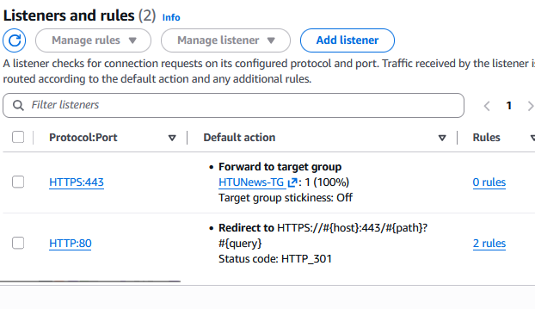
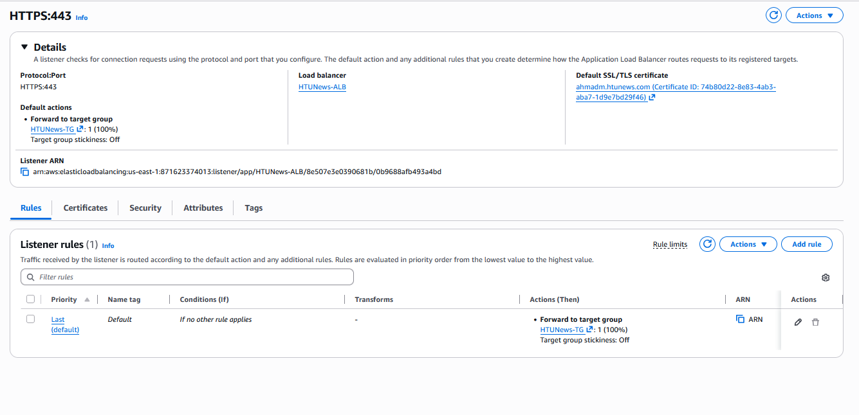

Task 5.3.4 — Configure Weighted DNS Records
Step 1: Record for old environment
Route 53 > Hosted zone > Create record. Name: . Type: A. Value: IP of old server. Routing policy: Weighted. Weight: 80. Record ID: OldEnvironment.

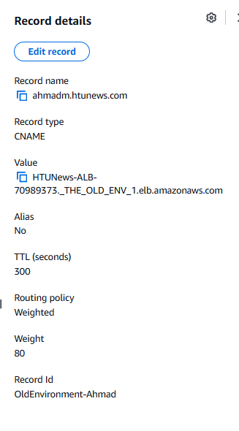

Step 2: Record for AWS ALB
Create another record. Name: Type: A — Alias. Alias to: ALB (select from dropdown). Routing policy: Weighted. Weight: 20. Record ID: NewAWSEnvironment.

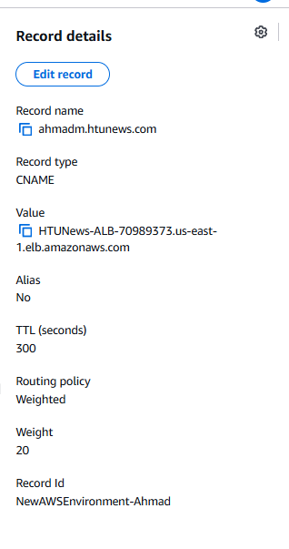

Step 3: Gradual migration
Adjust weights as testing progresses: 70/30 → 50/50 → 0/100 to complete migration.

Per the tutor's instruction, the implementation uses a subdomain of the shared course domain (ahmad.htunews.com). The hosted zone htunews.com is in the tutor's account; the ALB and ACM certificate are in the student's account. Because Route 53 Alias records cannot cross AWS accounts, a CNAME pointing to the ALB DNS name is used for the new-environment weighted record.

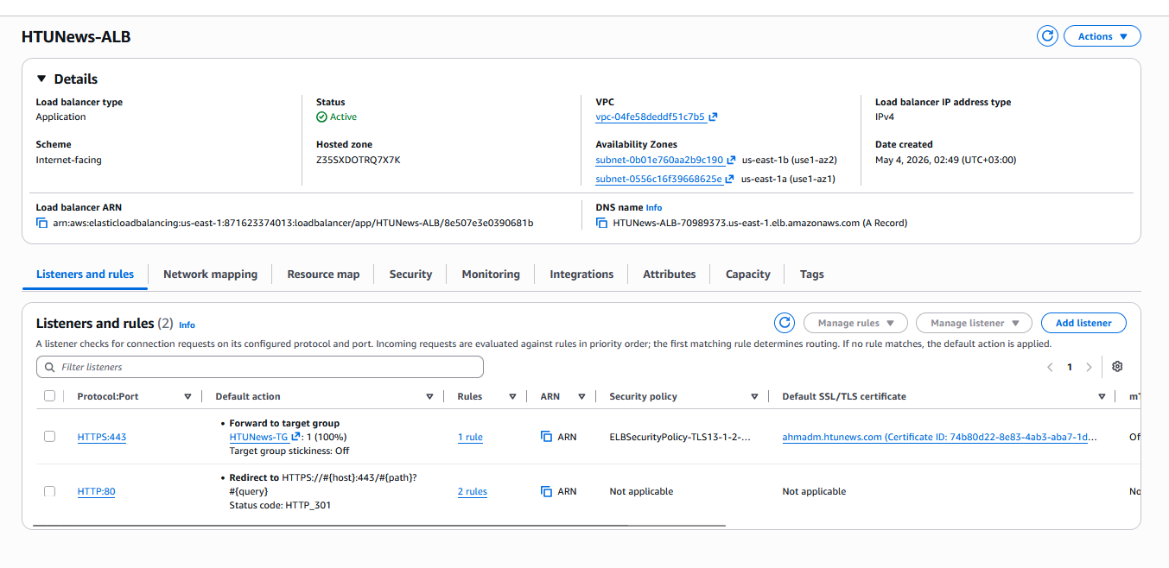

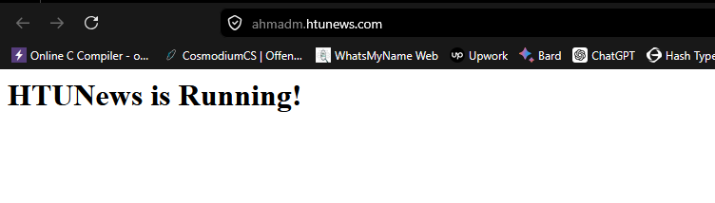

5.3.5 : Run the Load Test

Load Testing Validation
Apache Benchmark (ab) was used to validate the new AWS environment's performance under concurrent load.
Test 1: HTTP (Redirect Validation)
- Command: ab -n 500 -c 10 http://HTUNews-ALB-70989373.us-east-1.elb.amazonaws.com/
- Requests: 500 | Concurrency: 10 | Time: 0.086 seconds
- Requests/sec: 5,807.34 | Time per request: 1.722 ms (mean)
- Non-2xx responses: 500 (expected — HTTP:80 listener correctly redirects to HTTPS:443)
- Failed requests: 0

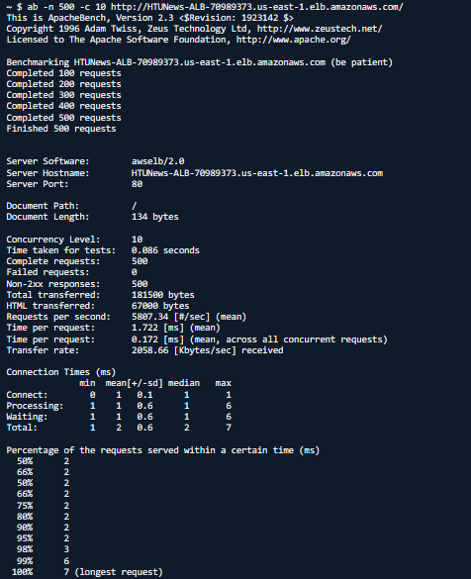

Test 2: HTTPS (Application Validation)
- Command: ab -n 500 -c 10 https://HTUNews-ALB-70989373.us-east-1.elb.amazonaws.com/
- Requests: 500 | Concurrency: 10 | Time: 0.578 seconds
- Requests/sec: 865.22 | Time per request: 11.558 ms (mean)
- Protocol: TLSv1.3 with AES-128-GCM
- All responses: HTTP 200 (OK), 28 bytes (the "HTUNews is Running!" HTML page)
- Failed requests: 0

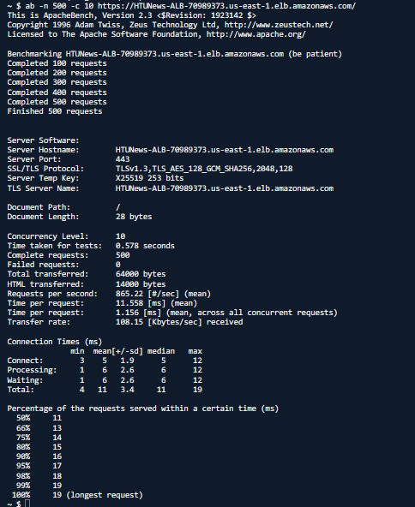

Interpretation:
The HTTPS endpoint handles 865 requests per second with an average latency of 11.6 ms, far exceeding the scenario's peak demand of approximately 22 requests per second (80,000 users per hour). The zero failure rate across 1,000 total requests (500 HTTP redirects + 500 HTTPS) confirms that:
- The ALB health checks correctly identify healthy instances
- The Auto Scaling group maintains sufficient capacity
- The application serves consistent responses under concurrent load
- TLS termination at the ALB does not introduce performance bottlenecks
Note on Environment Consistency:
The same application code (from https://github.com/AhmadM962/htunews-app.git) is deployed identically in both the new AWS environment and the simulated on-premise environment (represented by the placeholder IP 192.0.2.1 in Route 53 weighted routing). The Route 53 weighted routing configuration (90% old, 10% new) ensures that users receive identical content — the "HTUNews is Running!" page — regardless of which environment serves the request. This guarantees a seamless user experience during the phased migration, as the application logic, responses, and content are identical across environments. Only the underlying infrastructure differs, which is transparent to end users.

6.1 Architecture Overview
HTUNews has migrated its on-premise infrastructure to AWS using a phased approach. The architecture consists of five integrated layers:
Layer | Components | Purpose
Identity & Access | IAM Users, Groups, Custom Policies, MFA | Role-based access control ensuring least privilege for 9 users across 3 departments
Network & Security | VPC, Public/Private Subnets, Route Tables, NACLs, Security Groups, NAT Gateway | Isolated network with defense in depth; only the ALB is exposed to the internet
Compute & Scaling | Launch Template (t3.micro/t3.large), Auto Scaling Group, Application Load Balancer | Elastic compute that scales from 2 to 8 instances based on CPU utilization
Storage & Data Protection | S3 bucket with Lifecycle Policies, Versioning, Object Lock | Decoupled media storage with automated tiering and accidental deletion recovery
Observability & Delivery | CloudWatch Dashboards & Alarms, SNS Notifications, Route 53 Weighted Routing, ACM Certificate | Full operational visibility, proactive alerting, gradual traffic migration, encrypted communication

6.3 Analysis
Impact of Cloud Architecture on Availability, Scalability, and Fault Tolerance

Availability: The architecture achieves high availability through multi-AZ deployment. The ALB spans two public subnets across us-east-1a and us-east-1b. The ASG distributes EC2 instances across two private subnets in the same AZs. If one AZ fails entirely, the other continues serving traffic. The ALB health check (/ every 30 seconds with a 3-failure threshold) detects unhealthy instances within 90 seconds and routes traffic away. The ASG launches replacement instances automatically.

Scalability: Horizontal scaling is achieved through the ASG target tracking policy. At 80% average CPU utilization, a new instance is launched. With a maximum capacity of 8 instances, the platform can theoretically scale from 10,000 to 80,000 users per hour. The T3 burstable instance type provides additional vertical scaling headroom through CPU credit accumulation during low-traffic periods. Route 53 weighted routing adds deployment-level scalability — traffic can be gradually shifted between environments.

Fault Tolerance: Multiple layers of redundancy exist. The NAT Gateway is a single point of failure (acknowledged tradeoff for cost optimization) — failure of AZ-1 would cause private instances to lose outbound internet access but they would continue serving traffic through the ALB. S3 provides 99.999999999% durability through automatic cross-AZ replication. Versioning and Object Lock protect against data corruption and accidental deletion.

Secure and Scalable Network Architecture Following Best Practices
Defense in Depth: Security is implemented in layers. At the network edge, only ports 80 and 443 are exposed to the internet through the ALB Security Group. At the instance level, port 8080 accepts traffic exclusively from SG-ALB (security group reference, not a CIDR range). At the subnet level, NACLs provide stateless filtering as a secondary boundary. No inbound SSH is permitted — all administrative access uses SSM Session Manager, which is IAM-controlled and fully audited.

Least Privilege Networking: Public subnets contain only resources that require internet exposure (ALB, NAT Gateway). Private subnets contain application servers with no public IP addresses. Route tables enforce this separation: public subnets route to the Internet Gateway, private subnets route outbound only through the NAT Gateway. No direct path exists from the internet to EC2 instances.

Scalability by Design: The /16 CIDR (65,536 IPs) allows for significant future expansion. Additional subnets can be added without re-addressing. The ALB's cross-zone load balancing distributes traffic evenly regardless of per-AZ instance count. Security groups use source references rather than hardcoded IPs, so adding new services does not require rule updates.

Evaluation of Storage and Database Services
S3 Selection: S3 was selected over EBS (instance-attached, lost on ASG scale-in) and EFS (no native lifecycle tiering). The lifecycle policy automates cost optimization: Standard → Standard-IA at 30 days (45% cost reduction for infrequently accessed content) and → Glacier Instant Retrieval at 90 days (68% reduction for archival content). Versioning enables recovery from accidental deletion or overwrite. Object Lock in Governance mode provides 90-day retention protection with an auditable override path.

Database Note: Scenario 1 does not require a database service beyond S3 for media. Scenario 2 evaluates DynamoDB for appointment data (Section 7), providing the relational comparison expected in the criteria.

Automated Cloud Operations
Deployment Automation: The Launch Template includes a User Data script that automatically installs Node.js, clones the application from GitHub, configures systemd for process management, and starts the service — all without manual intervention. New instances launched by the ASG are production-ready within minutes.

Scaling Automation: The target tracking policy maintains 80% average CPU utilization. This triggers scale-out BEFORE performance degrades and scale-in when demand subsides. The 120-second warmup period prevents newly launched instances from skewing metrics before they are ready.

Recovery Automation: If an instance fails the ALB health check (3 consecutive failures over 90 seconds), it is marked unhealthy and traffic is routed away. The ASG terminates the unhealthy instance and launches a replacement. S3 versioning and Object Lock provide data recovery — deleted objects can be restored by removing the delete marker, and locked objects cannot be permanently deleted without authorized override.

6.4 Summary of Design Decisions
Decision | Selected Option | Primary Justification
Compute | t3.large (production) / t3.micro (implementation) | Burstable CPU matches news traffic pattern; free tier compliance during testing
Pricing | Reserved + On-Demand + Spot (optional) | 40% saving on baseline; flexibility for spikes
Network | VPC with public/private subnets, 2 AZs | Least privilege; fault tolerance; defense in depth
Load Balancer | Application Load Balancer | Layer 7 routing for path-based redirects and health checks
Storage | S3 with lifecycle policies | Decoupled from compute; automatic tiering; 11 nines durability
Data Protection | Versioning + Object Lock (Governance) | Recovery from accidental deletion; authorized override path
Access Control | IAM Groups + MFA for admins | Least privilege; centralized management; additional authentication layer
Instance Access | SSM Session Manager | No open inbound ports; IAM-controlled; audited sessions
DNS | Route 53 Weighted Routing | Gradual traffic migration; configurable weights
Encryption | ACM + HTTPS listener | Free auto-renewing certificates; TLS termination at ALB
Monitoring | CloudWatch Dashboard + SNS Alarms | Unified operational view; proactive capacity warning
Scaling | ASG Target Tracking 80% CPU | Automated; prevents CPU credit exhaustion on T3 instances

SCENARIO 2: HealthBooking Serverless System — AWS Serverless Architecture

HealthBooking is a web-based medical appointment booking platform being developed to allow patients to reserve time slots and administrators to manage appointments. The entire system uses a cloud-based serverless architecture, leveraging AWS-managed services to eliminate server provisioning, scaling concerns, and operational overhead.

Section 0: Data Design and Database Justification (DynamoDB)

0.1 Why DynamoDB for HealthBooking
Amazon DynamoDB is a fully managed, serverless NoSQL database service. It is the optimal choice for HealthBooking for the following reasons:
- Serverless alignment: DynamoDB requires no server provisioning, patching, or capacity planning — consistent with the overall serverless architecture mandate.
- Performance: Single-digit millisecond read/write latency at any scale, critical for responsive real-time booking.
- Scalability: DynamoDB scales read/write capacity automatically (on-demand mode) — matching Lambda's auto-scaling behaviour without manual intervention.
- Cost model: On-demand pricing charges per read/write request — no idle cost when the system has no traffic, ideal for a growing platform with variable usage.
- Event integration: DynamoDB Streams can trigger Lambda functions on data changes, enabling event-driven workflows (future enhancement).

Database Service | Type | Assessment for HealthBooking
Amazon DynamoDB | NoSQL (key-value / document) | IDEAL — serverless, millisecond latency, scales with Lambda, on-demand pricing
Amazon RDS (MySQL/PostgreSQL) | Relational SQL | NOT IDEAL — requires always-on EC2-style instances, not truly serverless, higher baseline cost
Amazon Aurora Serverless v2 | Relational SQL (serverless) | Viable alternative for complex relational queries, but DynamoDB is simpler for this appointment schema
Amazon ElastiCache | In-memory cache (Redis/Memcached) | Not a primary database — used for caching DynamoDB reads, not data storage

0.2 Table Design Analysis

Appointments Table — Updated Design
The Appointments table uses a a simple primary key (Partition Key only) as specified in the assignment brief:
Attribute | Type | Role / Justification
appointmentId | String | Partition Key — UUID generated at booking time. Uniquely identifies each appointment. Simple key design as per assignment brief.
createdAt | String | ISO 8601 timestamp. Used for display and audit.
patientName | String | Patient's full name for the appointment record and admin panel display.
slot | String | The booked time slot (e.g., '8 - 9'). Links to the Slots table for slot state management.
status | String | Appointment workflow state: Pending / In Progress / Completed. Updated by the PATCH endpoint.
symptoms | String | Patient-reported symptoms to provide clinical context before the appointment.

Slots Table
Attribute | Type | Role / Justification
slot | String | Partition Key — time slot label (e.g., '8 - 9', '9 - 10'). Direct O(1) lookup by slot. Updated atomically when a booking is made or reset.
isBooked | Boolean | Booking status flag. True = slot unavailable; False = available. Enables fast FilterExpression on Scan for the Get Time Slots API.

0.3 Daily Reset Data Access Pattern — Design Decision
The daily reset operation (Section 8) requires deleting all appointments created during the current day. DynamoDB's DeleteItem requires the partition key (and sort key if present) — it cannot delete by an arbitrary attribute alone. Two architectural solutions exist:

Solution | Approach | Efficiency | Cost
Option A: Full Table Scan | Scan entire Appointments table filtering by date, then batch delete | O(n) — scans all items regardless of date; slower at scale | Read capacity consumed for all items in table
Option B: Global Secondary Index (GSI) | Add GSI on date attribute; Query GSI to find today's items, then batch delete | O(k) where k = today's items; efficient | Additional GSI storage and read capacity cost
Option C: Composite Key (Selected) | Partition Key = date, Sort Key = appointmentId; Query by date returns all today's items directly | O(k) — Query operation; most efficient | No additional cost — uses base table

Selected Approach: Simple Primary Key (appointmentId only) — as provided in the instructor's code. The reset function uses a full table Scan to find and delete all appointments, which is acceptable for this system's scale.
"Justification: The simple primary key (appointmentId) follows the structure defined in the assignment brief (Table 3) and the provided application code. The daily reset performs a Scan of the Appointments table followed by a batch delete of all items. While a composite key with date as the partition key (Option C) would enable a more efficient Query at scale, the Scan approach is appropriate for HealthBooking's expected daily volume and keeps the table design aligned with the brief. The trade-off between Scan simplicity and Query efficiency is acknowledged; at significantly higher scale, adding a Global Secondary Index on a date attribute (Option B) is the recommended evolution path."

Updated Reset Lambda Logic
- Step 1: Scan and delete all current slots from the Slots table.
- Step 2: Re-insert the 5 default slots with isBooked = false.
- Step 3: Scan and delete all appointments from the Appointments table.
- Step 4: Publish reset confirmation to SNS.
NOTE: DynamoDB batch delete uses BatchWriteItem which supports up to 25 delete operations per call. For a typical day with more than 25 appointments, implement pagination over the batch delete calls.

Application Logic — Lambda Functions and API Gateway

7.1 Serverless Architecture Overview
Each backend operation is handled by a dedicated AWS Lambda function exposed through Amazon API Gateway (HTTP API). Lambda functions scale automatically from 1 to thousands of concurrent executions — matching HealthBooking's variable patient traffic without provisioning servers. Each function is independently deployable, which supports continuous delivery practices.

Function | HTTP Method | API Path | Lambda Handler | DynamoDB Operation
Get Time Slots | GET | /slots | getTimeSlotsHandler | Scan Slots where isBooked = false
Create Appointment | POST | /appointments | createAppointmentHandler | get_item availability check + PutItem (Appointments) + UpdateItem (Slots) + SNS Publish.
Get Appointments | GET | /appointments | getAppointmentsHandler | Scan all Appointments (admin panel)
Update Appointment Status | PATCH | /appointments/{appointmentId} | updateAppointmentHandler | UpdateItem by {appointmentId}
Reset Daily Bookings | EventBridge schedule | N/A (automated) | resetDailyBookingsHandler | Query by date + BatchDelete + Slots reset + SNS Publish

Architecture Overview
HealthBooking is a fully serverless medical appointment booking platform. Patients can book available time slots and administrators can manage appointments through a dashboard. All backend operations run on AWS-managed services — no servers are provisioned or maintained.

Request Flow
The end-to-end flow of a typical patient booking request:
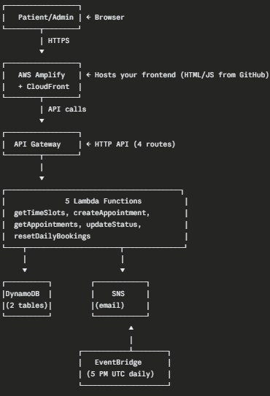

Services Used
Service | Purpose
AWS Amplify | Hosts frontend from GitHub with continuous deployment + CloudFront CDN
Amazon API Gateway | HTTP API exposing 4 REST endpoints
AWS Lambda | 5 serverless functions handling business logic
Amazon DynamoDB | NoSQL database — Appointments + Slots tables
Amazon SNS | Email notifications for bookings and daily reset
Amazon EventBridge | Cron-based scheduler for daily reset at 5 PM UTC
AWS CloudWatch | Monitoring dashboard and alarms
AWS IAM | Lambda execution role with DynamoDB + SNS + CloudWatch permissions

Implementation Order
The 9 phases must be done in order — each verifies the previous works:
- Phase 1 — DynamoDB tables (data layer)
- Phase 2 — IAM role (Lambda permissions)
- Phase 3 — SNS topic (email setup)
- Phase 4 — Lambda functions (5 functions, business logic)
- Phase 5 — API Gateway (HTTP API routes + CORS)
- Phase 6 — EventBridge schedule (daily automation)
- Phase 7 — CloudWatch (dashboard + alarms)
- Phase 8 — Amplify deployment (frontend from GitHub)
- Phase 9 — End-to-end testing

IMPORTANT: Before starting, find your AWS Account ID — click your username in the top-right of the AWS Console. You will need this 12-digit number to replace 'ACCOUNT_ID' in two Lambda functions (createAppointment and resetDailyBookings).

PHASE 1 — DynamoDB Tables

DynamoDB is a fully managed serverless NoSQL database.
We create two tables: Appointments and Slots — both using simple primary keys.
Task 1.1 — Create Appointments Table
Use a simple primary key (appointmentId only, no sort key) as specified in the provided code.

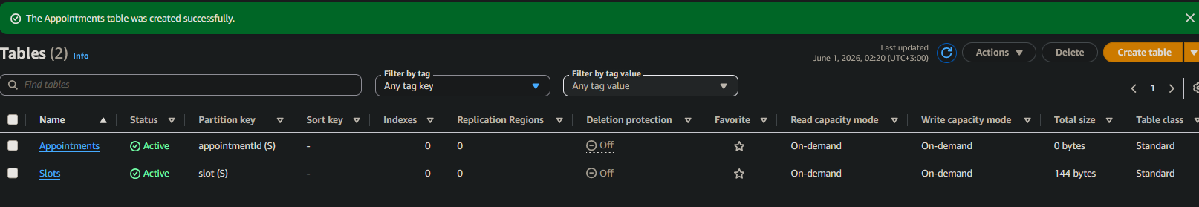

Step 1: Open DynamoDB
AWS Console > search 'DynamoDB' > Tables > Create table.
Step 2: Configure table
Table name: Appointments. Partition key: appointmentId (String). DO NOT add a sort key. Table settings: Customize settings. Capacity mode: On-demand.
Step 3: Create
Click 'Create table'. Wait until status shows Active.



Task 1.2 — Create Slots Table
Step 1: Create table
DynamoDB > Tables > Create table. Name: Slots. Partition key: slot (String). No sort key. Capacity mode: On-demand.
Step 2: Create
Click 'Create table'.

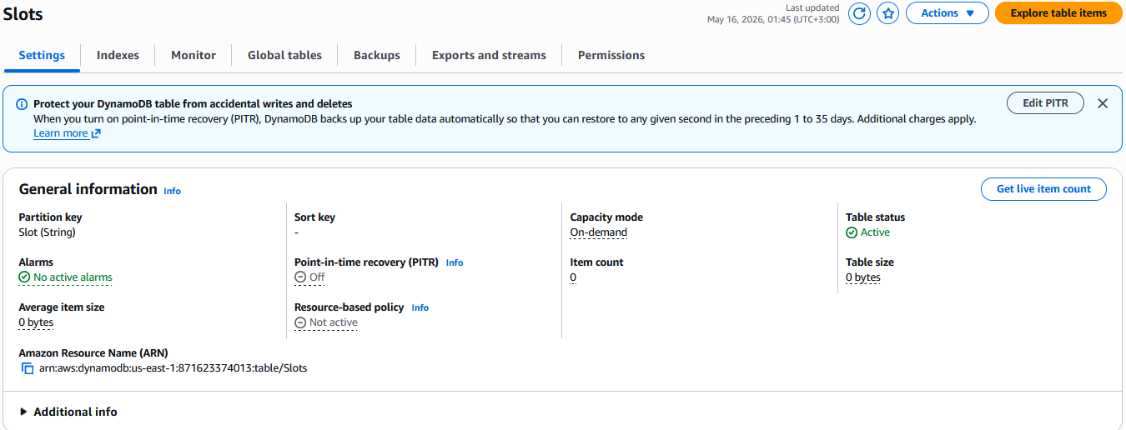

Task 1.3 — Seed Initial Slots Data
Manually populate the Slots table with 5 time slots matching the provided code.
Step 1: Open table items
Click 'Slots' table > Explore table items > Create item.
Step 2: Switch to JSON view
Top right of the form, click 'JSON view'. This makes it easier to enter Boolean values correctly.
Step 3: Add the first slot
Paste this JSON and click 'Create item':

Or using the form format is okay

{
"slot": {
"S": "8 - 9"
},
"isBooked": {
"BOOL": false
}
}
Step 4: Repeat for remaining 5 slots
Step 5: Verify
Click the back arrow to return to the items list. All 5 slots should appear, all with isBooked = false.
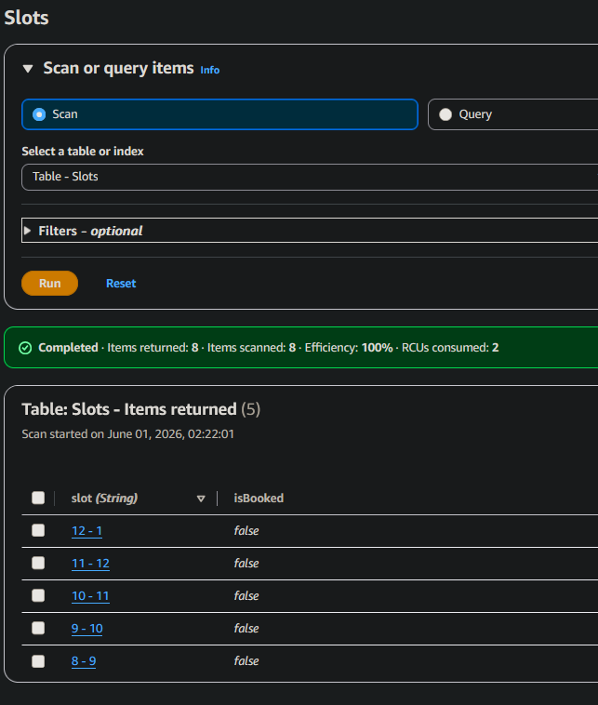

PHASE 2 — IAM Role for Lambda

Lambda functions need an execution role granting them permissions to access DynamoDB, publish to SNS, and write to CloudWatch Logs. One shared role works for all 5 functions.

Task 2.1 — Create the Execution Role
Step 1: Open IAM
IAM Console > Roles > Create role.
Step 2: Choose trusted entity
Trusted entity type: AWS service. Use case: Lambda. Click Next.
Step 3: Attach policies
Search for and attach all three of these AWS managed policies:
- AmazonDynamoDBFullAccess — Lambda can read/write DynamoDB
- AmazonSNSFullAccess — Lambda can publish notifications
- AWSLambdaBasicExecutionRole — Lambda can write logs to CloudWatch
Step 4: Name and create
Role name: HealthBooking-LambdaRole. Description: 'Execution role for HealthBooking Lambda functions'. Click Create role.

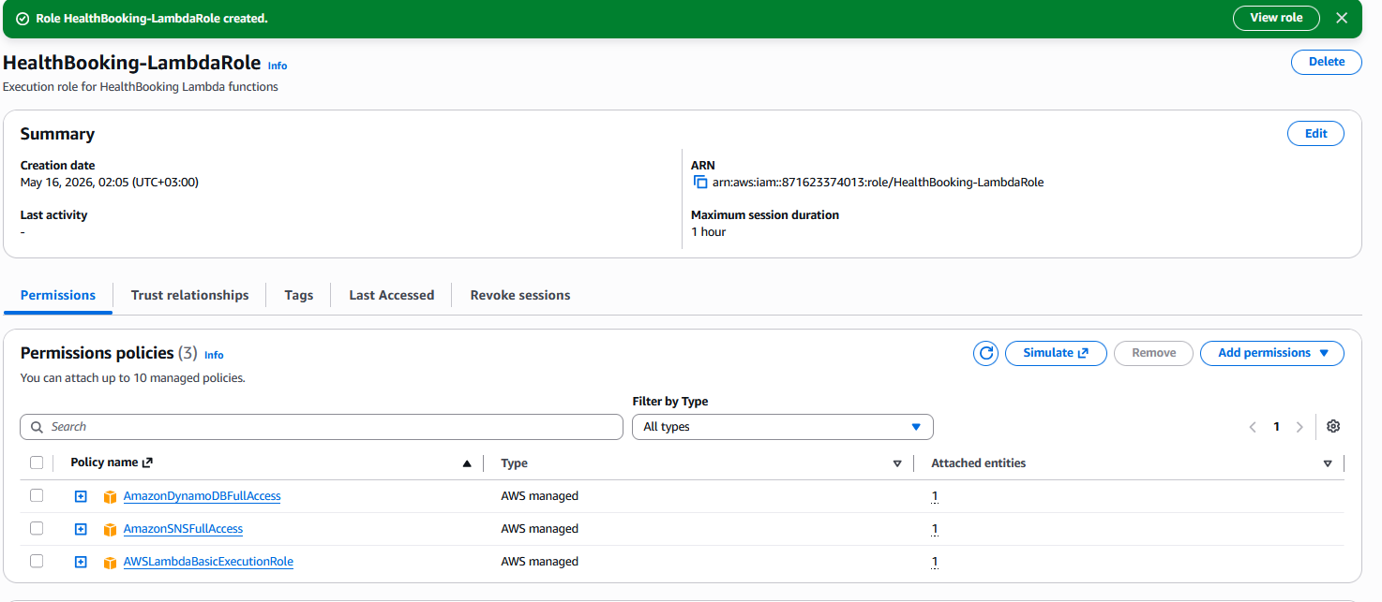

NOTE: For production, replace AmazonDynamoDBFullAccess and AmazonSNSFullAccess with custom policies scoped to only your specific tables and topic ARNs. Full-access policies are acceptable for assignments and proof-of-concept work, but violate least privilege in production.

PHASE 3 — SNS Topic for Notifications

SNS (Simple Notification Service) delivers email notifications when appointments are booked and when the daily reset runs. Create the topic first so Lambda functions can reference its ARN.

Task 3.1 — Create the SNS Topic
Step 1: Open SNS
SNS Console > Topics > Create topic.
Step 2: Configure
Type: Standard. Name: HealthBooking-Notifications. Leave all other defaults.
Step 3: Create
Click 'Create topic'.
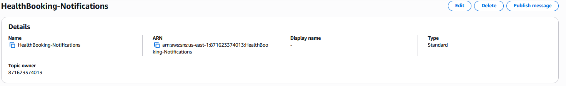

Task 3.2 — Copy the Topic ARN
arn:aws:sns:us-east-1:871623374013:HealthBooking-Notifications

Task 3.3 — Subscribe Your Email
Step 1: Create subscription
On the topic page, click 'Create subscription'.
Step 2: Configure
Protocol: Email. Endpoint: your email address.
Step 3: Confirm
Click 'Create subscription'. Then open your email inbox and click the 'Confirm subscription' link from AWS. Without this confirmation, you will NOT receive notifications.

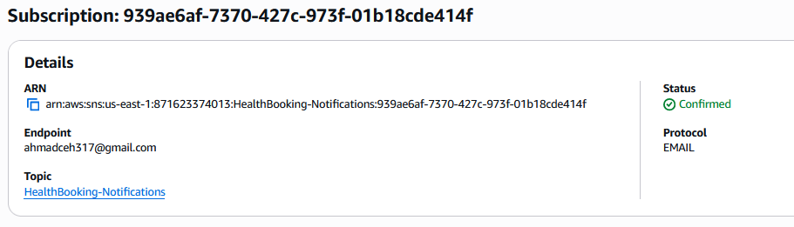

PHASE 4 — Lambda Functions (5 Functions)

Each business operation is a separate Lambda function. This follows the single-responsibility principle: each function does one thing, can be deployed independently, and scales independently.

Task 4.1 — Function 1: getTimeSlots
Returns all unbooked time slots. Called by the patient booking page to show available slots.
Step 1: Create function
Lambda Console > Create function. Author from scratch.
Step 2: Configure
Function name: getTimeSlots. Runtime: Python 3.12. Architecture: x86_64.
Step 3: Set execution role
Expand 'Change default execution role' > Use an existing role > select HealthBooking-LambdaRole. Click 'Create function'.
Step 4: Paste code
In the code editor, replace ALL existing code with:
import boto3 import json from decimal import Decimal dynamodb = boto3.resource('dynamodb') table = dynamodb.Table('Slots') class DecimalEncoder(json.JSONEncoder): def default(self, o): if isinstance(o, Decimal): return float(o) return super().default(o) def lambda_handler(event, context): try: response = table.scan( FilterExpression='isBooked = :false', ExpressionAttributeValues={':false': False} ) return { 'statusCode': 200, 'headers': { 'Access-Control-Allow-Origin': '*', 'Content-Type': 'application/json' }, 'body': json.dumps(response['Items'], cls=DecimalEncoder) } except Exception as e: return { 'statusCode': 500, 'headers': {'Access-Control-Allow-Origin': '*'}, 'body': json.dumps({'error': str(e)}) }
Step 5: Deploy
Click the orange 'Deploy' button.
Step 6: Test
Click 'Test' > Create new event > Event name: emptyTest > Event JSON: {} > Save. Then click 'Test' again. You should see a 200 response with all 5 slots in the body.

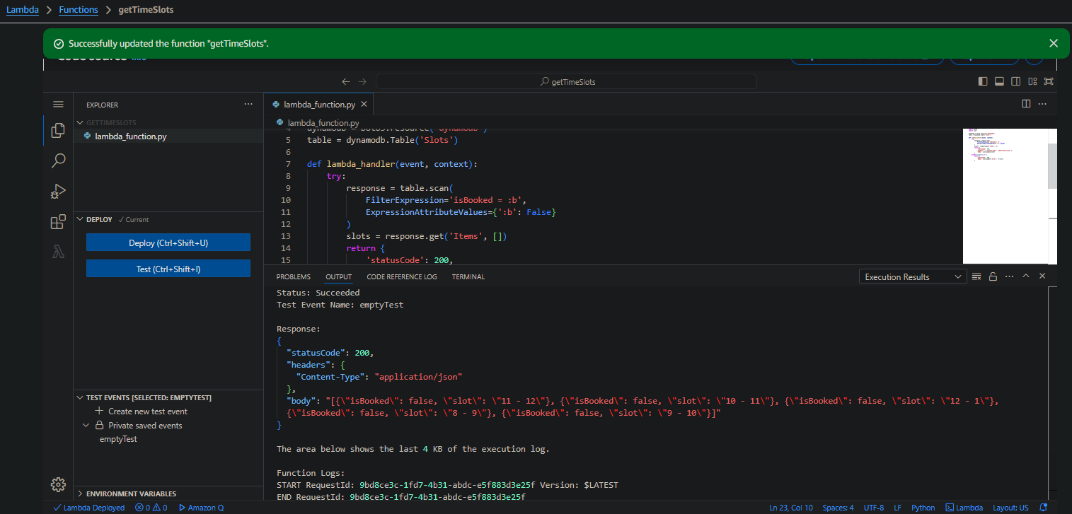

Task 4.2 — Function 2: createAppointment
Creates an appointment and marks the slot as booked. Checks slot availability using get_item before creating the appointment. Sends an SNS notification to the admin.
Step 1: Create function
Lambda > Create function. Name: createAppointment. Runtime: Python 3.12. Execution role: HealthBooking-LambdaRole.
Step 2: Paste code
Replace ALL code with the following. CRITICAL: Replace ACCOUNT_ID on the SNS_ARN line with your actual 12-digit AWS account ID:
Step 3: Deploy
Click Deploy.
Step 4: Test happy path
Create test event with this JSON (note the escaped quotes — the body is a JSON string inside JSON):
{ "body": "{\"slot\": \"8 - 9\", \"patientName\": \"Test Patient\", \"symptoms\": \"Headache\"}" }
Step 5: Run test
Click Test. You should see 201 status. Verify: Appointments table has the new item; Slots table shows 8 - 9 isBooked = true; you received an email notification.

createAppointment test result showing 201 success:

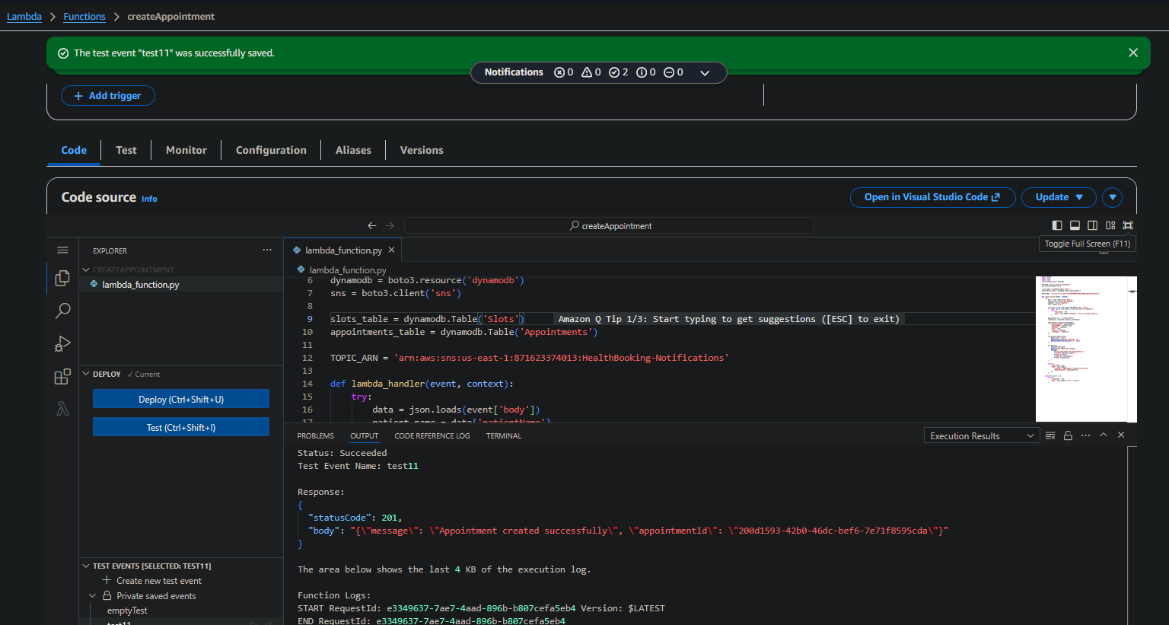

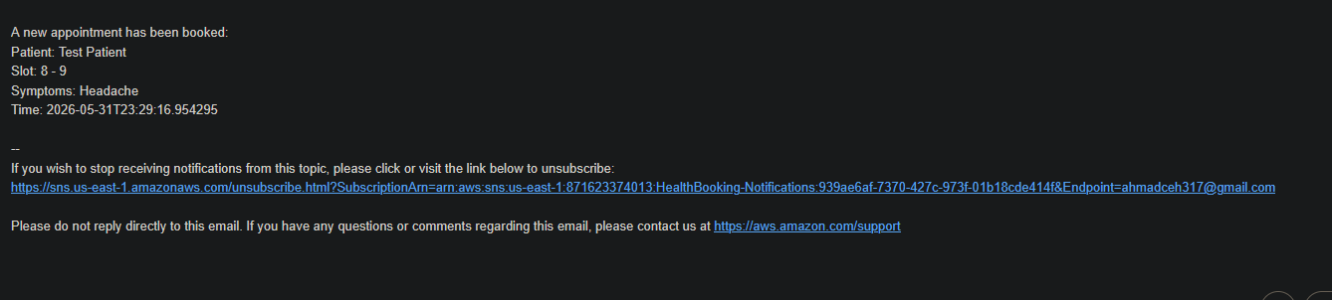

Step 6: Test race condition
Run the same test event again without changing anything. The second call returns 409 Conflict with 'Slot is already booked'. This confirms the availability check: the function reads the slot's isBooked status via get_item and rejects the booking if it is already taken. This check-then-write pattern is sufficient for HealthBooking's traffic. For a high-concurrency system, a DynamoDB ConditionExpression would add atomic protection against two simultaneous bookings of the same slot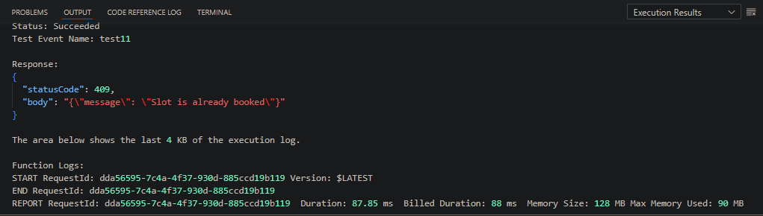

Task 4.3 — Function 3: getAppointments
Returns all appointments (for the admin panel).
Step 1: Create function
Lambda > Create function. Name: getAppointments. Runtime: Python 3.12. Execution role: HealthBooking-LambdaRole.
Step 2: Paste code
Replace ALL code
Step 3: Deploy and test
Deploy. Test with {} event. Should return your test appointment from Task 4.2.

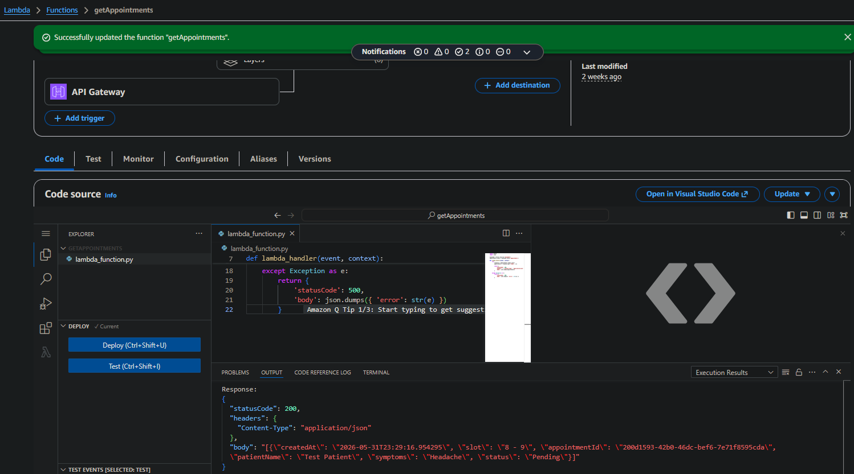

Task 4.4 — Function 4: updateAppointmentStatus
Updates the status of an appointment (Pending → In Progress → Completed). Called by the admin panel.
Step 1: Create function
Lambda > Create function. Name: updateAppointmentStatus. Runtime: Python 3.12. Execution role: HealthBooking-LambdaRole.
Step 2: Paste code
Replace ALL code
Step 3: Deploy
Click Deploy.
Step 4: Test
Get an appointmentId and date from the Appointments table. Use this test event (replace the ID and date):
{ "pathParameters": { "appointmentId": "PASTE-YOUR-APPOINTMENT-ID-HERE" }, "body": "{\"status\": \"In Progress\"}" }
Step 5: Run test
Should return 200. Check the Appointments table — status field has changed.

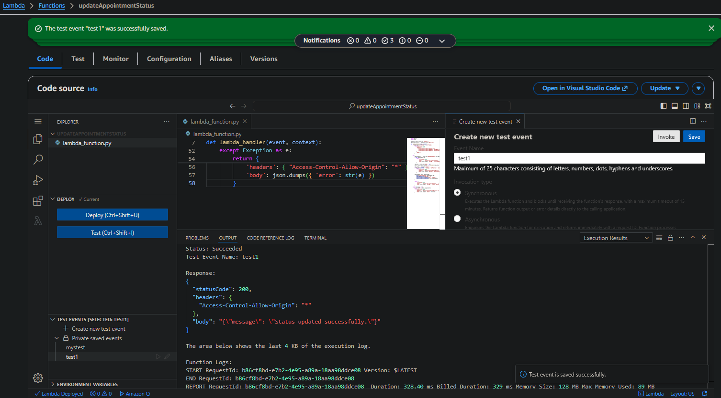

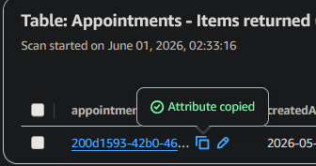

Task 4.5 — Function 5: resetDailyBookings
Performs the automated daily cleanup. Deletes all slots and re-inserts the 5 default slots. Deletes all appointments. Sends an SNS confirmation email.
Step 1: Create function
Lambda > Create function. Name: resetDailyBookings. Runtime: Python 3.12. Execution role: HealthBooking-LambdaRole.
Step 2: Increase timeout
BEFORE editing code: click Configuration tab > General configuration > Edit > Timeout: 1 min (60 sec) > Save. Default 3-second timeout is too short for batch operations.
Step 3: Paste code
Back to Code tab. Replace ALL code with the following. CRITICAL: Replace ACCOUNT_ID:
Step 4: Deploy
Click Deploy.
Step 5: Test
Make sure at least one test appointment exists for today (use createAppointment if needed). Then run resetDailyBookings with {} event. Verify: Appointments table empty; all 5 slots show isBooked = false; email received.
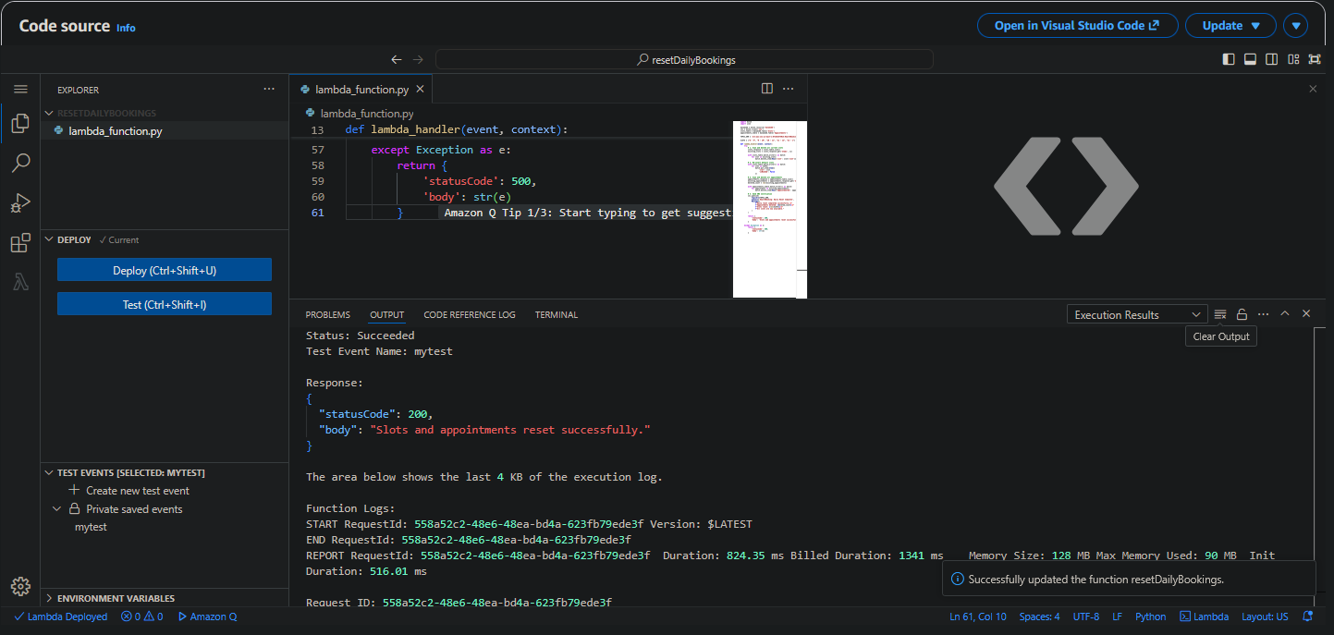
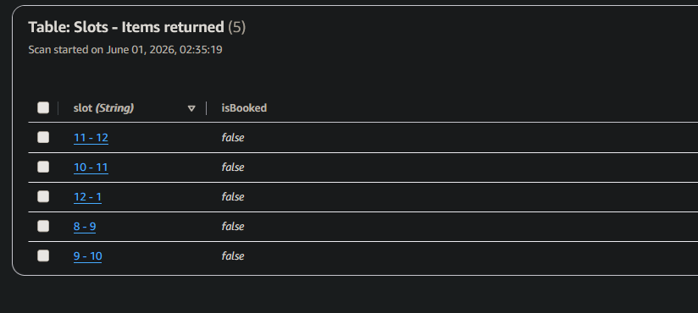
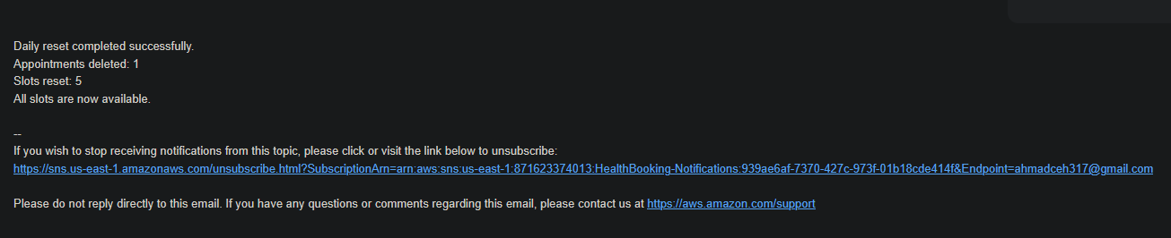

Phase 4 Verification
Open the Lambda console. You should see all 5 functions listed.

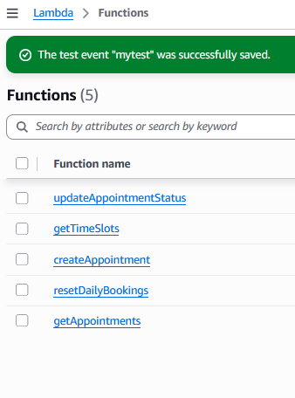

PHASE 5 — API Gateway (HTTP API)

API Gateway exposes the Lambda functions as HTTP endpoints. We use HTTP API (not REST API) because it is simpler, cheaper, and faster — appropriate for this use case.

Task 5.1 — Create the HTTP API
Step 1: Open API Gateway
API Gateway Console > Create API.
Step 2: Choose HTTP API
Under 'HTTP API', click Build (not REST API).
Step 3: Add first integration
Click 'Add integration' > Lambda. Lambda function: getTimeSlots. Version: 2.0.
Step 4: Configure
API name: HealthBooking-API. Click Next.
Step 5: Configure first route
Method: GET. Resource path: /slots. Integration target: getTimeSlots. Click Next.
Step 6: Stage
Stage name: prod. Auto-deploy: enabled (default). Click Next.
Step 7: Create
Review and click Create.

Task 5.2 — Add the Remaining 3 Routes
Click 'Routes' in the left sidebar. Create each route below and attach its Lambda integration:
Method | Path | Lambda Integration
GET | /slots | getTimeSlots (already done in 5.1)
POST | /appointments | createAppointment
GET | /appointments | getAppointments
PATCH | /appointments/{appointmentId} | updateAppointmentStatus

Step 1: Create route
Click Create. Select method, type the path. Click Create.
Step 2: Attach integration
Click the new route. Click 'Attach integration' > Create and attach an integration. Integration type: Lambda function. Select the right Lambda. Version: 2.0. Create.
Step 3: Repeat
Do this for POST /appointments, GET /appointments, and PATCH /appointments/{appointmentId}.
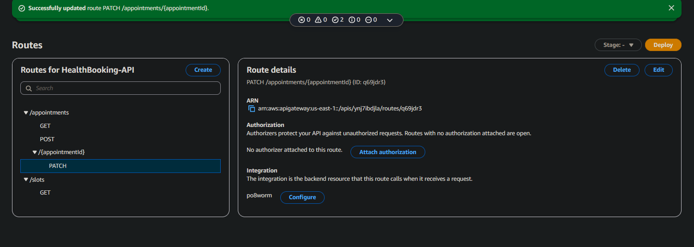

Task 5.3 — Configure CORS
CORS (Cross-Origin Resource Sharing) allows the frontend (different domain) to call the API. Without it, the browser blocks all requests.
Step 1: Open CORS settings
Left sidebar > CORS > Configure.
Step 2: Configure values
Access-Control-Allow-Origin: * (we will tighten this later). Access-Control-Allow-Headers: * (or 'content-type,authorization'). Access-Control-Allow-Methods: GET, POST, PATCH, OPTIONS. Access-Control-Max-Age: 3600.
Step 3: Save
Click Save.

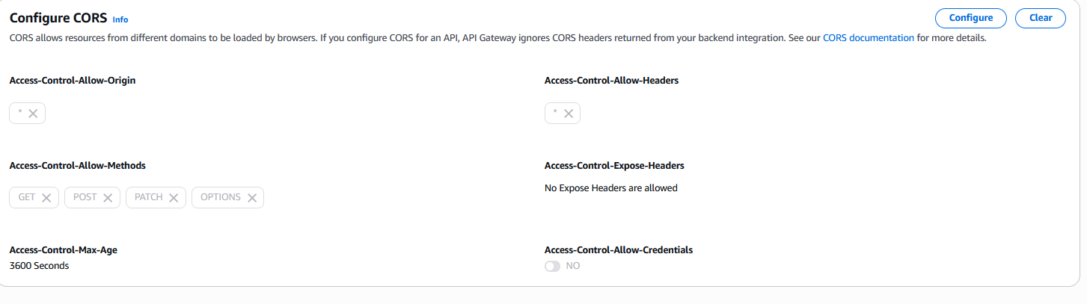

Task 5.4 — Get the Invoke URL
Step 1: Open stages
Left sidebar > Stages > click 'prod'.
Step 2: Copy invoke URL
Copy the Invoke URL (e.g., https://abc123xyz.execute-api.us-east-1.amazonaws.com). Save it in a notes file — you will paste it into the frontend HTML in Phase 8.

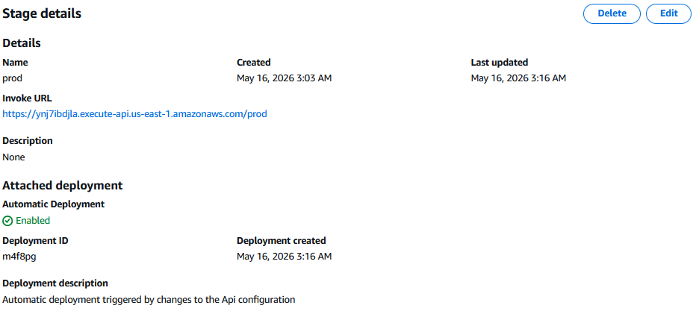

https://ynj7ibdjla.execute-api.us-east-1.amazonaws.com/prod

Task 5.5 — Test from Browser
Step 1: Open the slots endpoint
Step 2: Verify
You should see a JSON array of available slots displayed in the browser. This confirms API Gateway > Lambda > DynamoDB are all wired correctly.

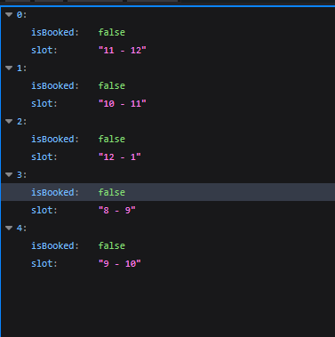

PHASE 6 — EventBridge Schedule

The daily reset at 5:00 PM UTC requires three automated actions: (1) delete all appointments created that day, (2) reset all time slots to available, (3) send a confirmation notification. Amazon EventBridge provides serverless, cron-based scheduling without managing any server infrastructure.

Component | Role in Automated Daily Reset
EventBridge Rule (cron schedule) | Triggers at 17:00 UTC daily. Cron expression: cron(0 17 * * ? *)
Lambda: resetDailyBookings | Scans the Appointments table and batch-deletes all items, deletes and re-creates the 5 default Slots, then publishes an SNS confirmation
DynamoDB Appointments | Source of records to delete — all items removed via Scan + BatchWrite
DynamoDB Slots | All isBooked attributes reset to false, making all slots available for the next day
SNS: HealthBooking-Notifications | Sends email confirming daily reset completed, including count of appointments cleared
CloudWatch Logs | Logs Lambda execution output for audit and debugging of the reset operation

Task 6.1 — Create the Scheduled Rule
Step 1: Open EventBridge
AWS Console > Amazon EventBridge > Rules > Create rule. (You may also use 'Schedules' under EventBridge Scheduler — both work.)
Step 2: Name
Name: HealthBooking-DailyReset. Description: 'Daily reset of appointments and slots at 5 PM UTC'. Event bus: default. Rule type: Schedule.
Step 3: Schedule pattern
Occurrence: Recurring schedule. Schedule type: Cron-based schedule. Cron expression: 0 17 * * ? *. Timezone: UTC. Flexible time window: Off.

NOTE: AWS cron syntax has 6 fields (minute hour day-of-month month day-of-week year). 'cron(0 17 * * ? *)' means: at minute 0 of hour 17 (17:00 = 5 PM), any day, any month, any day-of-week, any year. The '?' is required in either day-of-month or day-of-week — you cannot specify both.

Step 4: Set target
Target type: AWS service. Target: Lambda function. Function: resetDailyBookings.
Step 5: Permissions
Click Next. EventBridge automatically creates an IAM role to invoke the Lambda.
Step 6: Create
Click Next > Create rule (or 'Create schedule').

Task 6.2 — Verify Next Invocation Time
After creation, the rule page shows the next invocation time. It should be today at 17:00 UTC (or tomorrow if you created it after 5 PM UTC today).

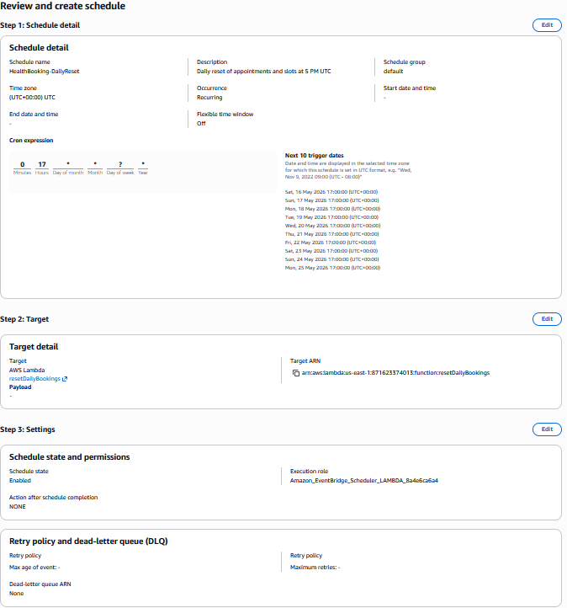
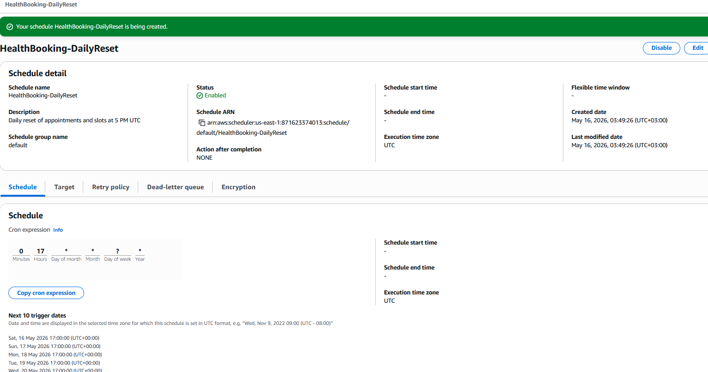

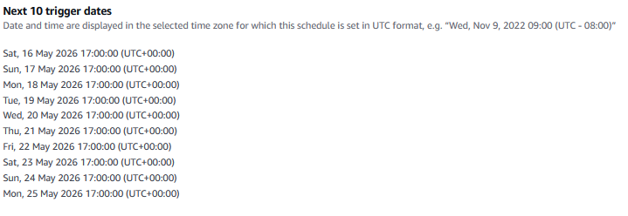
TIP: To save AWS costs after the assignment, disable the schedule (don't delete — keep it for the viva): EventBridge > Schedules > HealthBooking-DailyReset > Disable. The Lambda won't run automatically anymore.

PHASE 7 — CloudWatch Monitoring

Serverless systems require different monitoring approaches than traditional servers. Key metrics span Lambda execution, API Gateway traffic, and DynamoDB database operations:
Service | Key Metrics | What to Watch For
Lambda (all functions) | Invocations, Errors, Duration (ms), Throttles, ConcurrentExecutions | Error spikes indicate bugs; high Duration indicates slow DynamoDB or logic issues; Throttles indicate Lambda concurrency limits reached
API Gateway | Count, 4XXError, 5XXError, Latency | 4XX errors indicate client issues (bad requests, slot conflicts); 5XX errors indicate Lambda failures; high latency indicates DynamoDB slowness
DynamoDB | ConsumedReadCapacity, ConsumedWriteCapacity, SuccessfulRequestLatency, SystemErrors | Latency spikes indicate DynamoDB hot partitions; SystemErrors indicate service-level issues
EventBridge | SuccessfulInvocations, FailedInvocations (daily reset rule) | Failed invocations mean the daily reset did not run — critical to detect before the next booking day
SNS | NumberOfMessagesSent, NumberOfMessagesFailed | Failed messages mean booking confirmations or reset notifications were not delivered

9.2 Step-by-

Task 7.1 — Create the Monitoring Dashboard
Step 1: Open CloudWatch
CloudWatch Console > Dashboards > Create dashboard.
Step 2: Name
Name: HealthBooking-Dashboard. Click Create.

Widget 1: Lambda Health
Step 1: Add widget
Add widget > Line.
Step 2: Select metrics
Metrics > Lambda > By Function Name. Check all 5 HealthBooking functions.
Step 3: Choose metrics
For each function select: Invocations, Errors, Duration.
Step 4: Create widget
Label: 'Lambda Function Health'. Period: 1 minute. Create widget.

Widget 2: API Gateway Traffic
Step 1: Add widget
Add widget > Line.
Step 2: Select metrics
Metrics > ApiGateway > By API Name. Select HealthBooking-API.
Step 3: Choose metrics
Select: Count, 4xx, 5xx, Latency.
Step 4: Create
Label: 'API Gateway Traffic'. Create widget.

Widget 3: DynamoDB Operations
Step 1: Add widget
Add widget > Line.
Step 2: Select metrics
Metrics > DynamoDB > Table Metrics. Select both Appointments and Slots.
Step 3: Choose metrics
Select: ConsumedReadCapacityUnits, ConsumedWriteCapacityUnits, SuccessfulRequestLatency.
Step 4: Create
Label: 'DynamoDB Operations'. Create widget.

Widget 4: EventBridge Reset Status
Step 1: Add widget
Add widget > Number.
Step 2: Select metrics
Metrics > Events > By Rule Name > HealthBooking-DailyReset.
Step 3: Choose metrics
Select: Invocations, FailedInvocations.
Step 4: Create
Label: 'Daily Reset Status'. Create widget.
Step 5: Save dashboard
Click 'Save dashboard' at the top.

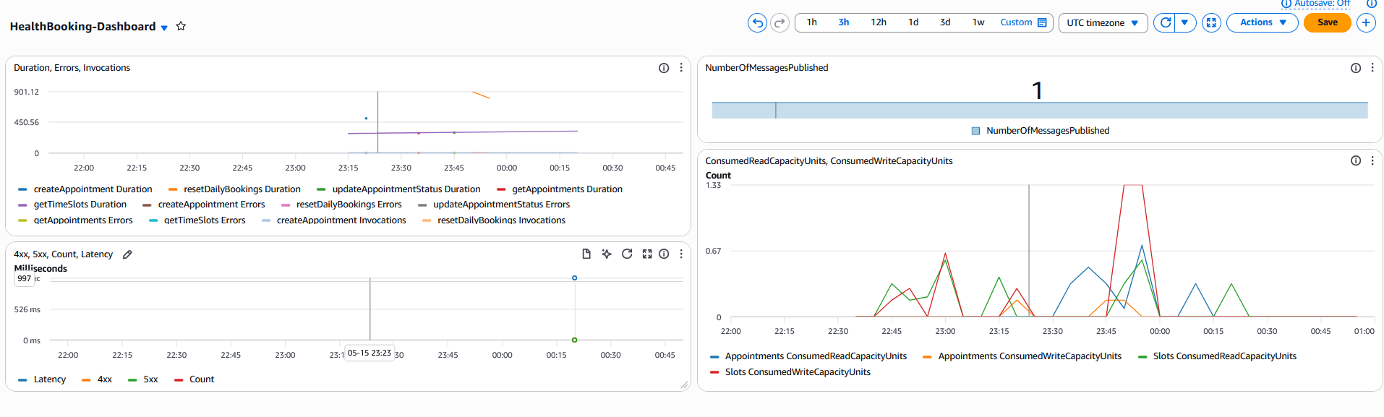

Task 7.2 — Create Critical Alarms
Three CloudWatch alarms detect failures across the system and send email alerts via SNS.

Alarm 1: Lambda Errors on createAppointment
Step 1: Create alarm
CloudWatch > Alarms > Create alarm.
Step 2: Select metric
Select metric > Lambda > By Function Name > createAppointment > Errors. Click 'Select metric'.
Step 3: Set threshold
Period: 1 minute. Threshold type: Static. Condition: Greater/Equal, value 1 (any error triggers).
Step 4: Configure action
Next. In alarm state: send notification to existing SNS topic > HealthBooking-Notifications.
Step 5: Name
Name: HealthBooking-Lambda-Errors. Description: Alerts when createAppointment fails. Create alarm.
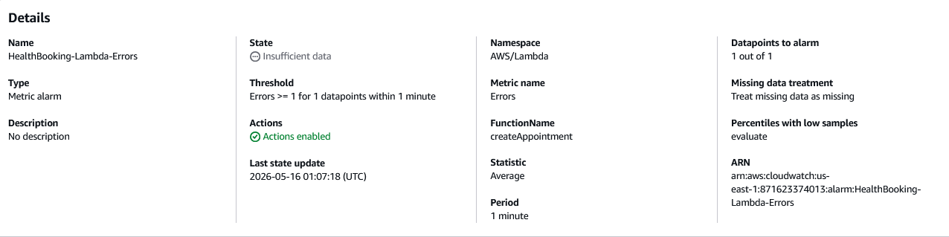

Alarm 2: EventBridge Reset Failure
Step 1: Create alarm
Same flow. Metric: Events > By Rule Name > HealthBooking-DailyReset > FailedInvocations.
Step 2: Threshold
Condition: Greater/Equal, value 1.
Step 3: Action and name
Action: HealthBooking-Notifications. Name: HealthBooking-ResetFailure.
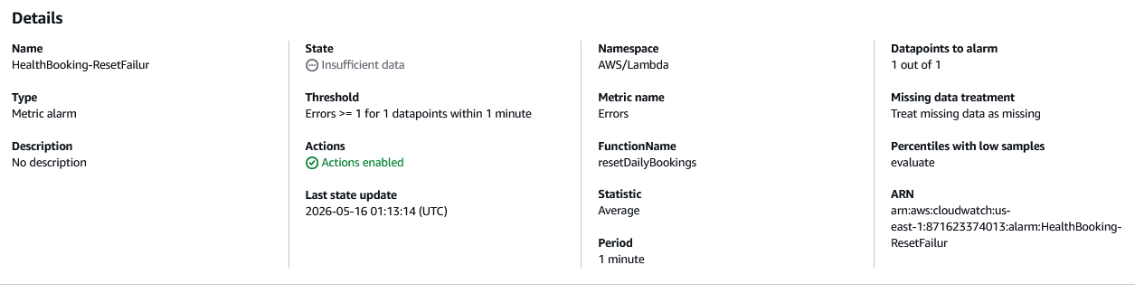

Alarm 3: API 5XX Errors
Step 1: Create alarm
Metric: ApiGateway > By API Name > HealthBooking-API > 5xx.
Step 2: Threshold
Period: 5 minutes. Condition: Greater/Equal, value 5 (5 or more 5xx errors in 5 minutes).
Step 3: Action and name
Action: HealthBooking-Notifications. Name: HealthBooking-API-5XX.
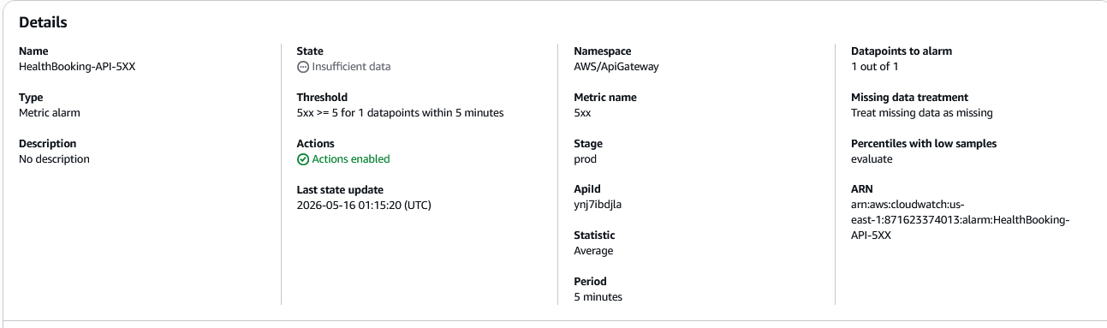

PHASE 8 — Frontend Deployment (AWS Amplify)

AWS Amplify Hosting provides continuous deployment from a GitHub repository. Every push to the connected branch automatically triggers a build and deployment pipeline. This eliminates all manual deployment steps and ensures users always access the latest version of the application without intervention.

Amplify Feature | Benefit for HealthBooking
GitHub continuous deployment | Every git push triggers automatic rebuild and deployment — zero manual steps
Amazon CloudFront CDN integration | Built-in global CDN with 450+ edge locations worldwide; content served from location nearest to each patient
HTTPS by default | Free ACM certificate provisioned automatically; all traffic encrypted
Custom domain support | Connect healthbooking.com; Amplify handles DNS records and certificate attachment
Branch preview environments | Automatic preview deployments for pull requests enable testing before merging to main
Environment variables | Store API Gateway URL and other config securely — not hardcoded in frontend code

Software-Defined Networking (SDN) Principles in CloudFront

AWS CloudFront implements SDN principles by abstracting physical network infrastructure behind a software-managed control plane:
- Programmable routing: CloudFront's control plane continuously evaluates network conditions across 450+ PoPs and routes each user request to the optimal edge location based on latency, availability, and capacity — decisions made in software, not by static routing tables.
- Global policy enforcement: Cache behaviours, security headers, CORS policies, and redirect rules are defined as configuration that propagates globally across all edge locations within minutes — the physical network is invisible to the application developer.
- Origin Shield: An optional intermediate caching layer (a software-defined regional cache tier) consolidates requests from all edge locations before hitting the Amplify origin, reducing origin load and improving cache efficiency.
- AWS Global Accelerator (optional): Routes API Gateway calls through AWS's private backbone network rather than the public internet, reducing latency for patients in regions far from the us-east-1 API Gateway endpoint.
- These SDN principles — programmable control, abstracted infrastructure, and centralised policy — deliver consistent low-latency performance for patients globally without any network hardware management.

Task 8.1 — the Frontend File
Fork the HealthBooking-Public GitHub repository to your own account. Clone it locally. Edit the API URLs in views/BookAppointment.vue and views/AppointmentsList.vue — replace the instructor's API URL with your API Gateway URL. Commit and push.

PHASE D — Frontend: Fork, Update, Deploy
Step D1 — Fork the Instructor's Repo
- Go to the instructor's GitHub repo for HealthBooking-Public
- Click Fork (top right)
- Fork to your own GitHub account
- You now have https://github.com/YOUR_USERNAME/HealthBooking-Public
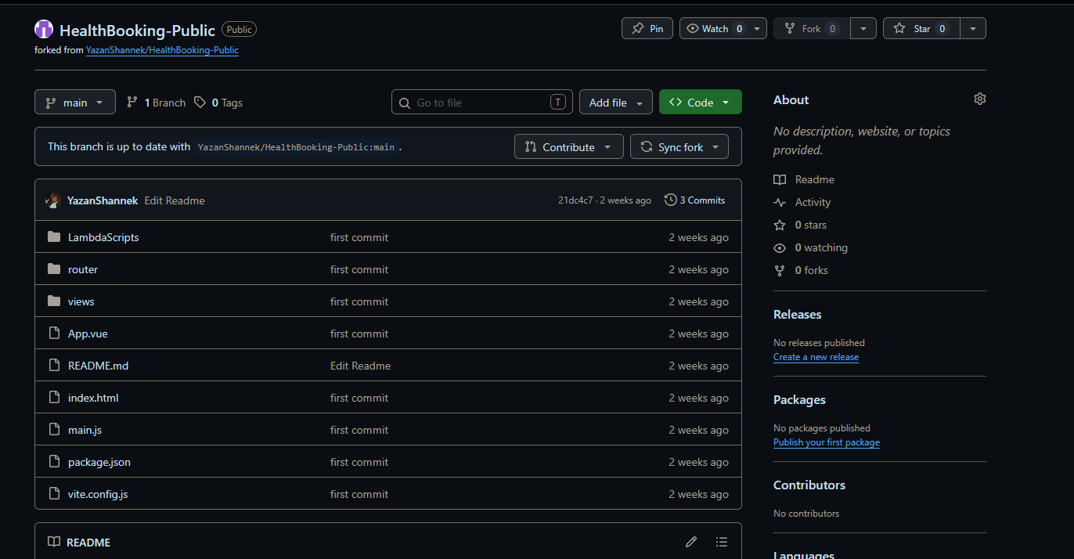
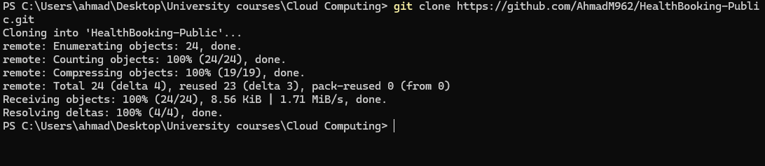

Step D2 — Clone Your Fork Locally
Open a terminal on your computer:

git clone https://github.com/USERNAME/HealthBooking-Public.git
cd HealthBooking-Public

Step D3 — Update API URLs in BookAppointment.vue
Open views/BookAppointment.vue in a text editor (Notepad, VS Code, etc.).
Find these two lines (they appear inside the <script> section):
https://e2m2b7y8c9.execute-api.us-east-1.amazonaws.com/prod/slots
https://e2m2b7y8c9.execute-api.us-east-1.amazonaws.com/prod/appointments
Replace BOTH with your API URL:
https://ynj7ibdjla.execute-api.us-east-1.amazonaws.com/prod/slots
https://ynj7ibdjla.execute-api.us-east-1.amazonaws.com/prod/appointments

Save the file.

Step D4 — Update API URLs in AppointmentsList.vue
Open views/AppointmentsList.vue.
Find these lines:
https://e2m2b7y8c9.execute-api.us-east-1.amazonaws.com/prod/appointments
https://e2m2b7y8c9.execute-api.us-east-1.amazonaws.com/prod/appointments/${appointment.appointmentId}
Replace BOTH with:
https://ynj7ibdjla.execute-api.us-east-1.amazonaws.com/prod/appointments
https://ynj7ibdjla.execute-api.us-east-1.amazonaws.com/prod/appointments/${appointment.appointmentId}

Save the file.

Step D5 — Commit and Push
git add .
git commit -m "Update API URLs to my API Gateway endpoints"
git push

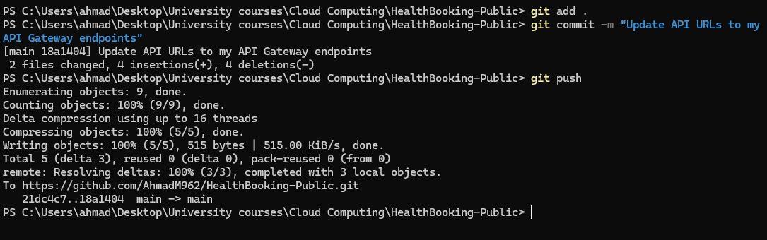

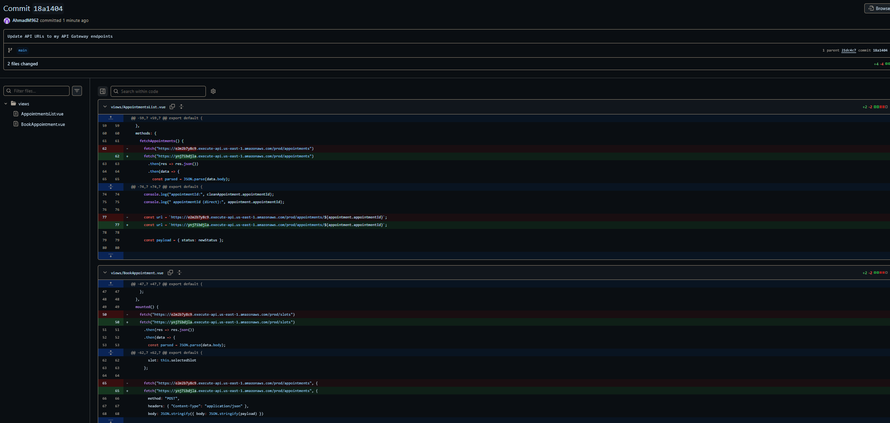

Task 8.4 — Deploy with AWS Amplify
Step 1: Open Amplify
AWS Console > AWS Amplify > Create new app.
Step 2: Deploy your app
Choose source: GitHub > Continue.
Step 3: Authorize GitHub
Authorize AWS Amplify on GitHub (one-time, you'll be redirected to GitHub then back).
Step 4: Select repository
Repository: HealthBooking-Public (your fork). Branch: main. Click Next.

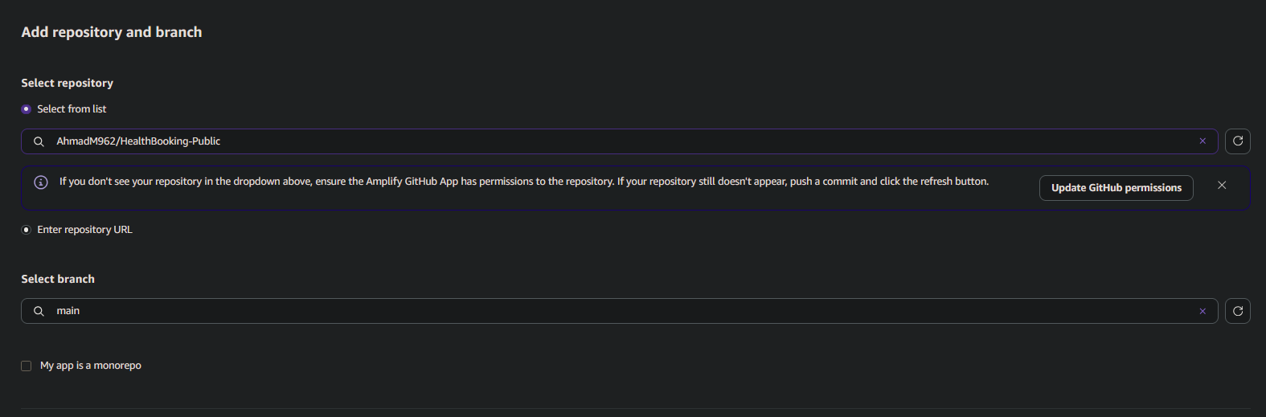

Step 5: App settings
App name: healthbooking-app. Build settings: Build command = npm run build. Output directory = dist. Amplify may auto-detect Vite from vite.config.js.
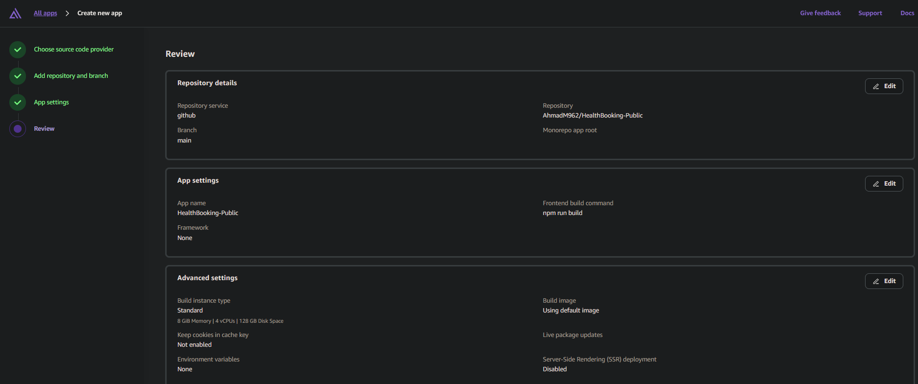

Step 6: Deploy
Click 'Save and deploy'. Wait approximately 3–5 minutes. All four stages (Provision, Build, Deploy, Verify) must turn green.

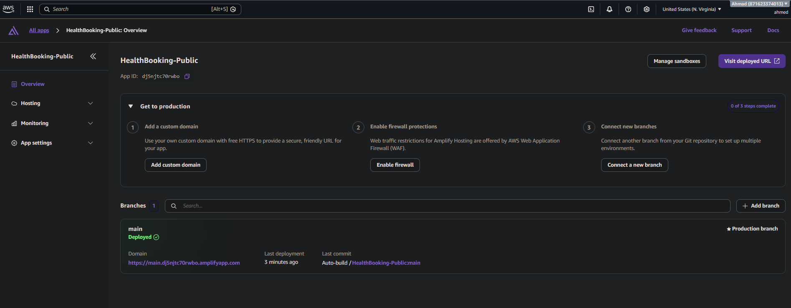

Step 7: Open the live site
Click the URL Amplify provides (https://main.d1g7ldurz4qgmx.amplifyapp.com/). The site loads from CloudFront edge locations globally.

https://main.dj5njtc70rwbo.amplifyapp.com/

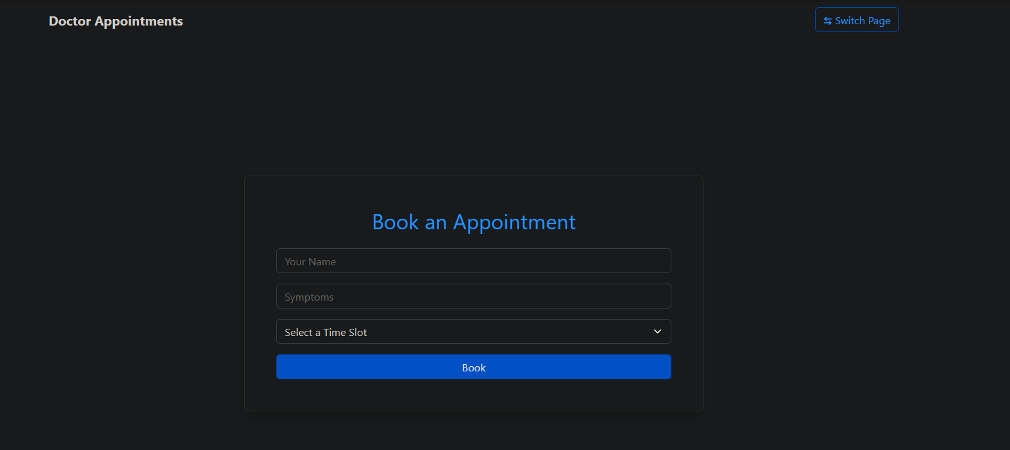

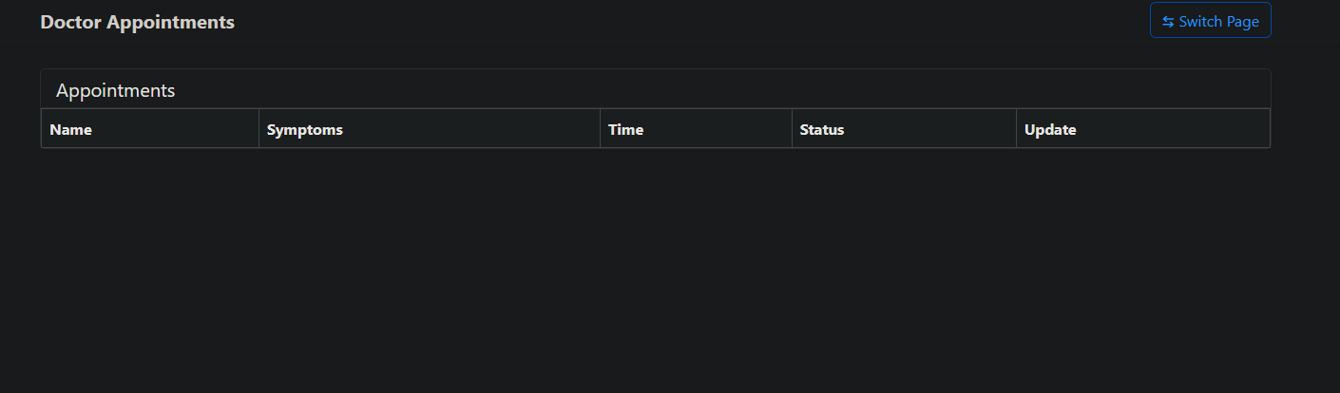

Task 8.5 — Connect Custom Domain (Optional)
Step 1: Add domain
Amplify > App settings > Domain management > Add domain. Enter healthbooking.com (or your domain).
Step 2: Follow Amplify's DNS steps
Amplify automatically provisions an ACM certificate and provides DNS records to add at your registrar.
[ SCREENSHOT: Amplify custom domain showing HTTPS and status: Available ]

PHASE 9 — End-to-End Testing

Test 1 — Book an Appointment
- Open the Amplify URL
- Enter a name, symptoms
- Select a slot (e.g., "10 - 11")
- Click Book
- Should see "Appointment booked!"
- Check email — notification should arrive

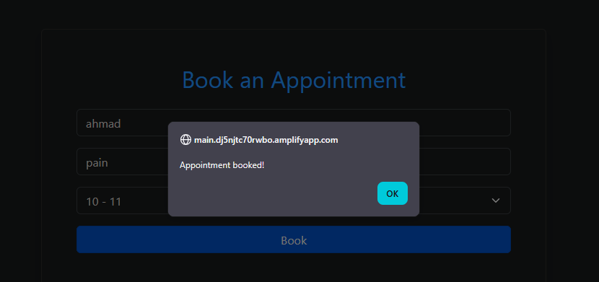

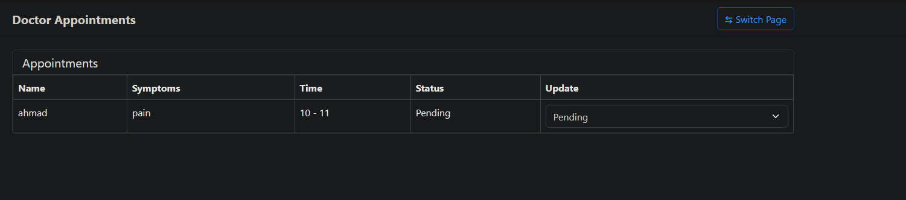

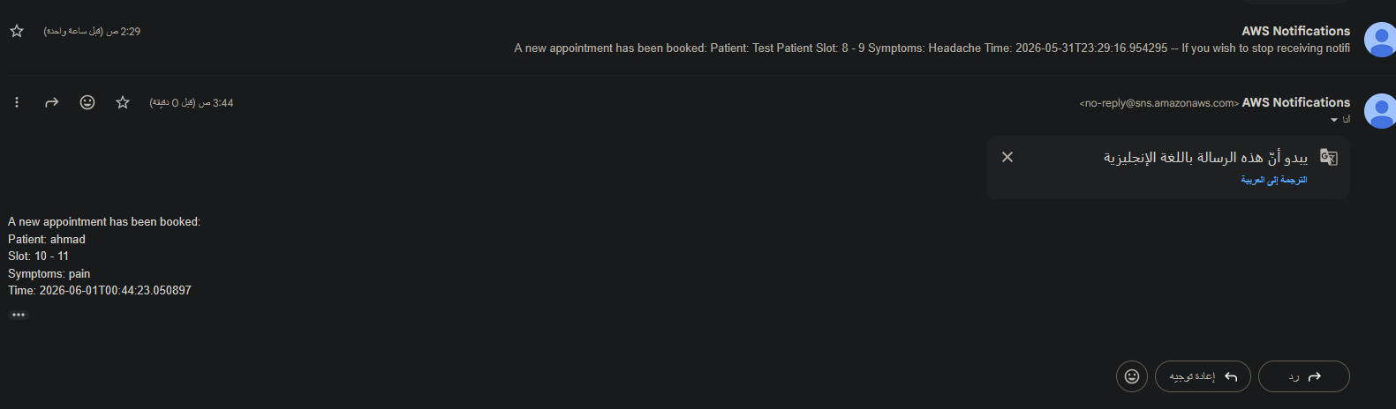

Test 2 — Admin Panel
- Click Switch Page (top right)
- You should see the appointment you just created
- Change status to "In Progress" using the dropdown
- Should see "Status updated!"

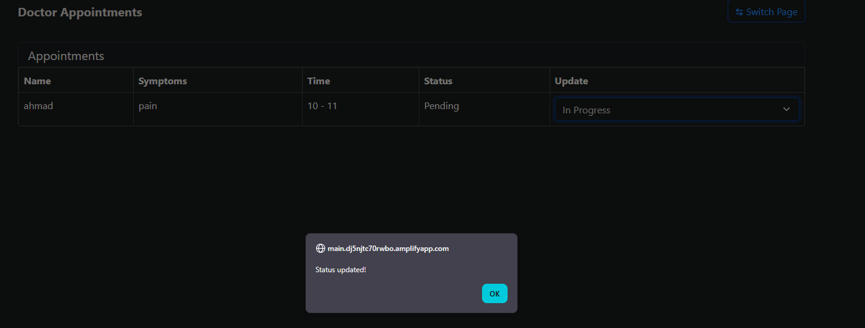
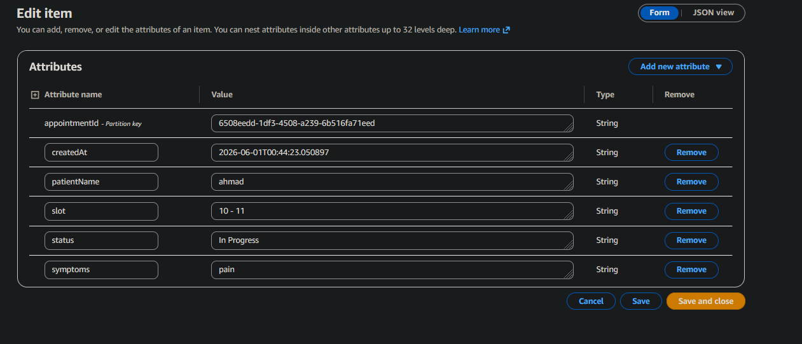
Test 3 — Reset
- Lambda → resetDailyBookings → Test with {}
- Refresh the Amplify site
- All 5 slots should be available again
- Admin panel should show no appointments

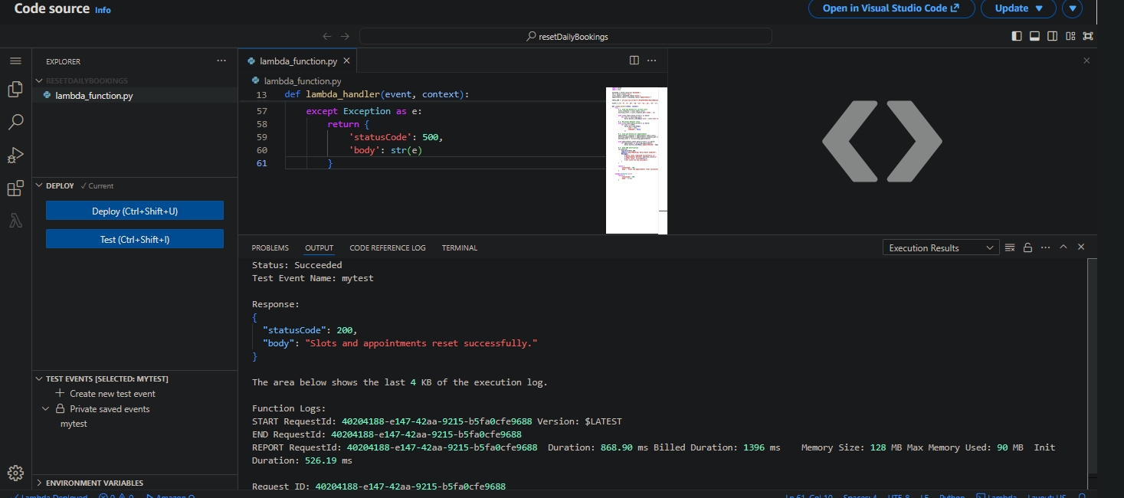

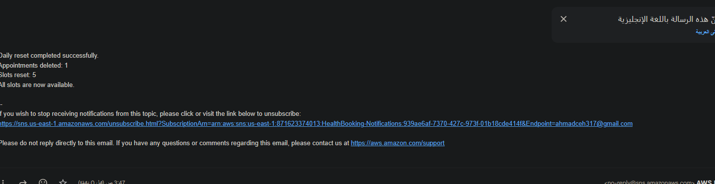

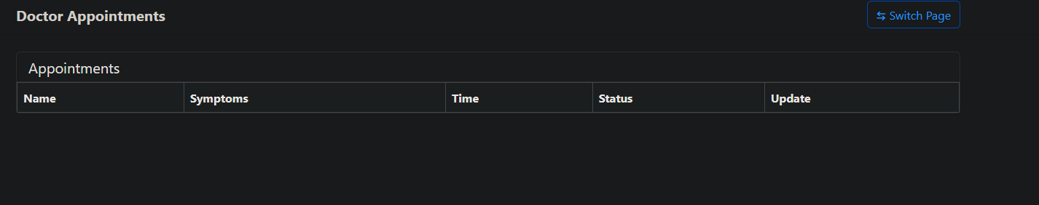

References
The following references are formatted using the Harvard Referencing System:

Amazon Web Services (2024) AWS Identity and Access Management (IAM) User Guide. Available at: https://docs.aws.amazon.com/IAM/latest/UserGuide/ (Accessed: 2 May 2026).
Amazon Web Services (2024) Amazon EC2 Auto Scaling Developer Guide. Available at: https://docs.aws.amazon.com/autoscaling/ec2/userguide/ (Accessed: 2 May 2026).
Amazon Web Services (2024) Amazon S3 User Guide. Available at: https://docs.aws.amazon.com/AmazonS3/latest/userguide/ (Accessed: 2 May 2026).
Amazon Web Services (2024) Amazon DynamoDB Developer Guide. Available at: https://docs.aws.amazon.com/amazondynamodb/latest/developerguide/ (Accessed: 2 May 2026).
Amazon Web Services (2024) AWS Lambda Developer Guide. Available at: https://docs.aws.amazon.com/lambda/latest/dg/ (Accessed: 2 May 2026).
Amazon Web Services (2024) Amazon API Gateway Developer Guide. Available at: https://docs.aws.amazon.com/apigateway/latest/developerguide/ (Accessed: 2 May 2026).
Amazon Web Services (2024) Amazon Route 53 Developer Guide. Available at: https://docs.aws.amazon.com/Route53/latest/DeveloperGuide/ (Accessed: 2 May 2026).
Amazon Web Services (2024) AWS Well-Architected Framework. Available at: https://docs.aws.amazon.com/wellarchitected/latest/framework/ (Accessed: 2 May 2026).
Amazon Web Services (2024) Amazon EventBridge User Guide. Available at: https://docs.aws.amazon.com/eventbridge/latest/userguide/ (Accessed: 2 May 2026).
Amazon Web Services (2024) AWS Amplify Hosting User Guide. Available at: https://docs.aws.amazon.com/amplify/latest/userguide/ (Accessed: 2 May 2026).
Alshannik, Y. (2025) Cloud Computing Course Slides — IAM, EC2, ASG/ELB. Al Hussein Technical University, Amman.

AI Tool Usage Disclosure
Claude (Anthropic) was used to assist in structuring this report, generating initial code samples, and organising technical explanations. All AI-generated content was reviewed, understood, and adapted by the student. All technical decisions, design justifications, and architectural choices reflect the student's own understanding of AWS best practices as taught in the Cloud Computing course. Screenshots throughout this report are from the student's own AWS console implementation.

